Plenary: which way forwards for Kenya?
Vision 1: Life in the fast lane
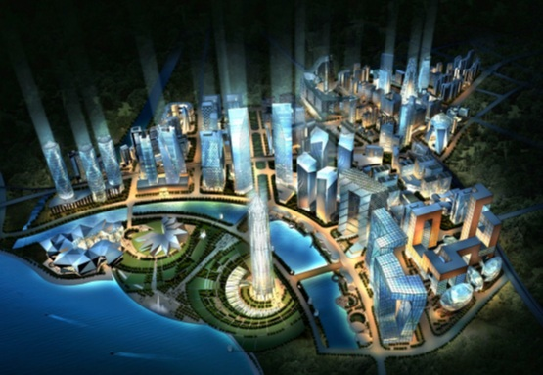
“It’s called Malili – a 5,000 acre East African technopolis – a proposed city built up for technology firms. It’s the Kenyan government’s dream of one day creating a regional ICT brand. The Malili project is modelled on other large technology and research parks around the world. One often cited in comparison is Smart Village Cairo, which currently hosts 120 companies and 20,000 professionals and they’re expecting that to increase to 500 companies and 100,000 professionals by 2012. One of Kenya’s government’s goals is to grow the ICT contribution to GDP from 3% to 10% in three years.”
Source: http://whiteafrican.com/2010/01/28/malili-kenyas-planned-technopolis/
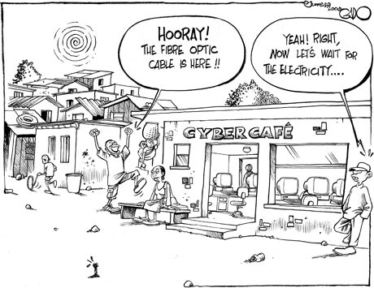
Vision 2: Life in the slow lane
“Some pretty long-term problems – like ensuring regular electricity supplies, improving kids’ basic education and eradicating government corruption and cronyism – need tackling before the benefits of ICT can be unlocked. Right now that all seems pretty far off still. This cartoon from Kenya’s Daily Nation newspaper just about sums it all up.”
Source: Gado cartoons (Daily Nation)

Which vision do you think seems most acheievable by 2020 and why?
...................................................................................................................................................................................................................................................................................................................................................................................................................................................................................................................................................................................................................................................................................................................

