Creating a transect on the Google Earth with photographs, using an iPad or an iPhone in the field

1) Using an iPhone or iPad (or another handheld device) – at each site take a photograph of your site.

2) Download the application Skitch from the internet.



Using the import function on Skitch – add a photograph from your handheld device photograph library. You could add annotations onto your photograph to give the details of the site:

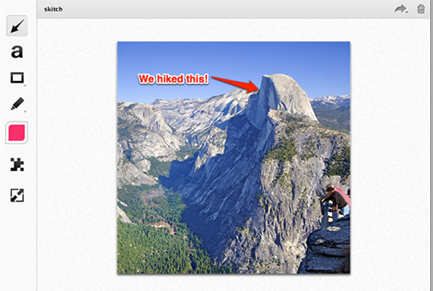

3) Now download the application GPS log form the internet. This will help us to gain a GPS location for each site.

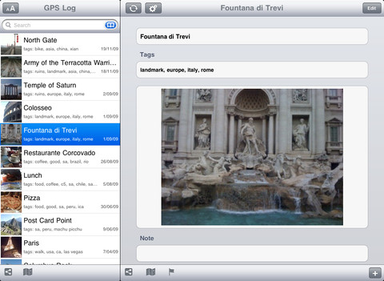

The application will give you the opportunity to label each site name, add notes for each site and import your annotated photograph.

For each new site you visit you can add a new site on GPS log and repeat the notes and photograph imports. Each time you create a new site it will appear on the left tab panel.

Once you have collected all sites you can upload them on the application onto Google Earth, and saving the file as a KMZ file.

Once completed you will have a KMZ file on Google Earth representing your fieldwork transect.

