21st Century Challenges- Global health Lesson 1 Resource Sheet
Starter – Key terms

Health
Morbidity
Mortality
Infant mortality
Case-mortality rate
Crude death rate
Prevalence
Incidence
Infectious
Non-communicative
Endemic
Pandemic

Health | The overall condition of an individual at a given time in regard to soundness of body or mind and freedom from disease or abnormality.
Morbidity | The state of being ill or diseased, or the occurrence of a disease or condition that damages health and quality of life. It can also be used to mean the relative incidence of a particular disease in a society.
Mortality | Death. The term is often accompanied by the cause of death (a specific disease or condition or injury).
Infant mortality | The number of deaths of children under the age of 1 year expressed per 1000 live births per year. It is useful as a barometer of social and environmental conditions and is sensitive to changes in either.
Case-mortality rate | The number of people dying from a disease divided by the number of those diagnosed as having the disease.
Crude death rate | The number of deaths per 1000 people in 1 year.
Prevalence | The number of cases of a disease per 10 000 of the population.
Incidence | The number of cases of a disease that are confirmed annually.
Infectious | A disease liable to be transmitted to people, organisms through the environment.
Non-communicative | A disease which is non-infectious.
Endemic | A disease that is prevalent to a peculiar or particular locality or region.
Pandemic | A disease that is prevalent over a whole country or the world.

Lesson 1 – Main activity – The global distribution of malaria

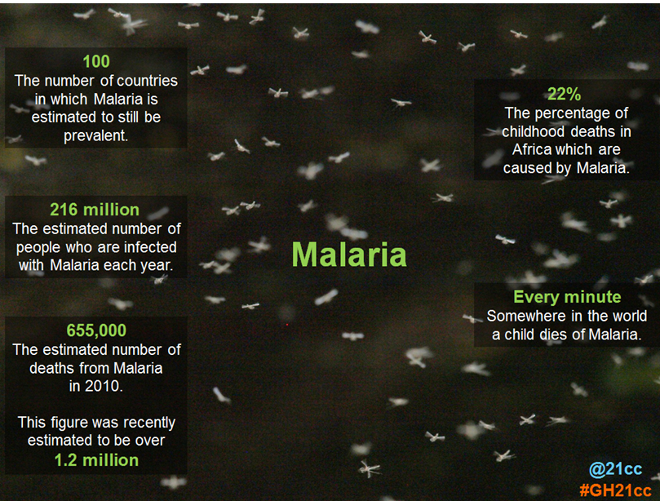
Activity 1: Key facts slide

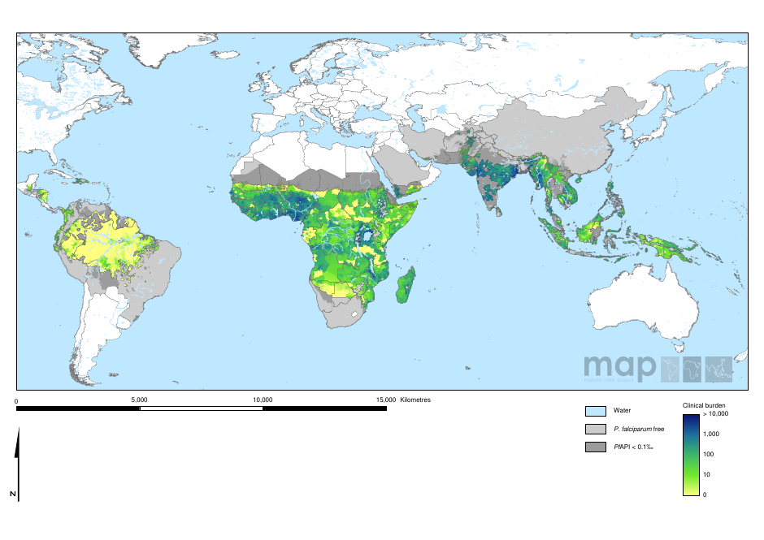
Activity 1: A map to show the clinical burden of malaria in 2007 (Source: Malaria Atlas Project University of Oxford http://www.map.ox.ac.uk/browse-resources/clinical-burden/Pf_burden/world/)
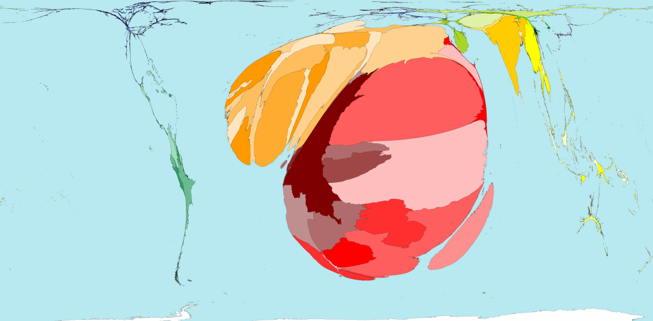 Activity 2: A map to show the number of malaria cases in 2006 (Source: Worldmapper)

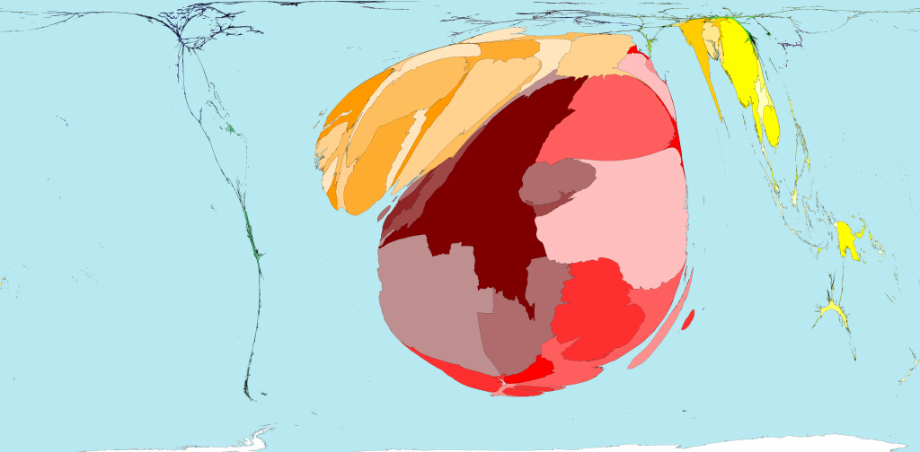
Activity 2: A map to show the number of deaths caused by malaria in 2003 (Source: Worldmapper)

Lesson 1 Plenary – Practice examination style questions
Source: AQA GCE Geography June 2009
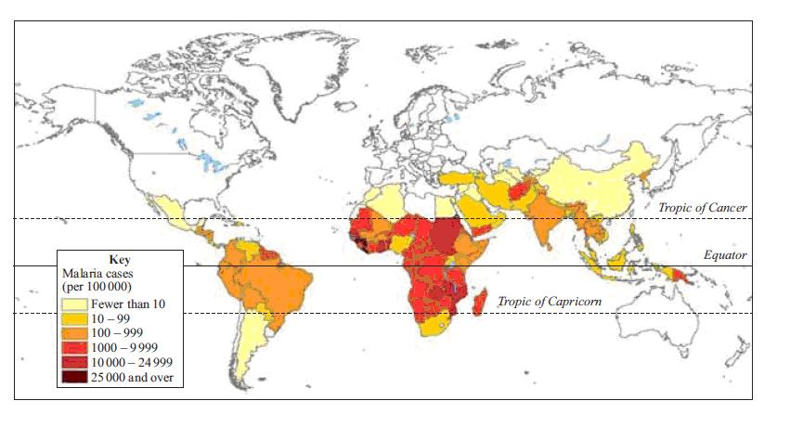

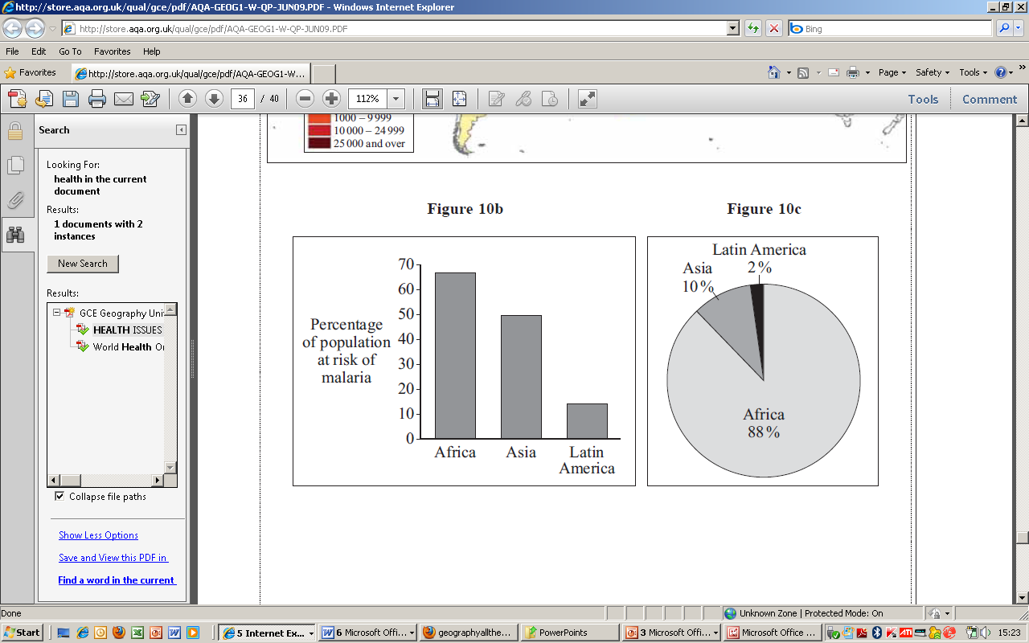
Figure 10a The distribution of malaria cases by country in 2005
Figure 10b The percentage of population at risk of malaria Figure 10c The percentage of global deaths from malaria

8 (a) (i) Describe the pattern shown in Figure 10a.
.................................................................................................................................
.................................................................................................................................
.................................................................................................................................
.................................................................................................................................
.................................................................................................................................
.................................................................................................................................
.................................................................................................................................
.................................................................................................................................
(4 marks)

8 (a) (ii) Study Figures 10b and 10c. Explain why the percentage of population at
risk of and the percentage dying from infectious diseases, such as malaria, varies.
.................................................................................................................................
.................................................................................................................................
.................................................................................................................................
.................................................................................................................................
.................................................................................................................................
.................................................................................................................................
.................................................................................................................................
.................................................................................................................................
.................................................................................................................................
.................................................................................................................................
(5 marks)

Mark scheme to practice examination questions

8 (a)(i) Cases are confined to the less economically developed world (1). Within this area, cases are much higher in Africa with much of the continent having over 1000 cases (1) and there are certain areas of high incidence e.g. cluster in eastern area and very high incidence e.g. west Africa (1). The tropical areas are worst affected and this is true for Asia and Latin America (1). The number of cases in Asia and Latin America are much lower – usually between 100 to 1000 in tropical areas (1). There are some exceptions – such as the cluster on the northern coast of South America and Afghanistan in Asia (1). The peripheral areas of the continents have the lowest number of cases – and this is true for Africa also (1). Any valid statement relating to pattern. (4 marks)

8 (a)(ii) Reasons likely to be referred to are: level of funding available for health care – thus, Africa fares worst; access to qualified staff for diagnosis; access to medicines; ability to control spread – insect here, but similar idea for different disease; education levels; availability/adoption of simple precautions e.g. bed nets for malaria, condoms for HIV/Aids. Level 1 (1-3 marks)
Describes the information in Figure 10b.
Begins to use this to identify the causes of the differences.
Reasons are simply stated.
Level 2 (4-5 marks)
Information in Figure 10b is used to provide the stimulus for reasons.
Reasons are clearly explained and answers are sequential and purposeful.

