Dear Jennifer,  I am having the best time in Florida. The weather is just perfect, and it has hardly rained since we arrived. I’m waiting for a storm to happen, because I have been warned about the flash floods here, especially in June.  It is wonderful being on holiday with sunshine every day. Today it was 33 degrees Celsius and I was so thankful that we were right next to the sea. The sea breeze definitely brought the temperature down at night.  Speak soon,  Georgia. |   Royal Geographical Society  1 Kensington Gore  London  SW7 2AR
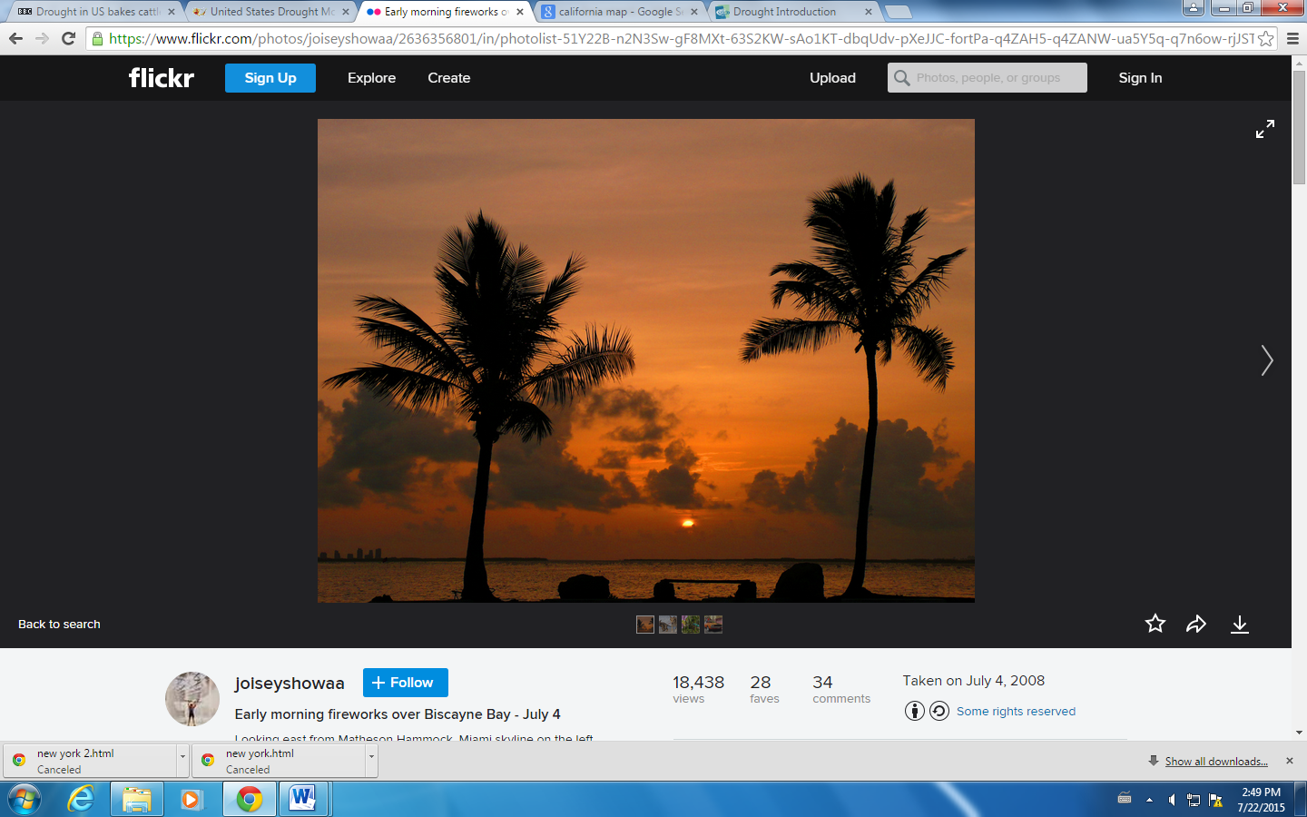
FLORIDA

