Hugging the Coast 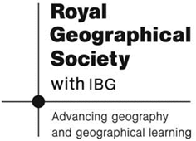
An exploration by sea kayak of liminal (marginal) living and rural development in North Sulawesi, Indonesia

Photographs © Vonna Keller
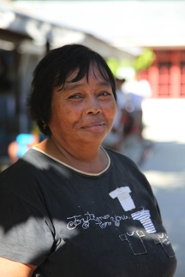

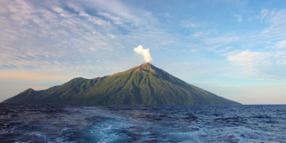

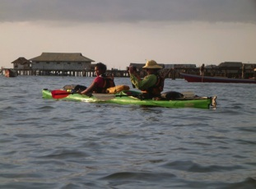


Author: Philip Avery
Goldsmiths Award

Photograph © Vonna Keller
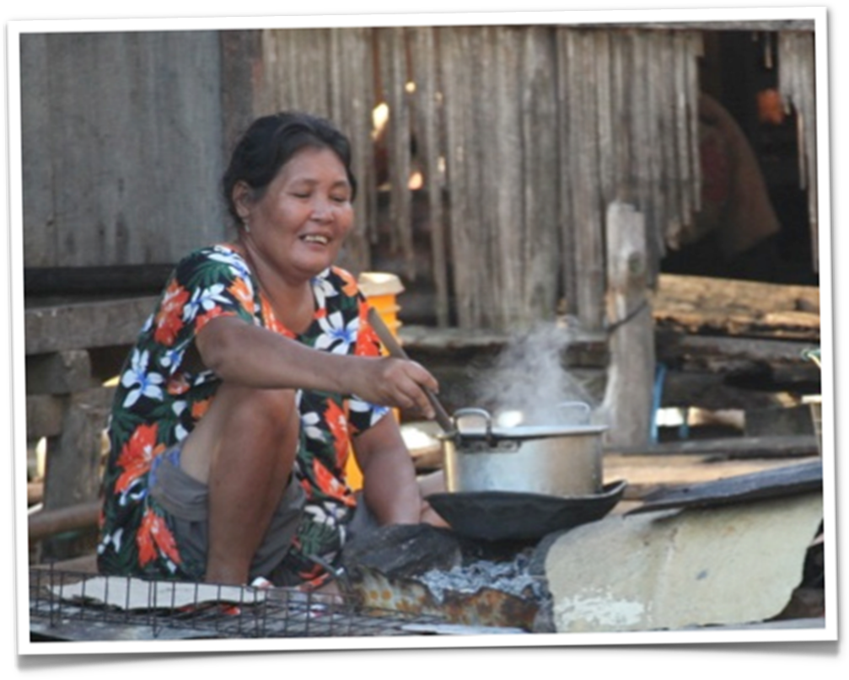

Expedition Summary

Between July and September 2012 an international team of six women traversed the 320km length of the Sangihe Archipelago, from Manado to Sangihe in the Celebes Sea, by sea-kayak. They observed, documented and engaged with life in the archipelago’s ‘liminal zones’, with a special focus on seaweed farming. This project was supported by the RGS-IBG through the From the Field Goldsmiths’ grant award programme.

Intriguing and inspiring elements of the journey:
- Exploration by kayak was adventurous, as well as practical (it broke down social barriers and gave access to remote communities).
- Clear links between the UK and the remote communities (e.g. Sulawesi seaweed ends up in our toothpaste and chocolate milk).
- The stories of the explorers and the explored; in particular the tales of the impact of climate change and the night the team were taken ‘hostage’.
- The concept of remoteness.

A video trailing how the expedition went can be found here:
http://vimeo.com/49028785

© Google maps

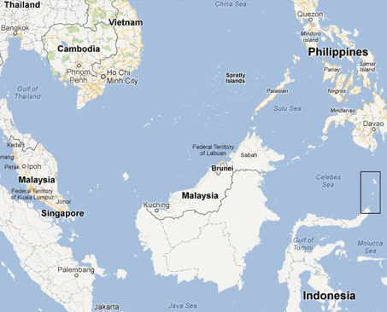


- further information on the route can be found here: http://huggingthecoast.net/?page_id=181

Remoteness:
Northern Sulawesi (where the expedition finished) is 2170 km (1350 miles) from Jakarta (the capital of Indonesia)

Research and noting techniques:
- Semi-structured and in-depth interviews
- Audio-recordings
- Video and digital photography

The team:
- Dr Duika Burges Watson: British and Australian citizen. Lecturer in Public Health at Durham University, post-graduate qualification in the Indonesian Language, PhD in Health Geography, teaches yoga, Chair of a Community Wildlife Garden in Whitley Bay and a keen mountain biker. Responsible for the academic write-up.
- Lena Conlan: Swedish. Leads sea kayaking and reindeer trekking trips, Wilderness Emergency Medical Technician, Search & Rescue volunteer and teaches Wilderness First Aid. Responsible for all things kayak related.
- Johanna Wadsley: British and Australian citizen. Mountain Instructor, Wilderness First Responder and has a PhD in Human Geography. Responsible for ensuring the project aims are met.
- Asa Pape: Sister of Lena and kayak support.

For more information on the team see: http://huggingthecoast.net/?page_id=384

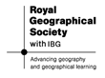
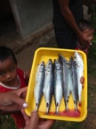

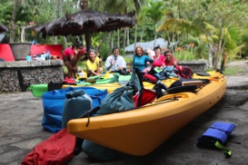

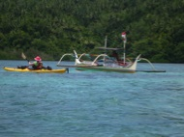

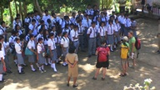
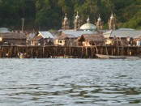

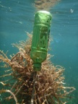

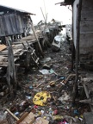

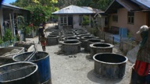

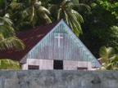

Quality of Life
Diet
Photograph © Vonna Keller
Team and Kit
The start line!
Photograph © Vonna Keller
Local Canoe vs
Team Kayak
Photograph © Lena Conlan

Standard of Living
Access to Education
Photograph © Lena Conlan

Liminal Living
Living on the edge
Photograph © Lena Conlan
Liminal Living
Seaweed Farming
Photograph © Lena Conlan

Standard of Living
Quality of the Environment
Photograph © Vonna Keller
Rural Development
Building Sea Defences
Photograph © Lena Conlan
Standard of Living
Religion
Photograph © Vonna Keller

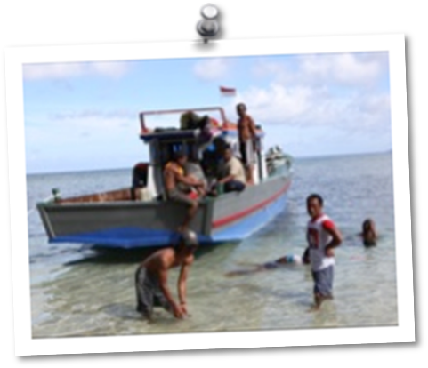

Key Questions 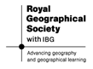
What is the quality of life for people living in the liminal zone of the Sangihe Archipelago, Indonesia?

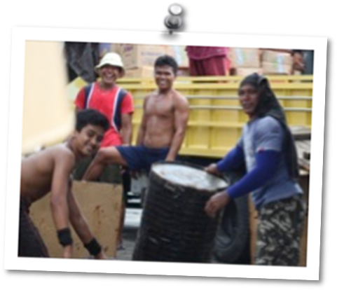

Is sustainable development currently possible in the case study area?

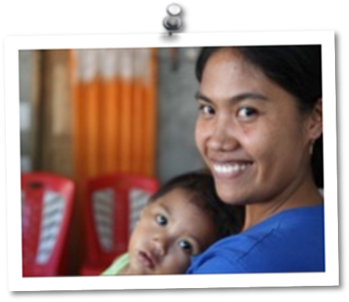
How can interviews and photography (still and video) best be used during fieldwork?

Photographs © Vonna Keller

Overview of Lesson Plans

Lesson One
The aim of this lesson is for students to create their own case study based on the research project and its outcomes.
Using a series of ‘lenses’ students will turn maps, photographs and video in to pen portraits in order to gain an awareness of the fieldwork area, the lives of the people that live in the liminal zone and any preconceptions they, themselves, hold.
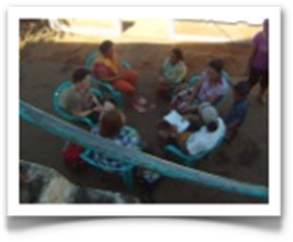
Students should leave the lesson being able to read photographs/maps to a high level and with an understanding of what the quality of life in the Sangihe Archipelago is like.

Lesson Two
In the second lesson, students are going to look at how meaningful data can be teased out from interviews using a technique known as phenomenological research.
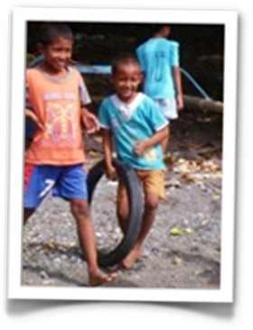
By the end of the lesson students should have an understanding of the concepts of sustainability and development and know one method of interpreting qualitative data (rather than the normal questionnaires).
Lesson Three
What the Hugging the Coast Expedition did really well was to find a way of breaking down the barriers between Western researchers and the local population. This final lesson in the series looks at how students can form a connection to the subjects they are studying and start a conversation that is meaningful to their work.
All photographs on this page © Lena Conlan

Groups of students are given the topic of ‘The Quality of Life in another Country or Culture’. Students must work out who in their extended network (or someone they research online) can give them useful information. They then choose two questions to ask them and a hook that will get their questions answered. The challenge is to get the replies and analyse them using the techniques from lesson two.

Follow up Homework Project
This lesson looks at the highs and lows of exploration and asks why people seek to explore and the challenges they face. It does draw together the geographical themes from Hugging the Coast, but it also looks at the psychology and purpose of remote travel. It involves a significant amount of data interpretation as well as skim reading of blogs.

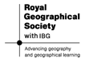

Teacher Fact File

This is a collection of information from the background information sections.

The Expedition
Between July and September 2012 an international team of six women traversed the 320km length of the Sangihe Archipelago, from Manado to Sangihe in the Celebes Sea, by sea-kayak. They observed, documented and engaged with life in the archipelago’s ‘liminal zones’, with a special focus on seaweed farming.

This area is known as the Coral Triangle. It is the Amazon of the seas. It is a tectonically active area and the team experienced numerous earthquakes (which resulted in nervous waits to see if they led to Tsunamis - locals are much more nervous since the Boxing Day Tsunami that affected the area) and spent time on a number of volcanic islands.

The initiative to introduce seaweed farming is trying to address a crisis of food security and climate change. The Government has limited rice imports as they want to become self-sufficient; this has led to food shortages. So seaweed farming is a poverty alleviation strategy, 100g of seaweed becomes a kilo and you get 4 harvests per year. The seaweed also scrubs the sea and sequesters carbon, so helping with climate change. It was because of the importance of the seaweed farming to these communities that the team wanted to go and study the area.

Liminal Zones
Rapidly changing, sensitive marine coasts in which, on which and from which people eke a living, increasingly through seaweed farming.

Quality of Life in the Sangihe Archipelago
In the Sangihe Archipelago of Indonesia many village communities are in a state of flux, experiencing declining standards of living. Despite their relative proximity to each other and to the provincial capital, villagers feel remote, pointing to multiple constraints upon their capacity to develop sustainable livelihoods:
- disempowerment due to physical distance
- a relationship between proximity to politicians and distribution of services and investment
- perceptions of socio-cultural differences between their village and the next
- ethnic marginalization
- the geography of their immediate land and marine environs
- changes in regional environmental and climatic conditions that are not universally understood

Key findings from the fieldwork team to date
Many village communities are in a state of flux, experiencing declining standards of living. Despite their relative proximity to each other and to the provincial capital, villagers feel remote, pointing to multiple constraints upon their capacity to develop sustainable livelihoods: disempowerment due to physical distance, a relationship between proximity to politicians and distribution of services and investment, perceptions of socio-cultural differences between their village and the next, ethnic marginalization, the geography of their immediate land and marine environs, and changes in regional environmental and climatic conditions that are not universally understood.

Despite a national investment programme to develop seaweed farming throughout the archipelago, most of the pilot projects had not continued beyond a few months. While very successful in one site (Nain) in other locations people reported three key reasons for the failure: inappropriate siting of farms, lack of on-going support, and crop failure due to predators and disease. Key respondents suggested the seaweed farming project had been too ‘top down’ to succeed. Seaweed farming has worked more effectively where it has been small scale, and where the farms have been individually owned.

In addition, weather changes have had an impact on seaweed cultivation and land plantation yields, and villagers reported that fishing was becoming more difficult and the catches smaller. In response, some villages are enacting individualized solutions: seaweed farming, building small-scale tourist accommodation, constructing ice-carrying ships to transport fish catches to more distant towns, or value-adding by smoking tuna for export to Jakarta. Such projects were generally instigated by a key individual, with the implication that success or failure will rest on their motivation, the level of respect accorded them by the community, and their capacity to influence village, island and regional -level decision-makers. These individuals lament their lack of connections to individuals and organizations with resources and expertise.

Only on Nain (a larger island) has seaweed farming been successful. Problems have included disease, predators, little support, climate change & an approach that has been too top down. Communities are declining and villagers feel increasingly remote. Some villages are coming up with individual solutions (for example ice ships), but they are lamenting the difficulty of creating contacts.

A positive result of the Hugging the Coast expedition is that it has raised the profile of coastal sustainability both within Indonesia and wider afield.

How the Fieldwork methodology impacts upon results

From the researchers:
“The fact that we were women and approached the coasts by sea kayak enabled us to access areas that were frequently overlooked because they are not accessible by larger craft, and enabled us to engage differently with our respondents. As reported in Kompas, the expedition proved the “tenacity of women”, challenged perceptions of the sea as a gendered domain, and demonstrated that how we ‘do’ research matters. We also experienced this at each location we visited. Our kayaks created connections through their initial similarity to local canoes, and we were instantly welcomed on that basis. The men, however, were fascinated by the boats, whilst the women were interested in us. We were warmly welcomed into their lives and respondents were immediately open to our questions about coastal lives and livelihoods. The kayaks, like local canoes, became a symbolic representation of liminal living, and a research tool that ‘worked’ to open up new ways of doing expedition geography.”

Bibliography
http://huggingthecoast.net/
R. J. Johnston, Derek Gregory and David M. Smith. The Dictionary of Human Geography. Oxford: Blackwell Publishers, 1998.
David Waugh. Geography an Integrated Approach. Cheltenham: Nelson, 2002.
Wikipedia, 31 Oct 2012, http://en.wikipedia.org/wiki/Standard_of_living
David Balderstone. Secondary Geography Handbook. Sheffield: Geographical Association, 2009.
Tim Ferriss. The 4-Hour Working Week. Ebury Publishing, 2011.

Links
Hugging the Coast:
There are many more resources you can explore from Hugging the Coast, including on-going discussions through our webpage and Facebook site. The Facebook site was created because the Sangehi archipelago is remote, but also connected – mobile phones and Facebook are ubiquitous; televisions and reliable access to the internet are not. The Vimeo site is for film clips from Hugging the Coast and includes a four minute introduction to the project and research. The website includes blogs from the expedition, and even a ‘recipe page’ of well tested treats learned from Carroll; the chef on the support boat that followed the trip.
- On the web: http://huggingthecoast.net/
- On Vimeo: http://vimeo.com/groups/156128
- On Facebook: https://www.facebook.com/pages/Hugging-the-Coast/488745574476886

Exploration:
www.theseroughnotes.org The website of ‘Explorer’, an organisation that aims to inspire young people to have adventures, advise them on how to make them happen and promote the work that they create whilst on them. Offers an annual grant.

http://www.theyet.org/ The website of the Young Explorers Trust, the UK’s association of youth exploration societies.

www.jamesketchell.net The webpage of James Ketchell who wants to try and row the Atlantic, climb Everest and cycle around the World, all in a year.

http://www.sarahouten.com/ The webpage of Sarah Outen who is trying to travel around the World by human power alone. Some fantastic educational resources on it.

