Tenzing Norgay

Born in the village of Moyey in Tibet, raised in Nepal, and a resident of India for most of his life, Tenzing Norgay was fluent in several languages.
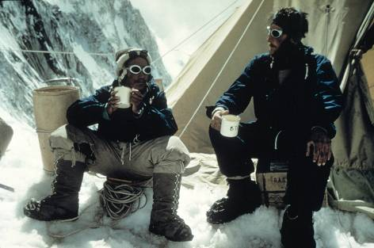
Tenzing Norgay (left) Edmund Hillary (right)
©Royal Geographical Society

Tenzing Norgay, (1914–1986) went to Everest as a high-altitude porter on the 1935, 1936, and 1938 expeditions as well as the 1953 expedition.

1953 ascent

Tenzing’s role was widely acknowledged to have been as significant as Hillary’s in the 1953 ascent. After the news of the ascent came out, there was some controversy over who had actually reached the summit first. The climbers themselves remained quiet on the subject at the time, and claimed to have reached the summit almost together. But the issue became a source of public debate as different nations (Britain, New Zealand, Nepal and India) claimed the prize. In fact, Tenzing had been born in Tibet and was reluctant to express his feelings in terms of national identity.

Tenzing’s achievement was celebrated in both Nepal and India, where there were proposals to have a national holiday and the mountain itself named after him: one political party in Nepal suggested the name “Tenzing Peak”, while an opinion poll in India supported “Mount Tenzing”, although there was also strong support for combined names such as “Tenhillary” and “Hillarsing”. None of these names were adopted, and the name remains Mount Everest today.

The Queen awarded Coronation medals to 12 leading Sherpas from the 1953 expedition, including Tensing Norgay who also received the George Medal, the highest civilian award for gallantry (while Hillary was knighted). These were presented by Charles Evans, deputy leader of the 1953 expedition, in a ceremony at Thyangboche monastery in June 1954. This contrasted with the lack of recognition granted to the Sherpas in 1922, who were not amongst those awarded medals by the International Olympic Committee in February 1924.

Since 1953, Sherpas have gained much more influence and responsibility in the conduct of climbing expeditions on Everest. Tenzing became the head of the Himalayan Mountaineering Institute, established in Darjeeling, India. Gradually Sherpas also came to play a more important role in the economy of mountaineering, with Sherpas owning a number of trekking and climbing agencies by the 1980s.

To find out more about Tenzing, see http://hiddenhistories.rgs.org/index.php/exhibition/further-reading#everest

