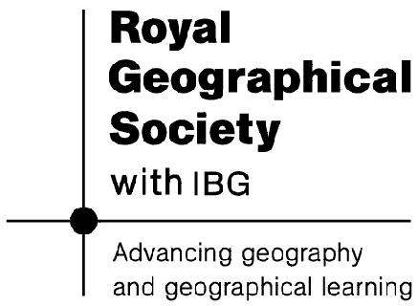
Royal Geographical Society
1 Kensington Gore
London
SW7 2AR

