
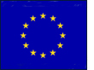
Into the UK

Study the table and graph on the following page, both of which are taken from a Home Office report (which you can access on the BBC website – http://news.bbc.co.uk/1/hi/uk_politics/5274476.stm). They show the numbers of people who immigrated to the UK from the eight countries that joined the European Union in 2004 between 2004 and 2006.

Your task is to use proportional flow arrows to represent the data on the map of Europe on the following page. Proportional flow arrows are different widths to represent different volumes of people. Proportional arrows, or Sankey diagrams, are also often used in science to show flows of energy.

This is what you need to do:

- Decide on a suitable scale for your proportional flow arrows. This is quite tricky in this example as there is such a wide range of figures. It might be an idea to use the scale of 1mm per 5,000 people, and think of an alternative way of representing the tiny number of immigrants from Slovakia. Calculate the width of each arrow using your scale and write the answer in the third column of the table.

- Locate the eight countries listed on the map of Europe.

- Draw an arrow the correct width from each country to the UK.

- Complete the key to show the scale that you have chosen for your proportional arrows.

- Give your map a title.

Economic migrants to the UK between 2004 and 2006 from eight countries which joined the EU in 2004.

Country | Number of immigrants | Width of arrow (mm)
Czech Republic | 22,000
Estonia | 5,000
Hungary | 13,000
Latvia | 27,000
Lithuania | 50,000
Poland | 265,000
Slovakia | 44,000
Slovenia | 500

Crown copyright, reproduced under PSI licence from ‘Accession Monitoring Report’, by DWP, HMRC, DCLG and the Home Office (2006)

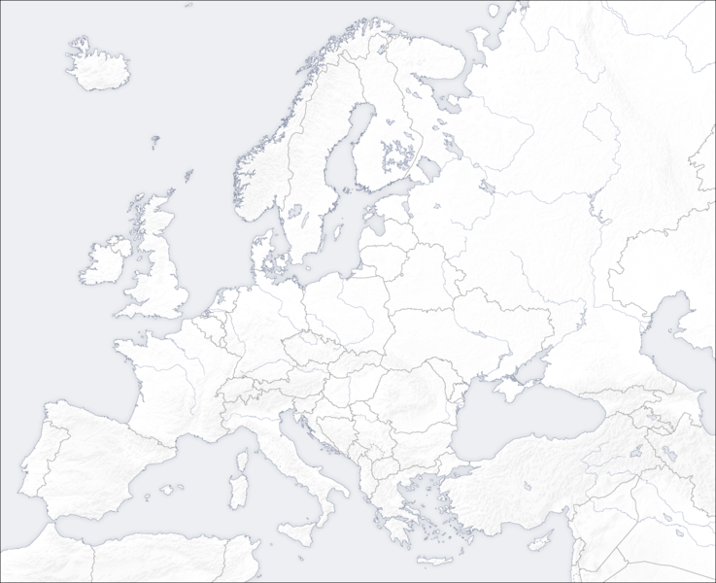
Key

