Who lives in the Everest region?

Sherpa people
The people of the Everest region are mainly the Sherpa who live in an area called the Solu-Khumbu district. The district lies in the northern part of the Sagarmatha National Park which was set up in 1976.

The word Sherpa means ‘people from the East’ as they originally came from Eastern Tibet. Subsistence farming was how they used to live with some people taking part in trading. In the past, Sherpa food came from crops such as potatoes, barley and buckwheat. Nepali foods like lentils and rice are also part of the Sherpa diet.
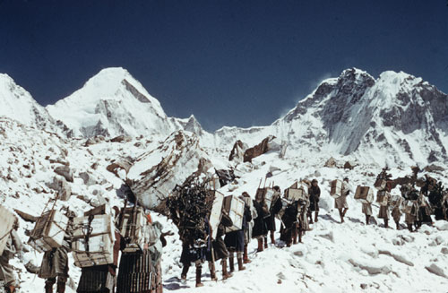
Tourism is recognised to be of great importance to the well-being of people in the region as it brings jobs and people can earn wages. But there are also problems. These include the effects of tourism on the Sherpa people’s religious traditions and way of life. Although many Sherpas have managed to adapt to tourism successfully and without losing their traditional way of life. However, the effects on the environment have been far greater.

Nepal’s porters
Nepal’s people have always moved goods around the high alpine reaches of the Himalayas. The ‘traditional porter’ continues to work for local people. The job is not well paid and the loads are heavier but it is not so dangerous as it is usually carried out between villages at a lower altitude. What is new is modern trekking and tourism in which they now work. It is an important industry that provides jobs in one of the world’s poorest countries on the one hand, while at the same time porters have been working under dangerous conditions.

The high altitude porters are often Sherpas who carry loads above base camp on expeditions. Most trekking porters are poor farmers from lowland areas, and are as unused to the high altitudes and harsh conditions as western trekkers. As a result they can get hypothermia, frostbite and Acute Mountain Sickness. This happens when trekkers gain altitude too quickly and don’t drink enough water. Many people don’t know this and a myth seems to have been created that porters are superhuman, that they can carry massive loads in harsh conditions and they are used to cold and high altitudes meant nothing to them.

In 1997, the International Porters Protection Agency (IPPG) was formed after a young Nepali mountain porter fell sick and was sacked while still at high altitude. After being paid off and sent down on his own, he died at the side of the trail. The aim of the IPPG is for every porter to have clothing, boots, shelter and food, for the altitude and weather, and medical care when ill or injured.

Websites International Porters Protection Group www.ippg.net Tourism Concern www.toursimconcern.org.uk

