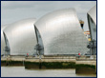
Are you flood ready?

Investigating how improved water quality has brought positive change to the cities of Manchester and Liverpool.

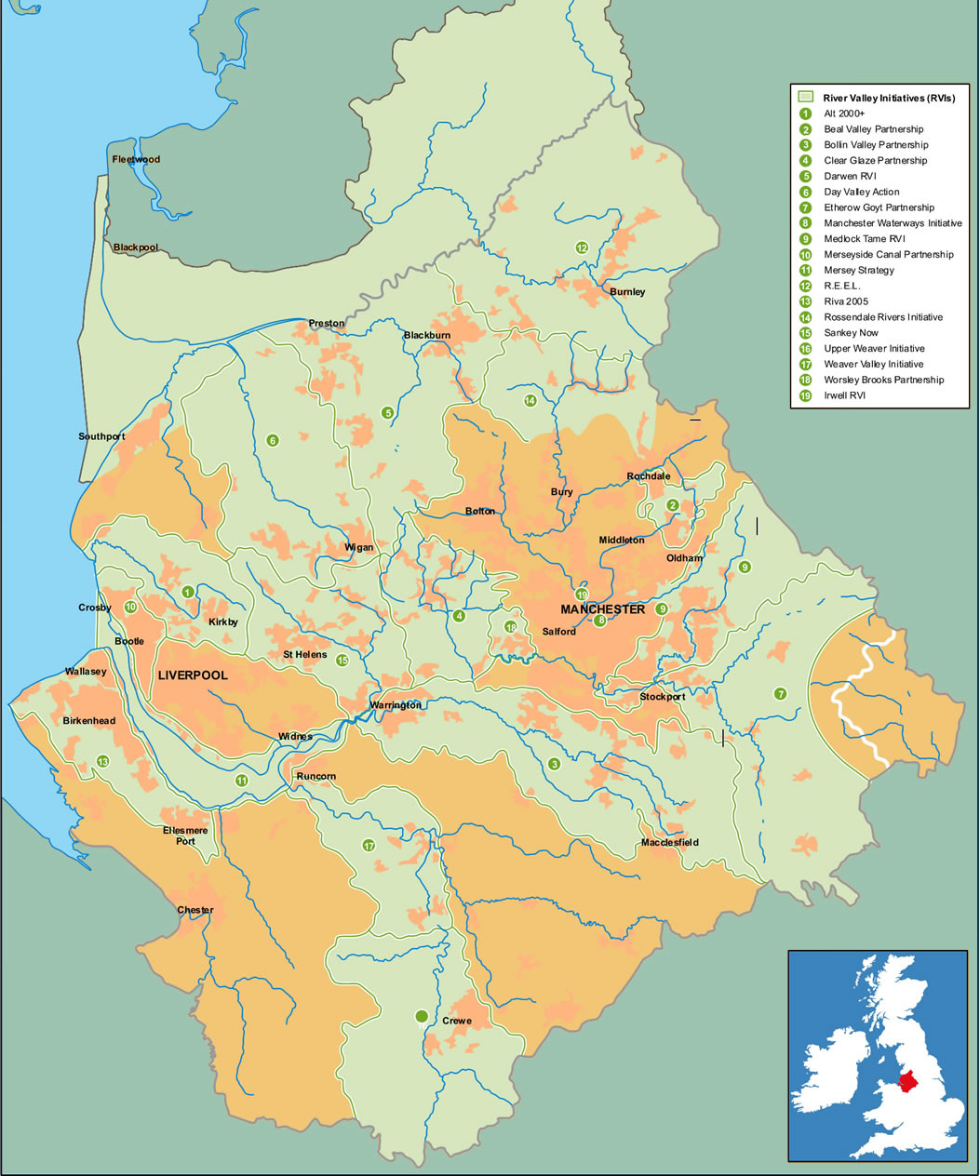
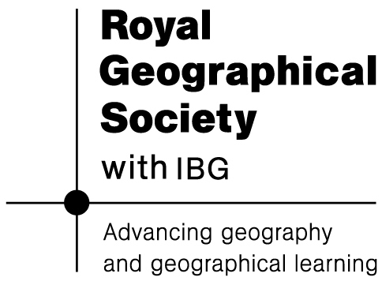
The Mersey and its tributaries


In the early 1980s, water quality and riverside conditions were so poor that urgent action was needed. The Mersey Basin Campaign (MBC) was set up by the Government to sort it out.

Since 1985, the MBC has worked very hard to restore the river ecosystems and encourage floodplain regeneration in the area. There are three reasons why help was needed.

1. The rivers and canals of the Northwest had centuries of industrial pollution. The Mersey was famous as one of Europe’s most polluted rivers and since the 1970s oxygen levels were so low that few species could live in it.
local people would joke that it was impossible to drown in the Mersey as you would be poisoned first!

The smells from the river were also unpleasant, with beaches and sandbanks often affected by crude sewage, fat (from oil manufacturing) and tar. It was so disgusting that local people would joke that it was impossible to drown in the Mersey as you would be poisoned first!

2. The environmental conditions were so bad it resulted in wasted opportunities for housing, retail and leisure developments. No one was going to build new businesses next to a really smelly river!
This situation was made worse as lots of people became unemployed. Locally people did not have money to invest or spend in leisure pursuits.

3. Social problems were made worse due to poor environmental quality during the 1980s. There were riots and these revealed how bad the urban decline was in Liverpool and Manchester. As people were poor the local environment suffered. Shops closed and decayed as no one was spending money.

Government discussed tackling the pollution in the Mersey and improve the appearance of their banks. The untreated sewage, pollutants and poisonous discharges were totally unacceptable and this all needed to change. A report drew a link between crime and local environmental issues. So hopefully by improving one, the other would also benefit.

Sadly, as the 1980s continued physical and social conditions got increasingly worse. The affluent middle class people moved away leaving the poor, elderly and deprived. Without their money business, like shops, also failed.

The population declined. It was decided that by acting and improving conditions of the Mersey Basin, hopefully the well-to-do would come back. As they would move back in, so too would shops where they would spend their money. The social change would improve the physical environment.
Name | Why they want to help | How they can help
United Utilities | They needed to improve the standards of the water. | They raised money through billing customers and managed the water supplies in the region.
Environment Agency | Their job is to improve environmental quality. | They forced companies to clean up local waterways.
Local Authorities | They try to improve the quality of life of their residents. | They help other agencies get involved if the health of their residents may be effected.
Property Development Firms | Money can be made from re-development.  (Urban Regeneration) | They can financially contribute to restore the area.
RSPB | Improve the habitats for birds along the river-ways. | They are experts on birds, so made sure the river environment was suitable for them to live there.

ACTION WAS FINALLY TAKEN!

Restoring all of Merseyside’s rivers and canals was a big, expensive and difficult job. There was no one organisation that could do it all. However by getting different people and organisations to work together change could occur!

The Mersey Basin Campaign got private industries, local government branches and charities to work together using teamwork. Each participant had a different strength to sort out one element, together they focused on three major objectives:

- Improving the water quality across all the rivers
- Clear up the waterside environment and encourage new building and businesses to brighten up the area (Urban Regeneration).
- Encouraging public, private, community and voluntary sector participants to work together as a team to achieve these objectives.
The MBC asked lots of different organisations, each with their own specialist skills, to work on the projects. (See the table on Page 3 for a few of these).

The MBC was set up to get these organisations together, so that by using teamwork a lot could be achieved. They worked towards improving water and riverside quality for the region’s waterways.

Success Story (1):
Riverside Regeneration
at Salford Quays

One of the Campaign’s objectives was to make the waterside a good and useful place for the local people. As most of the Merseyside’s industrial plants closed in the 1970s and 1980s, the riverside was full of derelict factories. The factories had also poured pollutants into the rivers,

The water was full of poisons and smelled foul. The worst effected area was the Turing Basin at Salford Quays, 28 hectares of foul-smelling and frequently bubbling open water.

Local agencies began to think about how these properties could be used in a different way. Firstly they had to address the state of the water. In order to improve the water they needed to address the oxygen levels. These had dropped significantly due to the pollution and foul-smelling sewage. Science had taught them that if oxygen was present at a sufficient level the bubbles and smells would disappear. The solution was to increase the oxygen levels.

An oxygenation tank was installed in 2001 at a cost of £4.5 million.
As the oxygen was injected into the water, life returned. The smells disappeared and more creatures were able to live in the water.

In 2004 Salford Quays hosted the UK’s first ever Triathlon World Cup. A 3 km swim in the docks was included!

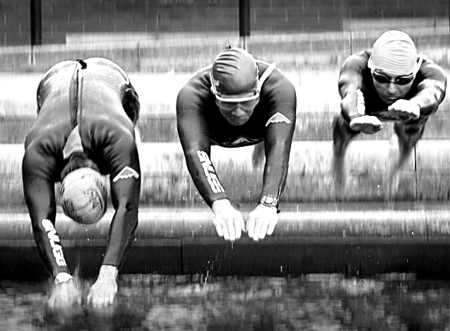

Figure 3 Triathlon World Cup

Source: Mersey Basin Campaign

Success Story (2):
Water Quality

Since the MBC was established water quality has improved dramatically throughout the region. Native salmon is now living in the Mersey Basin. 30 species of fish are now thriving where there used to be just four, all due to greater pollution control, and improved oxygen levels.

Success Story (3):
Mersey Basin Week

The Mersey Basin Campaign had the objective to get support and help from many organisations. They all successfully used teamwork to sort out the problems of the Mersey Basin rivers and canals.

They also worked directly with local residents and encouraged people to keep the local waterways clean and tidy. Every year since 1992, the MBC organise an event, known as Mersey Basin Week, to remind people that everyone can help look after the waterways.

During the 2006 Mersey Basin Week, more than 4,500 local volunteers, including schools, took part in waterside clean-ups, recycling projects and conservation work in riverside nature reserves. The annual event is sponsored by local firms, all of whom were contacted by the MBC and asked to participate.

Teamwork is a tool that the MBC successfully is still using today!

Notes

The Mersey Basin Campaign website hosts a number of reports and information including reviews of activity:

http://www.merseybasin.org.uk/

The Channel 4 website includes a short film that is relevant to the work of the MBC:

http://www.channel4.com/fourdocs/film/film-detail.jsp?id=1549

Case study (c) Simon Oakes 2008. An A-level version of this case study has previously been published as a GEO FACTSHEET (211). Thanks to the MBC’s Caroline Riley for all of her help and picture sourcing for the original article

