Lesson One: Journey of a River
Factsheet

Purpose of Lesson
Ninety-seven percent of all the water on Earth is found in the oceans. The remaining three percent is fresh water. This fresh water is found primarily frozen in ice sheets, ice caps or in glaciers. Fresh water is also held deep underground, in naturally occurring aquifers (porous rocks that hold water like a sponge) or in groundwater (contained in soils). Only 0.011% of all water is fresh water found on the surface as rivers or lakes. However, rivers continue to shape the landscape and impact of the lives of people who live in their vicinity.

Vocabulary
This lesson uses the following geographical terms. These should be used and explained to pupils as the lesson is taught.

Source The point at which a river starts.
Upper course The first stage of river, often located on high ground.
Middle course The second stage of a river, where the land is flatter and the river wider.
Lower course The land is flat and the river is at its widest.
Channel The river bed and banks in which water flows.
V-shaped valley The river in the upper course flows through steep gradients
Tributaries Small streams that join the larger river.
Erosion Material is cut away from river beds and banks by the water
Transportation When eroded material is taken downstream.
Deposition Material is ‘dropped’ or deposited when the river no longer has the capacity to carry it.
Undercutting A feature of erosion when the river cuts away at the bank.
Meander The natural bend in a river.
Oxbow lake A section of a meander that becomes isolated from the main river channel and eventually dries out.
Mouth The point where the river ends.
Estuary In the lower course, where the river meets the sea.
Delta Characterised by mud and sediment deposits, deltas are formed at the mouth of a river when the incoming tide cannot wash them away.
Precipitation Precipitation is rain, hail, sleet and snow. It is important that pupils do not think that the only source of fresh water is rain.
Surface runoff When precipitation runs over the surface of the land.
Throughflow When water infiltrates the layer of soil and flows through it, rather than overland.

The Water Cycle
It is assumed that pupils are already familiar with the water cycle. Otherwise it may be necessary to teach this in advance. For an animation of the water cycle follow this link:
Go to Crickweb http://www.crickweb.co.uk/ks1science.html#watercycle

The River Severn
The River Severn, at 354km, is the UK’s longest river. Its source is in the Cambrian Mountains of mid Wales (610 metres above sea level). It flows through Shropshire, Worcestershire and Gloucestershire. The Severn Estuary is the mouth of four major rivers, the Severn, Avon, Wye and Usk. The estuary then flows into the Bristol Channel. The Severn Estuary, which in places is up to 8km wide, is spanned by two bridges. The first bridge was opened in 1966 and replaced a ferry crossing. The second bridge, shown in the photograph on the Journey of a River PowerPoint presentation (see downloadable resources), was opened in 1996 and is 5128m long. The Severn Estuary is tidal, with water at high tide travelling up to 25 km upstream.
The Upper Course
On a river, the courses are not clearly defined, but gradually merge from one to the other.
The photographs, taken in Glencoe in Scotland and Snowdonia in Wales show steep land, sparse vegetation and V shaped valleys - classic features of the upper course. In the upper course precipitation feeds the emerging river, additionally rivers can begin as snow melts off hills and mountains.

While rivers typically start on high land, some also have their source in lowland valleys. Here the throughflow, rather than overland flow, of water is significant. Water stored deeper, as ground water, also helps to form lowland rivers.

Waterfalls: The photograph of High Force on the River Tees also shows how waterfalls can create steep, high-sided gorges. As the river erodes softer rocks the overhanging hard rock eventually collapses. The waterfall then moves upstream and, as it retreats, a gorge is formed. The formation of waterfalls is covered in depth in Lesson five.

The Middle Course
In the middle course, rivers become wider and deeper. While the water is less obviously turbulent than in the upper course (which can often give the upper course the appearance of fast flow) in the middle course the water is actually moving with greater velocity. With a wider river bed and deeper water there is also less friction. As such the river has a greater energy to erode the river bank.

Meanders: Water never flows in a straight line. Even in an apparently straight river channel, water will twist and turn around stones and other obstacles. This will result in areas of faster and slower moving water and the river will gradually begin to flow a more winding course. Over time these meanders will become more and more pronounced.

River processes: In the middle course the shape of the river is under constant change. The water erodes, transports and deposits soil and other material.

- Erosion: This causes the wearing away of the river banks and river bed. In the first instance, the sheer weight of the water can move material from the river bed and river bank. In a process called abrasion, small rocks and sediment can also act like sand paper, rubbing away at the river bed. Attrition also causes rocks and pebbles to collide and break apart. Finally, erosion can occur through corrosion, where water reacts with minerals in the rocks it flows over. Erosion occurs on the outside of the meander where the water is moving at its fastest. This will also cause a deeper channel to be formed- so consequently the water on the outside of a meander will be deeper than on the inside.

- Transportation: Any eroded material is transported downstream. This material is transported as whole boulders or rocks; is held in suspension within the body of the water; or is dissolved and held in solution.

- Deposition: This occurs where water lacks the energy to transport the load it is carrying. In the middle course this happens on the inside of a bend or meander, where the water flows slowly. In the lower course, deposition can happen at the mouth of the river, where the estuary meets the sea. This can form a delta. Oxbow lakes form when meanders become extreme.

- Flooding: This can occur at any point along the middle and lower course of a river - where the land is flatter and the river carries a higher volume of water. When there is too much water to be contained in the river channel, the river will over flow its banks and spread across the flood plain. The process of flooding and the impact of flooding on the landscape and people are covered in more depth in Lesson two.
The Lower Course
Estuaries and deltas: Many rivers have estuaries, which are characterised by wide, flat land, where the river flows into the sea. Deposition occurs at the estuary, but at high tide this is carried away by the sea. Deltas are formed where the tides are not strong enough to wash the sediment away. There are no large deltas around the coasts of the UK.

World Rivers
The longest rivers in each continent are:
Africa Nile 6695km
South America Amazon 6400km
Asia Yangtze 6380km
North America Mississippi 3766km
Europe Volga 3570km
Australasia Darling 1472km
Antarctica Onyx 40km (note the Onyx only flows during a few months of the Antarctic summer)

The Journey of a River
Expect pupils to be able to identify the following:

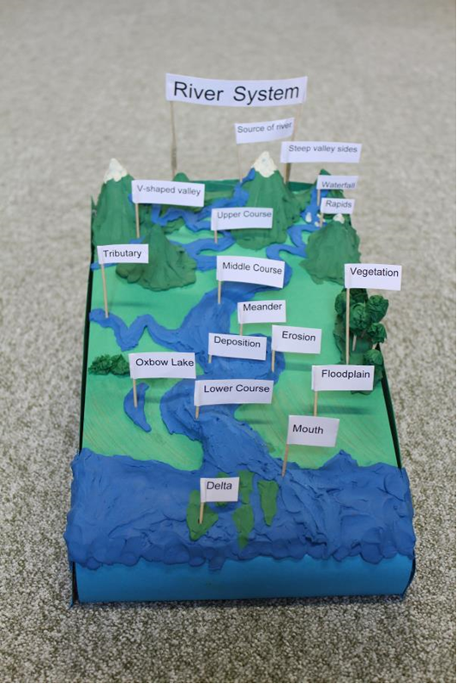
Upper course
Precipitation runs off the land to form the source of the river
High land and steep slope
The river flows rapidly over rocks
Waterfalls are formed

Middle course
The land becomes flatter
Tributaries join the main river
Meanders form
The outside of the meander has faster flowing, deep water. Erosion occurs
The inside of the meander has slow flowing water, shallow water, deposition occurs.
Oxbow lakes

Lower course
The land is very flat
Estuary
Deposition
Mud and debris is washed away at high tide
The sea

