Lesson three: Answer Sheet
Using Grid References and Keys:

- (Map Extract 2) What is located at the grid reference 336802?
Tower Bridge.

- (Map Extract 2) What is located at the grid reference 415793?
Thames Barrier.

- (Map Extract 2) To the east of the feature you identified at 415793 is a big blue V. Use the key to find out what this symbol means.
Visitor centre.

- (Map Extract 2) in grid square 3381 and grid square 3481 there are four different types of religious building. Name each type, draw their symbol and count them.

Current or former place of worship with tower | 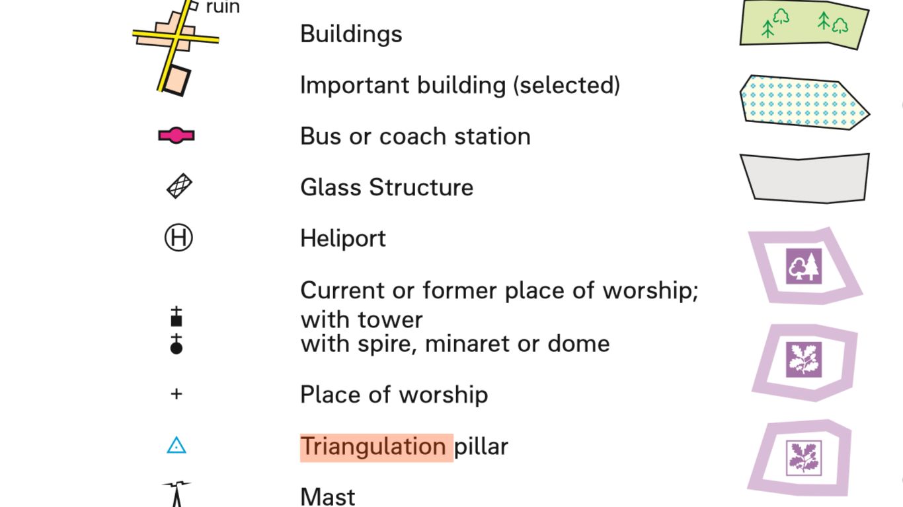 | 4  A 5th may be counted because it is bisected by the grid square to the west | grid square 3381
Current or former place of worship with spire, minaret or dome |  | 2 | grid square 3381
Mosque- Current or former place of worship with tower |  | 1 | grid square 3481
Place of worship |  | 4  2 | grid square 3381  grid square 3481

- (Map Extract 3) What is located at grid reference 698752?
A beacon is located close to mud flats and an uneven river bank to help guide vessels.

- (Map Extract 3) Find two more features that visitors might want to see in the locality. What are they? What are the grid references for each feature?
For example, nature reserves at 693745, 707757, 722770, a golf course at 677717, recreation/leisure/sports centre 672719, power station 665755.

Knowing Direction:

- (Map Extract 2) You on standing at the top of Shooters Hill (439765) looking across London. In what compass direction is the Isle of Dogs (375788)?
North West.

- (Map Extract 2) Is the Cutty Sark (383780) to the north or south of the Isle of Dogs?
South.

- (Map Extract 2) From the Cutty Sark, you look downstream. In which direction is the river flowing?
The river is in the middle/lower course, therefore meanders. It flows east from the Cutty Sark, then north along Blackwall Reach, west passed the O2 arena and finally south west under the cable car and west towards the Thames Barrier.

- Using Map Extract 3, devise two more questions for your class to answer using the 8 points of the compass. Remember, you must know the answers yourself.
These questions will all differ. Use the best questions as the starter activity for Lesson 4.

Understanding Contour Lines:

- (Map Extract 3) At what height is the golf course in grid square 6771?
60 metres. (Pupils will also need to use their key to find the symbol for golf course).

- (Map Extract 3) From the golf course, walk north. Are you walking uphill or downhill?
Downhill.

- Continue walking north from grid square 6771 until you reach the River Thames. Estimate the height of the river at this point. Give a reason for your estimate.
The height will be between 0 and 10 metres – the height depicted by the last visible contour line.

High ability pupils may also comment on other evidence that the river is near its estuary (at sea level or 0 metres):
The width of the river
The presence of marshland
The location of Tilbury Docks and a power station

Using Scale:

- Your task is to measure the width of the river channel at the high water mark, in three locations, as detailed below: (Remind pupils that the high water mark will include the mud flats).

Map Extract 2 Grid Square 3280 0.25km

Map Extract 2 Grid Square 4479 0.5km

Map Extract 3 Grid Square 6975 and 6876 1.3km (or answers greater than 1km and less than 1.5km- measured from the beacon in grid square 6975 to Coalhouse Point in grid square 6876).

- What do you notice about the width of the river? What does this tell us about the river course?

The river is becoming wider as it flows downstream from west to east, middle course to lower course.

