Site selection on Villarrica for data collection – boxes show site numbers

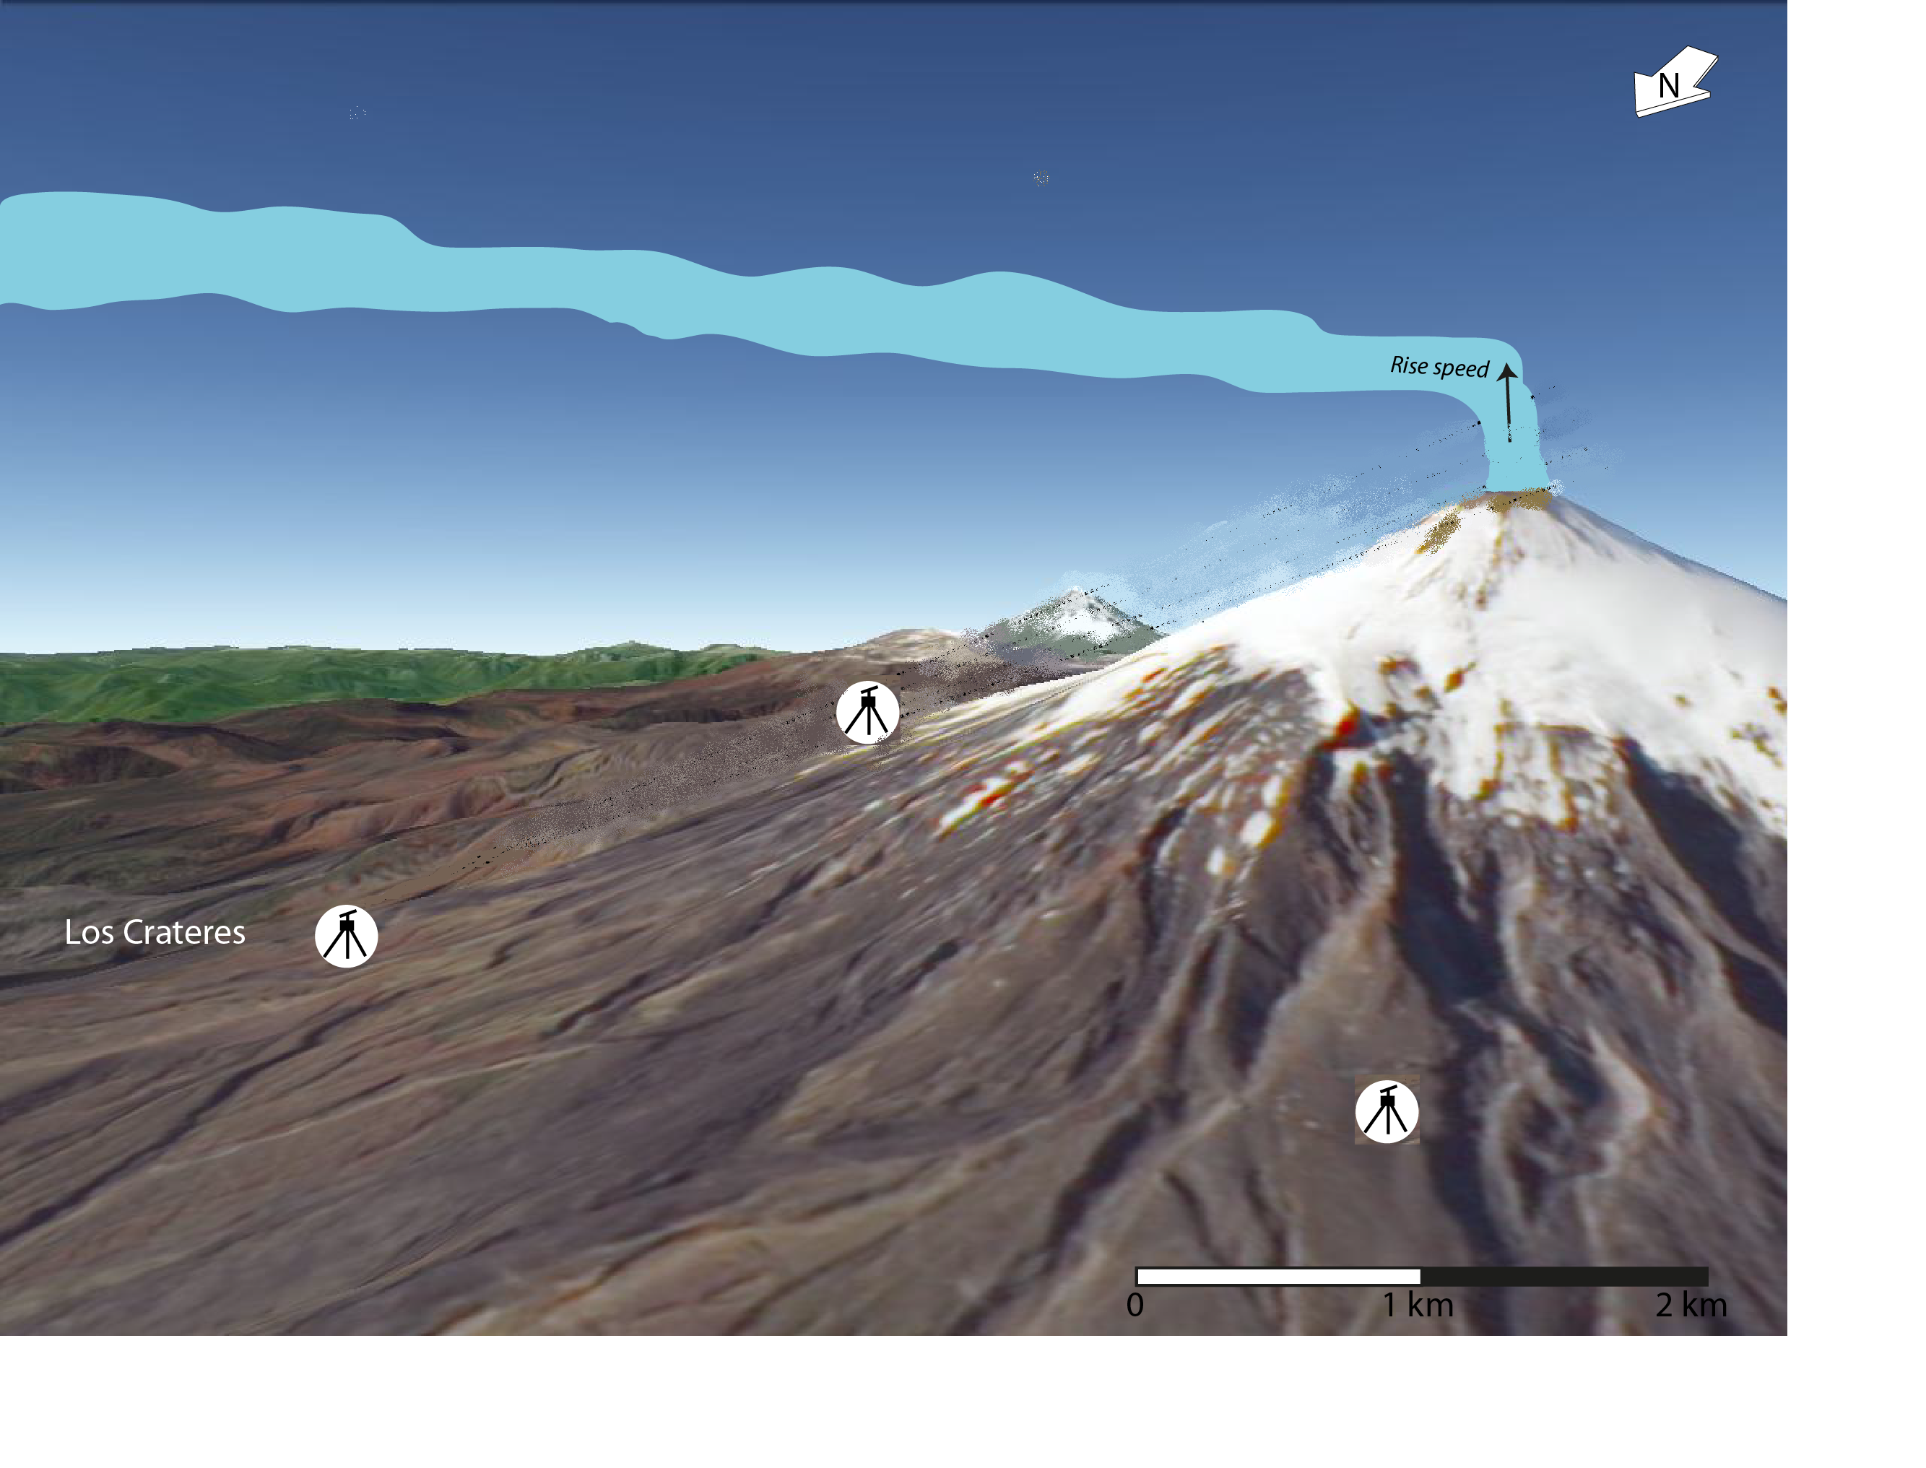
1
2
3

