The Death Zone
Mount Everest is
8850m (29,035 ft).
At these heights
some people get Summit 8850m
sick and even die.
As mountaineers
climb the mountain South Summit
they certainly feel 8763m
the affects of the
changes in the
atmosphere. When Western Ridge
trekkers first started 7524m
going to Mount
Everest, about one
in every 50 died. Khumbu
Above 3000m is Glacier 4926m
called the Death
Zone.

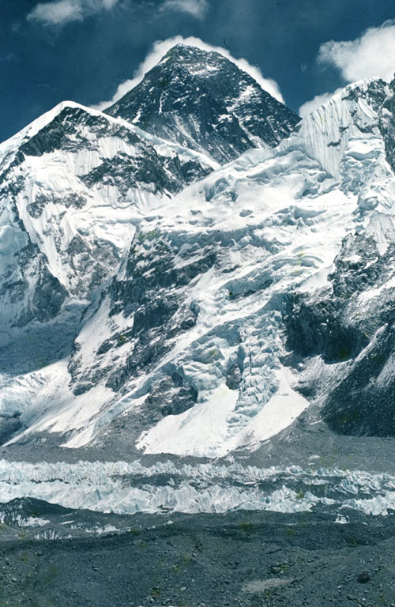
Task 1
If the temperature falls by 10°C every 1000m you climb, what would you expect the temperature to be at the locations listed below?
Fill in the table with your answers:
Above 8,000m is called the Death Zone

 | Height (metres) | Estimated temperature (°C)
Khumbu glacier | 4926 | -15
Western Ridge
South Summit
Summit

Climbers have to take precautions to guard themselves against the extremely low temperatures. Without proper equipment or poor planning, frostbite is an ever present threat.

What precautions could you take to prevent you from getting frostbite?

_______________________________________________________________________

_______________________________________________________________________

_______________________________________________________________________

_______________________________________________________________________

_______________________________________________________________________

Task 2
As you go further up a
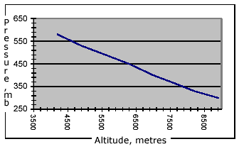
mountain, the atmospheric
pressure drops.
Using the graph,
estimate what the air
pressure would be at
various points up
Mount Everest, and fill
in the table.

 | Height (metres) | Estimated pressure (millibars)
Khumbu glacier | 4926 | 530
Western Ridge
South Summit
Summit

