MODULE 10: HOW IS THE UNITED KINGDOM’S PRECIPITATION CHANGING?

STUDENT ACTIVITY 1 & 2
The climate of the UK is strongly influenced by the Atlantic Ocean; the warm currents of the Gulf Stream moderate the seasonal extremes that affect other regions at this latitude, and south westerly Atlantic weather systems (depressions) and storms bring the majority of the UK’s rainfall.
There is a strong east to west gradient in total rainfall received throughout the year resulting from the combined effects of southwesterly weather systems and topography in the west. Mean annual rainfall varies between 2500mm in the mountainous areas of Wales and Western Scotland, and 500mm in the drier region of East Anglia.
Year to year variations in the UK climate are linked to the North Atlantic Oscillation (NAO). This is a fluctuation of the atmospheric pressure at sea level because of the relative differences in the warmth of the sea and atmospheric fronts between the Icelandic Low pressure and the Azores High pressure. Through east-west oscillation motions of the Icelandic Low and the Azores High, it controls the strength and direction of westerly winds and storm tracks across the North Atlantic Ocean and into Europe. In a ‘high’ NAO winter, storms tend to take a more northerly path, causing high rainfall totals in the UK and Northern Europe, whilst in a ‘low’ NAO winter storms travel further south bringing greater rainfall to Mediterranean Europe.

Activity one
The first part of the graph below with the black and brown lines represents the period 1960 – 2009. The blue, green and red lines represent the predictions of change according to which of the three greenhouse gas emissions scenarios, A2, A1B and B1 is used with the climate model.

GRAPHIC 10.1
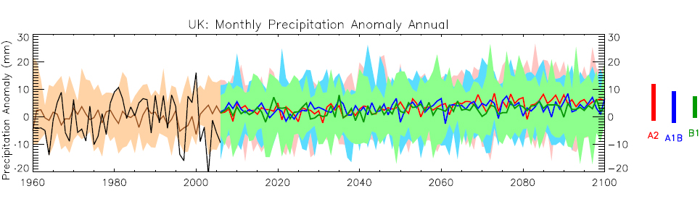
- The black line shows the precipitation anomaly for each year from 1960 to 2000.
- This is the difference, compared to average precipitation recorded between 1970 and 1999 shown by the brown line.
- The brown shading shows the range of precipitation anomalies.
- The green, blue and red lines show projected future precipitation from 2009 to 2100, according to three different emissions scenarios – B1 green (low), A1B blue (medium) and A2 red (high).
- The coloured bars summarise the range of precipitation for each emissions scenario, which was explained in Module 2.

- What is the general trend of the brown line?
- What happens to the black line?

Activity two
- What are the general trends of the precipitation in these scenarios?
- Which regions might have more rainfall and which ones less? Think of proximity to the sea, global wind patterns, altitude and latitudinal effects.

PERSONAL Activity
What will be the effects of changes in precipitation and temperature where you live?
How will a change in the amount of precipitation affect your lifestyle?

