MODULE 3: what evidence do we have of climate change?

STUDENT ACTIVITY 1-5
IS THE WORLD'S CLIMATE CHANGING?
Scientists have studied the average climate of the world over time. They have noticed some changes in the global temperature over time. Variability might be due to a particularly hot summer or very cold winter. The world’s climate has been getting warmer since 1900. However, this overall warming has not occurred evenly across the world’s surface and different places, because of their location and geography, are affected in different ways.

Activity One
How has the average temperature of the earth’s surface changed?

Graphic 3.1 - The average air temperature of the Earth’s surface from 1850 – 2008

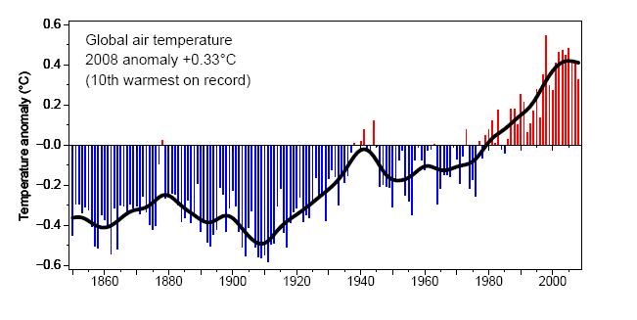
Source: Climatic Research Unit, University of East Anglia (2008) 1: Global Temperature
Record. [Accessed June 2009] Available from World Wide
Web:http://www.cru.uea.ac.uk/cru/info/warming/gtc2008.pdf

- What does the graphic show?
- Is this the only element of climate?
- What does the horizontal axis show?
- What does the vertical, y, axis show?
- What does each of the bars show? What does the black line show?
- What has been happening to the climate since 1900? Is the change spread evenly throughout the period? Explain your answer.
- Will this occur evenly across the world’s surface and different places? Explain your answer.

Activity Two
What do you know about the world’s climate?

CLIMATE QUIZ
Statement | True or false?
Without the natural Greenhouse Effect, our planet would be much warmer than it is now.
The greenhouse gases which absorb heat coming from the earth’s surface are mainly methane and ozone.

Over the last 50 years, global warming has been caused by changes in the sun’s energy.

Dark surfaces absorb more of the Sun’s energy than light surfaces.

Climate is the day-to-day condition of our atmosphere, for example how warm, cold, dry or wet each day is.

High clouds tend to warm the climate, low clouds tend to cool the climate.
Since the 1970’s global warming has been greater over the oceans than over the land.
Global temperatures are likely to rise 2-4°C by the end of the 21st century.
Global warming means that every country will get hotter and drier.
Over the past 150 years global temperatures have fallen.
Changes in the concentration of greenhouse gas in the atmosphere is the main reason for global warming in the past 50 years.

The only way to predict the climate for the next 100 years is to use very complex mathematical models.
A sustained rise in local temperatures of about 6°C would melt the Greenland Ice Sheet.
Temperatures over the ocean are likely to rise twice as fast as temperatures over the land.
If we stop emitting greenhouse gases now, the climate will stop warming.
Without the natural Greenhouse Effect, our planet would be much warmer than it is now.
The greenhouse gases which absorb heat coming from the earth’s surface are mainly methane and ozone.

WHAT IS THE EVIDENCE FOR CLIMATE CHANGE?
As the Earth’s climate gets warmer, the likelihood of some extreme events such as heat waves increases. Scientists believe the risk of a summer heat wave has doubled due to human activities. More information about this can be found in Module 5.

Determining whether a specific, single extreme event is due to a specific cause is difficult for two reasons:
- Extreme events are usually caused by a combination of many different factors
- A wide range of extreme events is normal even in an unchanging climate.

The Earth’s climate has always changed, long before we humans existed. There have been warmer and colder periods. For example, in the last ice age, 20,000 years ago, it was about 9°C colder than it is now. The causes of most of these changes are very well understood.

Activity THree

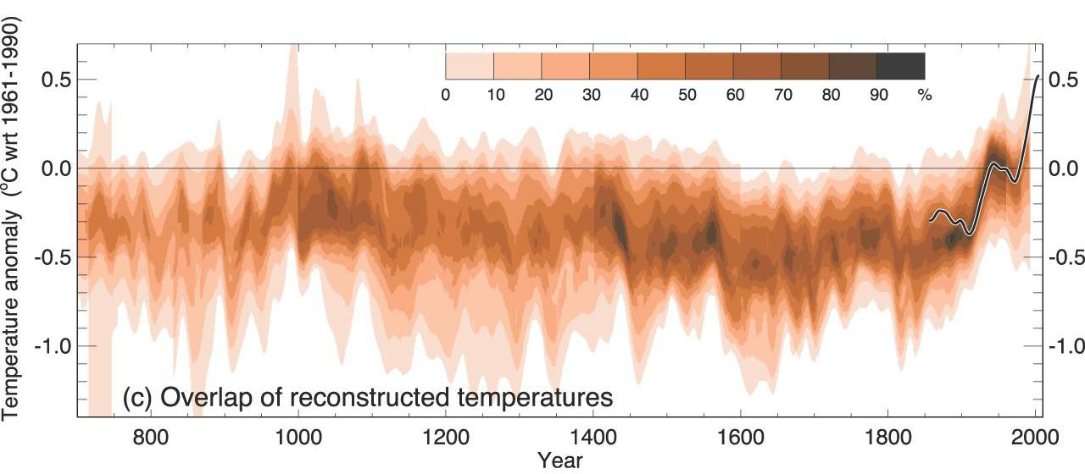
Intergovernmental Panel on Climate Change (2007) IPCC Fourth Assessment Report. Climate Change. [Accessed June 2009] Available from World Wide Web: http://ipcc.ch/graphics/graphics/ar4-wg1/jpg/fig-6-10.jpg
- This graphic shows Northern Hemisphere temperatures for 700-2000AD.
- The vertical, y axis shows how different the temperature is from the average of 1961 - 1990 temperatures (temperature anomalies).
- The horizontal, x, axis shows time in years from 700 - 2000AD

- Why is it difficult to be certain about what the globally averaged surface temperature was hundreds of years ago?
- What do you notice about the temperature anomalies since 1950, the black line will help you?

Activity Four
The likelihood of some extreme events, such as heat waves, has increased with the changing climate, and the likelihood of others, such as extremely cold nights, has decreased. You can find out more about this in the National Futures section. For example, a recent study estimates that human influences have more than doubled the risk of a very hot European summer.
Source: Climatic Research Unit, University of East Anglia (2008) 1: Global Temperature Record. [Accessed June 2009] Available from World Wide Web: http://www.cru.uea.ac.uk/cru/info/warming/gtc2008.pdf
- This graphic shows the average temperature of the Earth’s surface from 1850-2008.
- The horizontal, x, axis shows time in years from 1850-2008.
- The vertical, y, axis shows how different the temperature is from the average of 1961-1990.
- Each red bar shows the world’s ‘weather’ for that year.
- The black line shows the changing ‘climate

Current global temperatures are warmer than they have been during at least the past five centuries, probably for more than 1000 years. The 17 warmest years on record have all occurred in the last 20 years.
- When have the two warming phases of the 20th Century taken place? Which has been the most significant?
Alongside the warming, there has been an almost worldwide reduction in the extent and mass of glaciers in the 20th century. We know that the Greenland Ice Sheet is melting, that the thickness and extent of sea ice in the Arctic have decreased in all seasons and that sea level is rising due to thermal expansion of the oceans and melting of land ice.
Instrumental observations over the past 150 years show that air temperatures at the Earth’s surface have risen globally.

Activity Five

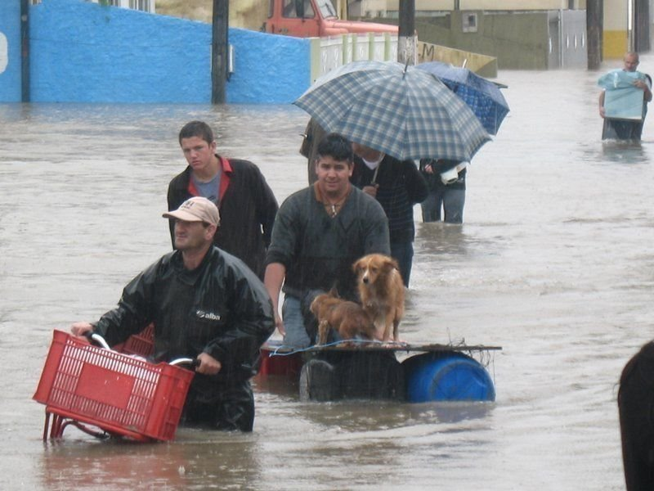
Source: Orkut Images, 2008, Santa Catarina Floods, Itajai floods, ‎Accessed: June 2009, http://commons.wikimedia.org/wiki/File:Itajai_floods.jpg#filehistory

This picture shows the 2008 flooding in Santa Caterina, Brazil. The flooding occurred after a period of heavy rainfall during late November, most significantly during days 20, 21, 22 and 23 of November.
In some regions there have been increases in droughts and floods. The number of days of very heavy rain has increased in some places. Tropical storm and hurricane frequencies vary considerably from year to year, but evidence suggests substantial increases in intensity and duration since the 1970s. Use the internet or read newspapers and watch the television news to investigate extreme weather conditions. Write your own newspaper article to show the effects of these weather extremes on the people who live in these places.

Personal Activity
Keep a weather diary and note down any extreme weather events where you live.
Write an account of an extreme weather event that you have experienced.

