Not In My Back yard
Lesson 1 Resources
Starter
Mix and match
Match the acronyms and statements below. In pairs, try to work out what the acronyms stand for using the clues provided in the statements. Then try to work out the acronym.
Acronym | Answers | Clues
NIMBY |  | A term used to express the way in which a politician might react to proposals for new roads, railways or power station whilst they are in office.
NIABY |  | Something that businesses or those with industrial links might use to enable infrastructure to get the go ahead
BANANA |  | A term used to express the opposition people feel towards the construction of infrastructure near where they live
NAMBI |  | An expression that would stop anything being built regardless of where it is being built
NIMTOO |  | An expression someone would use to oppose building even if it were not in their back yard

ANSWERS
NIMBY | Not In My Back Yard
NIABY | Not In Anyone’s Back Yard
BANANA | Build Absolutely Nothing Anyway Near Anything
NAMBI | Not Against My Business Or Industry
NIMTOO | Not In My Term Of Office

Main Activity
Why in my back yard? Hinkley Point C Information Sheet
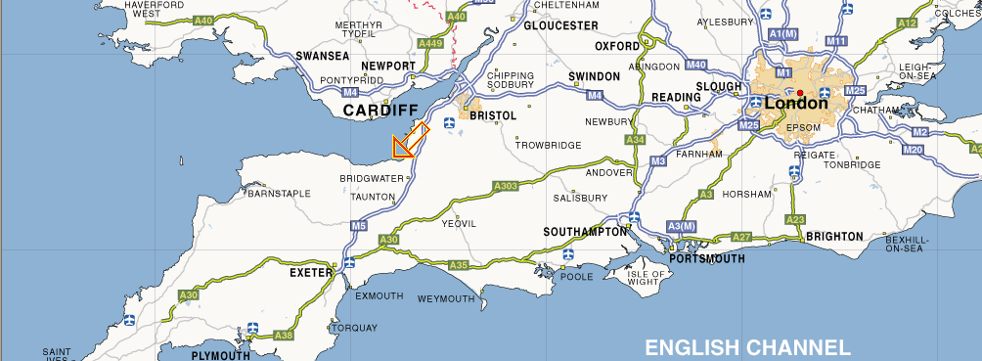
Hinkley Point Power Stations
Source: Ordnance Survey
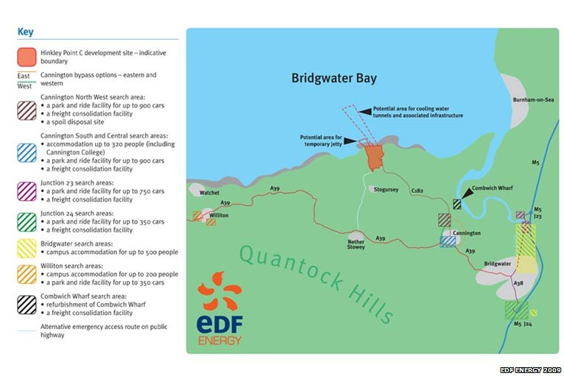
Source: BBC courtesy of EDF Energy 2009
Proposals to build a new nuclear power station in Somerset have been released.
Source: BBC http://news.bbc.co.uk/local/somerset/hi/people_and_places/newsid_8391000/8391011.stm
The new reactor building will take up much of the existing land at Hinkley Point, west Somerset.
Plans include a new 400m (1,300 ft) jetty into the sea, rigs for cooling water tunnels, four park and rides, accommodation and leisure facilities.
As the work is completed, EDF Energy - the company behind the proposals - would have to close the coastal foot paths to ramblers and move badger sets.
Chairman of the west Somerset group of ramblers, Ann Foxhuntley, said her main concern was to ensure a suitable alternative could be found.
"Quite a lot of local people walk dogs. The paths are used to a certain extent and it's always a pity if a path disappears without a replacement."
As part of the construction of a new power station, adjustments to the existing sea wall are planned.
Nigel Nee from EDF Energy said: "Clearly while we're building this wall we'll need to divert the path around the site but as soon as possible we'll reinstate it so that there is a continual coastal access.
"For the main site, when it is completed, clearly we will not be allowing members of the public across the site.
"During construction we will need to fence it off to make it safe and secure but exactly when we do that and how much is still something we are discussing with local authorities."
Minimise impact
The construction would also impact wildlife in the area.
Glen Miller, an advisor with Natural England, said the main ecological issues were to do with badgers and bats.
There is a large community comprising of many social groups of badgers whose sets would need to be moved and bats rely on the hedgerows and native species of trees for their food.
He said they were working together with EDF Energy to minimise the power stations impact if it gets the go-ahead and that surveys were currently being undertaken.

The key benefits
Source: EDF Energy http://hinkleypoint.edfconsultation.info/key-benefits
New nuclear power station at Hinkley Point have the potential to provide a range of benefits, both to people living in the immediate vicinity as well as those from the wider area.
- The key benefits from a new nuclear power station with two generating units are expected to be:
- A clean, secure and affordable source of electricity for around five million homes
- Around 700 directly employed permanent jobs at the new power stations for more than 60 years
- Thousands of direct and indirect jobs for nearly a decade during the construction period
- A package of community benefits targeting education, local infrastructure, transport, environment, regeneration and training
- Increased spending in the local economy, providing spin off for local businesses and local employment.
EDF Energy already has a strong presence in the South West employing close to 4,000 people in the region including those at Hinkley Point, two offices in Exeter, an office in Plymouth, and offices at Barnwood in Gloucestershire, as well as regional field staff.
The government’s position
Source: Sections taken from the 2008 White Paper on Nuclear Power http://www.berr.gov.uk/files/file43006.pdf
Following the consultation we have concluded that, in summary, nuclear
power is:
• Low-carbon – helping to minimise damaging climate change
• Affordable – nuclear is currently one of the cheapest low-carbon electricity generation technologies, so could help us deliver our goals cost effectively
• Dependable – a proven technology with modern reactors capable of producing electricity reliably
• Safe – backed up by a highly effective regulatory framework
• Capable of increasing diversity and reducing our dependence on any one technology or country for our energy or fuel supplies.

Based on a conservative analysis of the economics of nuclear power, as outlined in the consultation document, the Government believes that nuclear power stations would yield economic benefits to the UK in terms of reduced carbon emissions and security of supply benefits under likely scenarios for gas and carbon prices. As an illustration, under central gas and nuclear cases, and with a future carbon price of €36/tCO2, the net present value over 40 years of adding 10 GW of nuclear capacity would be of the order of £15 billion.

We have reviewed the arguments and evidence put forward, and based on the conservative analysis of the economics of nuclear power, the Government concludes that, under the most likely scenarios for gas and carbon prices, nuclear power would yield economic benefits to the UK in terms of reduced emissions of CO2 and improved security of supply. It is for investors to determine whether the financing characteristics of nuclear power provide sufficiently attractive returns. However, on the basis of our cost-benefit analysis, we believe that nuclear power is likely to be an attractive economic proposition to them. The Government is committed to working to strengthen the EU’s Emissions Trading Scheme (EU ETS) and to building investor confidence in a long-term multilateral carbon price signal. We will keep open the option of introducing further measures to reinforce the operation of the EU ETS in the UK should this be necessary to provide greater certainty for investors.
Environmental impact assessment and socio-economics
Source: Infrastructure Planning Commission
http://infrastructure.independent.gov.uk/wp-content/uploads/2010/02/Hinkley-Point-C-Scoping-Report.pdf
EDF Energy’s strategy for Off-site Associated Development, in terms of location and
scale, has been assisted by the baseline assessment of the local population, local
employment, accommodation provision and the likely origins of workers expected to
be employed to construct the Hinkley Point C Development. Socio-economic impact assessment involves a systematic appraisal of the impacts on day-to-day quality of life of people and communities. Sensitivities can be defined in terms of the various groups and agencies likely to be affected by the proposed development. Construction stage employment is estimated to peak at 4,000, plus a 20% contingency, based on current estimates and actual monitoring information on the workforce profile for Sizewell B Nuclear Power Station which provides some valuable comparative information. Operational workforce numbers are expected to build up from about the middle of the construction programme and well before the reactors are commissioned. The fully operational station (from 2020 onwards) will provide approximately 700 permanent jobs, comprising various categories. In addition, approximately 1,000 other workers will be employed at the site during refuelling and maintenance outages.

Case Study Sheet: Hinkley Point C, Somerset
The location of the proposed Hinkley Point C | Social issues | Environmental issues | Economic issues
Advantages for different groups at the national scale | Disadvantages for different groups at the national scale | Advantages for different groups at the local scale | Disadvantages for different groups at the local scale

Plenary Question Time Role Cards
Chair person:  Your role is to ensure that all audience members ask a question, select the most appropriate person(s) to respond and ensure that the discussion remains on topic. | Member of Parliament:  Your role is to defend the current government policy, supporting nuclear energy in the UK.  The current government believes that nuclear energy is the main way in which a reduction in CO₂ emissions in a bid to reduce the impact of climate change. | A member of the Infrastructure Planning Commission:  Your role is to ensure that an independent view is taken on planning at a national scale.  You need to ensure that all views are heard and taken into consideration.
A local resident:  Your role is to ensure your local community benefits from the proposed plans.  e.g. new schools, medical centres, jobs for local people with training provided | An environmentalist:  Your role is to ensure that any planned work has not impact on the environment.  e.g. protecting the local nature reserve | Audience members:  Each member of the audience must ask a question. The question should come from the resources provided so that the panel members have the information to respond to them.  e.g. Do the benefits of nuclear energy outweigh the costs
Information sheets for the debate:
21CC Introduction by Julian Glover, the guardian Evening Standard: John Prescott slams 'nimby' councils 21CC: What is the Infrastructure Planning Commission? 21CC: Wind farms: harmless or harmful? 21CC: High Speed Rail in Britain

