Look at the sectors of industry in which Britain’s top billionaires work
1. Lakshmi Mittal (steel) £19.3 billion  2. Roman Abramovich (oil and industry) £10.8 billion  3. The Duke of Westminster (property) £7 billion  4. Sri and Gopi Hinduja (industry and finance) £6.2 billion  5. David Khalili (art and property) £5.8 billion  6. Hans Rausing (packaging) £5.4 billion  7. Sir Philip and Lady Green (retailing) £4.9 billion  8. John Fredriksen (shipping) £3.5 billion  9. David and Simon Reuben (metals and property) £3.5 billion  10. Jim Ratcliffe (chemicals) £3.3 billion. | Total Value of the UK economy is around £1 trillion

Look at the pie chart below. It shows the contributions that the different sectors of industry make to national wealth as a whole.

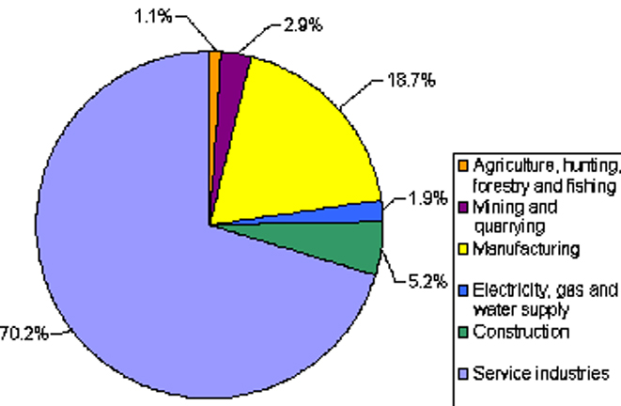

Compare the contributions that the different sectors of industry make to national wealth as a whole with those of the sectors of UK billionaires – do they fit?

