1. Incredible India

Shade the map on the next page, to show India’s relief.

The correct shading is shown on the final page!

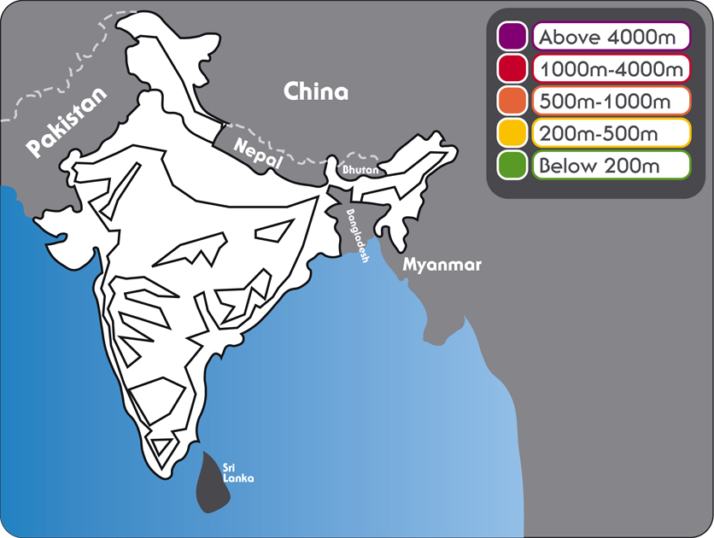
2. A country of diverse landscapes!

Put these landscapes on the map on the following page: use the clues below to help you. Answers at the end!
Himalayas | High mountains reaching across northern India and bordering countries. The highest mountain in India is K2 in the Karakorum Range. India has the largest area of snow and glaciers in the world, covering 248,000km.
Deccan Plateau | An area of raised land occupying much of central India. It is bordered by two hill ranges: the Western and Eastern Ghats.
Western Ghats | Hills that are often called the ‘backbone of India’. They stretch from the tip of the country for 1000km along the western coast.
Thar Desert | Also known as ‘The Great Indian Desert’, it forms the border between India and south eastern Pakistan.
Low-lying areas | These are mainly near to the coast, which is 5,656km long. In the hot season (April to May), temperatures can reach over 40°C.
River Ganges | This holy river rises in the Himalayas and flows into the Bay of Bengal.
Bay of Bengal | A bay that borders India, Bangladesh, Myanmar, and northern Thailand. It has a triangular shape and has an area of 2,172,000km.

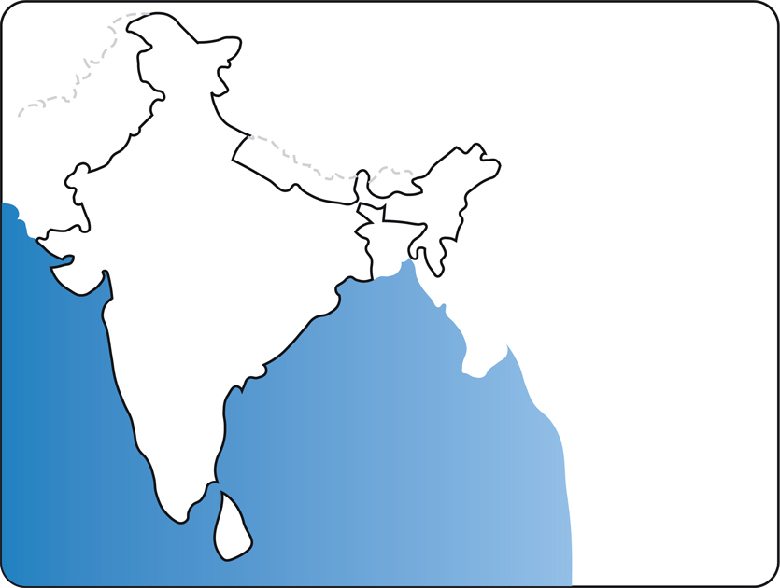
3. Where are all the people?

On the map, now see if you can correctly mark 4 of India’s main cities.

They are:

New Delhi (the capital city)
Bangalore
Mumbai (Previously Bombay)
Kolkata (Previously Calcutta)
Now use your map to make full sentences out of these half-statements:

Low-lying areas near to the coast tend to have | linked to global warming.
High mountain areas, such as the Himalayas, have | low population densities (fewer people).
Areas with an extreme climate, such as the Thar Desert | high population densities (more people).
The eastern coast of India has suffered from cyclones and flooding | 1.1 billion today (17 times greater than the UK).
India’s population has grown from 357 million in 1950 to | and 23% in towns and cities.
77% of people live in rural areas | because of the new wealth here caused by globalisation.
More and more people are migrating (moving) to urban areas | are most sparsely populated.

4. Monsoon!

India’s monsoon lasts from June to October. Cherrapunji, situated high up in north east India, is one of the wettest places in the world with 11,000mm of rainfall!

There are two distinct seasons dry and wet. The seasons change when the wind changes.

When the land is warmer than the sea, air is constantly rising on land creating a low pressure.

From April, heat builds over the land and rising of less dense air (as the land warms faster) form areas of low pressure, over North India and the Himalayas.

Over the oceans the air is cooler so to maintain the energy balance the air starts flowing from the oceans (high pressure) to the land (low pressure) bringing in the moisture rich southwest winds across southern Asia - the ‘wet’ phase which starts around June.

When the monsoon rains have cooled the land so much that the air is warmer out to sea, the wind changes direction and become a north-easterly and the rains retreat and end around the end of October–the dry phase.
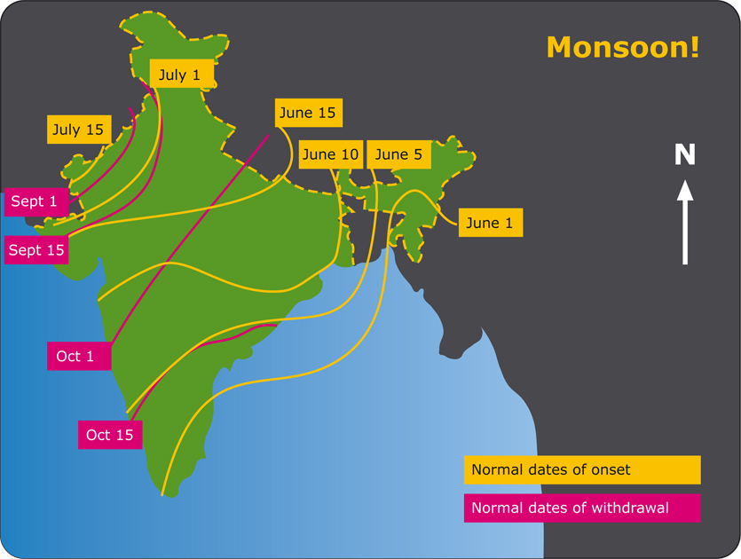
Answers

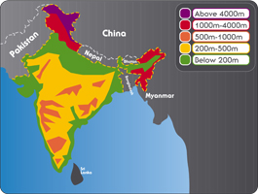
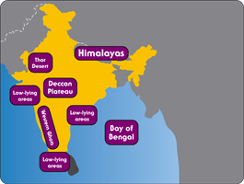 | 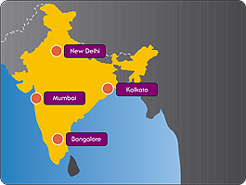
Low-lying areas near to the coast tend to have high population densities (more people).

High mountain areas, such as the Himalayas, have low population densities (fewer people).

Areas with an extreme climate, such as the Thar Desert are most sparsely populated.

The eastern coast of India has suffered from cyclones and flooding linked to global warming.

India’s population has grown from 357 million in 1950 to 1.1 billion today (17 times greater than the UK).

77% of people live in rural areas and 23% in towns and cities.

More and more people are migrating (moving) to urban areas because of the new wealth here caused by globalisation.

