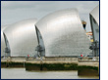
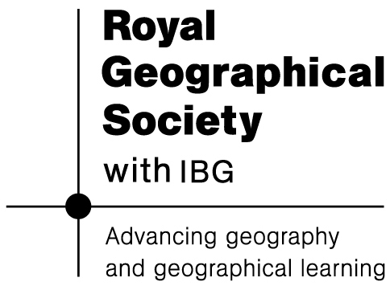
Are you flood ready?

Lesson 6: The river team players

Key Ideas:
- Drainage basins and flood plains are home to many different stakeholders whose activities may impact upon one another.
- For effective governance, one agency may need to take a leading role (an approach that has worked very well for the River Mersey) and this is also important for water quality management.

Starter activity:
Who are the river team players?
Students should imagine that all the different groups of people who live near and use a river are like players on the same team. These people include home-owners, shop-keepers and who else? They should work in groups and brainstorm as many suggestions as possible (they might suggest schools, local service providers, tourism enterprises, industries, farmers and many more besides).

Main activity:
What can the players do? [poster design]
The key idea for the lesson is that the activities of some players can make flooding worse for other players. Different groups of people depend upon one another to keep their river safe. But some players can make it harder for different players to use the river in other ways (e.g. industry can hurt tourism along a waterfront). Students need reminding how different types of floods can be made worse by the presence of concrete, tarmac and a loss of vegetation (fact-sheet available – also refer back to Lesson 2). They should take the players they identified as part of the starter exercise and proceed to design a table or A3 poster showing how the different players may either be making flooding worse for other players – or are perhaps “doing their bit” to improve matters. Issues relating to water quality and wildlife can also be included.

The following are suggestions / prompts for teachers:
- Homeowners: if they pave over their gardens to make a parking space they will make flooding worse as water cannot soak away. This makes things worse for everyone (this could equally apply to pub car parks!)
- Farmers: if they remove trees or hedgerows then rain-water cannot be caught (intercepted). This allows more water to reach the ground and makes things worse for everyone.
- Industries: they may pollute water, making it harder for tourist businesses (e.g. river cruises) to attract customers.
- There are many more to consider.

And who will be the ‘referee’?
Who will make sure all the players get together, talk and try and fix problems? The referee could be placed at the centre of the poster. Possible suggestions include:
- Town Council or The Environment Agency
- Conservation groups / The National Trust
- Special organisation e.g. Mersey Basin Campaign (download available)

Plenary:

A quiz revisits the main themes studied over the course of the unit. Students should organise themselves into teams with a water themed name e.g. ‘Water babes’ & ‘Water boys’ or ‘River rats’ …

