What grows where?

Using the world map select one of the four countries to find out what the climate is like there.

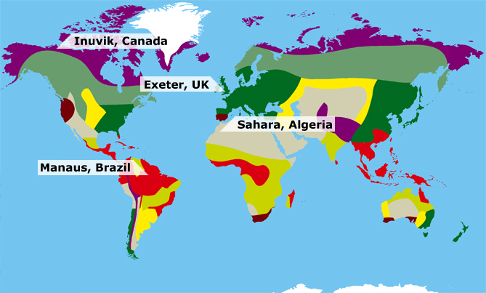

Look at the climate graphs on the next page to decide what climate belongs to which place.

Climate graphs show us how rainfall (mm) and temperature (ºC) change over a year:
- Read the blue bars (using the right hand axis) to see how much rain fell on average each month and how rainfall varies over the year.
- Read the red line (using the left hand axis) to find out what the average temperature is each month and how this changes across the year.
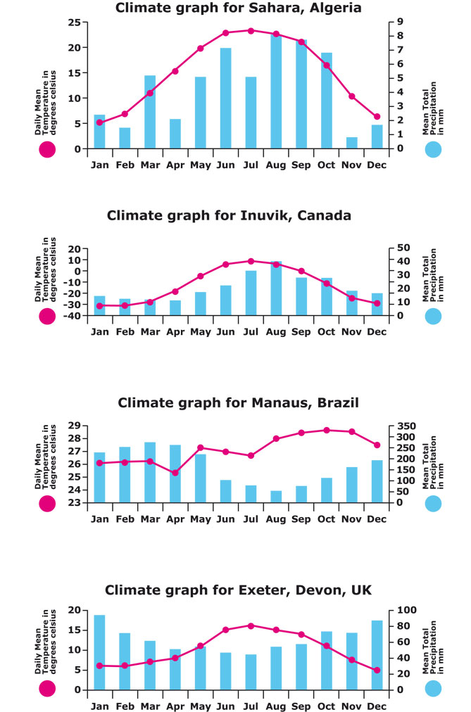
Now, try and match the correct description of the climate with the country and the type of biome - ecosystems that extend over large geographical areas - that exists there.

Climate descriptions:
A. Rainfall is low all the year round and temperatures don’t drop below freezing.
B. Temperatures are highest when rainfall is lowest
C. Temperatures are highest when there is most rainfall
D. It’s the rainiest and the hottest!

Biome types:
A. Sahara Desert
B. Amazon rainforest
C. Arctic Tundra
D. Deciduous Forest

Now go to the final page…

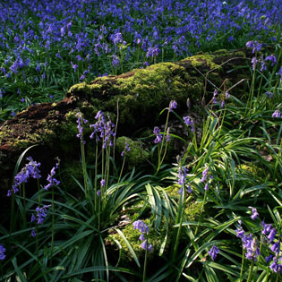
Finally, can you match these four plants to the correct places?

