Activity Landscape and Process in Antarctica

Activity One
Look at the map of Gondwana which shows the position of Antarctica in relation to the other continents about 200 million years ago.

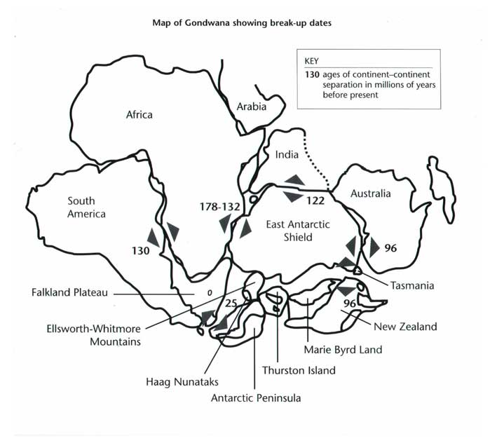
Source: BAS

If the evidence from the rocks in Antarctica suggests temperate forests, on which other continents would you expect to find evidence of similar environments? What are the positions of the southern continents today?

A useful animated version can be found at http://www.exploratorium.edu/origins/antarctica/ideas/gondwana3.html

Activity Two
Download the map of Antarctica. Using an atlas, label the Ross Sea and the Weddell Sea; add the Ross Ice Shelf and Mt. Erebus. Check out the the British Antarctic Survey website for further information about these places: www.antarctica.ac.uk/about_Antarctica/Rock/Volcanoes.htm

Activity Three
The table below gives the average monthly temperature information in °C for three Antarctic bases Amundsen-Scott (USA), Rothera (UK), and Vostok (RUS).

 | Jan | Feb | Mar | Apr | May | Jun | Jul | Aug | Sep | Oct | Nov | Dec
A-S | -29.1 | -40.7 | -54.1 | -57.2 | -58.0 | -58.4 | -59.5 | -59.7 | -59.3 | -51.1 | -38.4 | -27.9
R | 1.0 | 0.1 | -1.8 | -4.3 | -6.8 | -9.9 | -11.6 | -11.5 | -9.1 | -6.1 | -2.7 | -0.2
V | -32.1 | -44.2 | -57.9 | -64.8 | -65.8 | -65.2 | -66.7 | -68.2 | -66.2 | -56.9 | -43.2 | -32.1
Source: BAS
A-s: Amundsen-Scott at South Pole 90°C
Altitude: 2800m
R: Rothera at 67.5°S, 68.1°W
Altitude: 16m
V: Vostok at 78.5°S, 106.9°W
Altitude: 3488m

Draw the temperature graphs for all three stations. Use a scale for temperature putting 0°C at the top and a descending scale to -70°C at the bottom of the vertical axis with equally spaced months on the horizontal axis.

On the map mark the Amundsen-Scott base at the South Pole, add arrows radiating outwards from the South Pole then label them katabtic winds. Using all the information above, describe the main features of the climate at each of the three stations and then explain the differences in temperature, and likely wind speeds.

Activity Four
Most of the scientists who travel to Antarctica pass through Christchurch Airport, New Zealand. In order help the general public understand Antarctica the authorities have built an Antarctic information centre inside people can simulate an Antarctic climate. Check it out at www.iceberg.co.nz

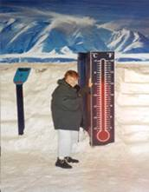
Look at the photograph that shows a woman in the simulated Antarctic environment. By pressing the blue button she can experience the wind chill factor. This is how you would feel in absolutely calm conditions: -

Freezing cold below -25°C
Bitterly cold -25 to 15°C
Very cold -15 to 10°C
Cold -10 to 0°C
Cool 10 to 15°C
Mild above 15°C

© Pat Wilson

The temperature is -5°C in the photograph, what is the woman feeling now on the ‘sensation’ scale? How low a temperature do you think she could stand in calm conditions? What do you think happens to the ‘sensation’ scale as you increase the wind speed up to gale force (62 km per hour) at -5° C? Which of the three Antarctic bases is most likely to suffer from severe wind chill conditions and why?

Activity Five

Look at the four graphs below.

At what date is there a significant rise in emissions from the three gases? Can you suggest a reason for this? Describe the changes in the temperature graph from 1860 to 2000. Explain the possible reasons for the lower temperatures around 1910 and 1960-1980? In what direction do you think the graphs will go in the next 50 years? From what you have discovered about Antarctica, list three effects this might have on the continent’s landscape and climate.

Sources: Graphs 1-3, Climate Research Unit, University of East Anglia. Bottom graph: DETR/Met Office

Compiled by Pat Wilson

