Malaria
The Geography of Diseases

Drag and drop the diseases into the map of the UK
Some will stay and some will disappear.
What is the link?
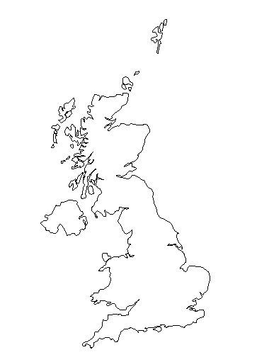
Smallpox
Typhoid
Cholera
Lung cancer
Other cancers
Obesity
Diabetes
Heart disease

Famine
Cholera
Influenza
Heart disease

