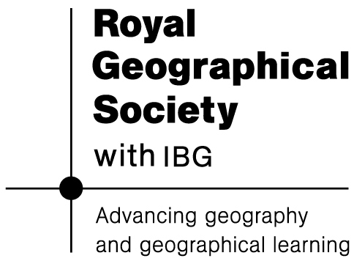
Africa – a continent of contrasts
Lesson 3

Sudan mystery activity:
Why does Betty speak a different language to her parents?

1. Sudan became a British colony in 1898. | 12. Mayo camp is one hour south of Khartoum, the capital of Sudan.
2. Betty’s family fled their home in southern Sudan when the civil war began in 1983. | 13. Educating mothers means their children are 50% less likely to die in early childhood.
3. Only 1 in 4 adults in Sudan can read and write. | 14. There are no drains in Mayo camp and the water supply is irregular.
4. The civil war forced 10% of the Sudanese to flee their homes. | 15. Betty was only 1yr old when the civil war began.
5. At the age of 20, Betty sat her Sudan School certificate and failed. | 16. Betty is now studying management at the university in Khartoum.
6. Schools in Sudan have students of all ages as many people were unable to attend school during the civil war (the schools were either destroyed or there were no teachers). | 17. Sudan gained independence from Britain in 1956, but has never had a fully democratic election.
7. Around 250 000 people live in Mayo camp just outside Khartoum. Betty is one of them. | 18. The war in Sudan ended in 2005, but many people still have not returned home.
8. It costs £25 to send one child in Sudan to school for a year. | 19. There are no trees, parks, libraries or play areas in Mayo camp.
9. At the age of 21, after enrolling in school for a year, Betty passed her Sudan School certificate. | 20. Several families share one pit latrine in Mayo camp.

10. Betty became a mother at fourteen. This is not unusual in Sudan. | 21. In 1972, the Addis Ababa Agreement gave the southern part of Sudan the right to have its own government.
11. The houses in Mayo camp are made of mud and could wash away in the rainy season. | 22. Betty got work embroidering bed linen. It takes 6months to embroider one set and it makes US$200.
23. In 1983, the Addis Ababa Agreement was scrapped. Civil war began soon afterwards between the Sudanese People’s Liberation Army (SPLA), who were mostly from southern Sudan and the government. | 24. Most of Sudan’s population lives in rural areas and about 80% of people are employed in agriculture.
25. Different languages are spoken by people in the north than in the south of Sudan. | 26. Khartoum is in the northern part of Sudan.
27. Violence is still a problem in the west of Sudan in the Darfur region. | 28. Despite the peace deal in 2005, southern Sudan is still very volatile and many people have not returned to the south.
29. Many children were orphaned by the civil war. Some of these became child soldiers. | 30. The refugee camps established by displaced people have caused lots of damage to the environment.


Africa – a continent of contrasts
Sudan lesson 3 Foundation task
Lesson 3: Sudan mystery activity

Tasks to accompany the mystery:

Main task: Why does Betty speak a different language to her parents?
Using the cards, you need to answer the above question. Some of the clues are not as important as others, but they will all help you to make sense of what life has been like in Sudan. The numbers on the cards are only to aid discussion, they do not go in number order.

Guidance questions:
1. Who is Betty?
2. Where was Betty originally from?
3. Why does Betty speak a different language to her parents?
4. Why did Betty’s family leave their original home?
5. Why are education rates in Sudan so low?

Extension questions:
What impact would so many extra people – such as those in Mayo camp – have on the services of an area?
What impact would the additional people have on the environment?

Africa – a continent of contrasts
Lesson 3: Sudan mystery activity
Sudan lesson 3 Higher task

Tasks to accompany the mystery:

Main task: Why does Betty speak a different language to her parents?
Using the cards, you need to answer the above question. Some of the clues are not as important as others, but they will all help you to make sense of what life has been like in Sudan. The numbers on the cards are only to aid discussion, they do not go in number order.

Use as many of the cards as possible to write your answer to the question above. Suggested paragraph content is below:
- Introduction to the issue of civil war in Sudan
- Information about who Betty is and what she does.
- Reasons why Betty speaks a different language to her parents.
- Your own personal views on the situation and the impacts on people in Sudan.

Extension questions:
What impact would so many extra people – such as those in Mayo camp – have on the services of an area?
What impact would the additional people have on the environment?

