Lesson six: Global Trade End of Unit Quiz

- Define ‘trade’. When is trade described as ‘global’?

(2)

- Label the arrows with ‘import’ and export’.

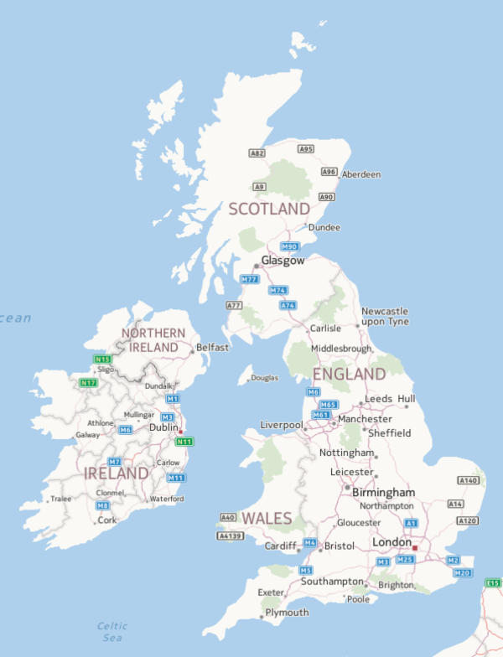
(2)

- List two key things that allowed trade to become global.

(2)

- Why do we import some foods into the UK such as pineapples?

(1)

- Are the European countries Germany, Italy, Switzerland and the UK more or less developed countries?

(1)

- Greenland’s highest-value export is fish. Give one physical feature of Greenland that determines the country’s highest-value export.

(1)
7) Why buy fairtrade?

(1)

9) Name two goods that the UK exports to other countries.

(2)

Total marks: /12

