Flood!



Heavy downpours have caused flash floods at Glastonbury Festival over the years. 2005 and 2007 were very wet. Look at the images from these festivals to:

- Write a ‘catchy caption’ to go with each picture to summarise what it shows (as if it’s part of a newspaper article).

- Imagine you are the man sitting in his tent as the water flows through. Write a few sentences to describe what you are thinking / feeling at that moment.
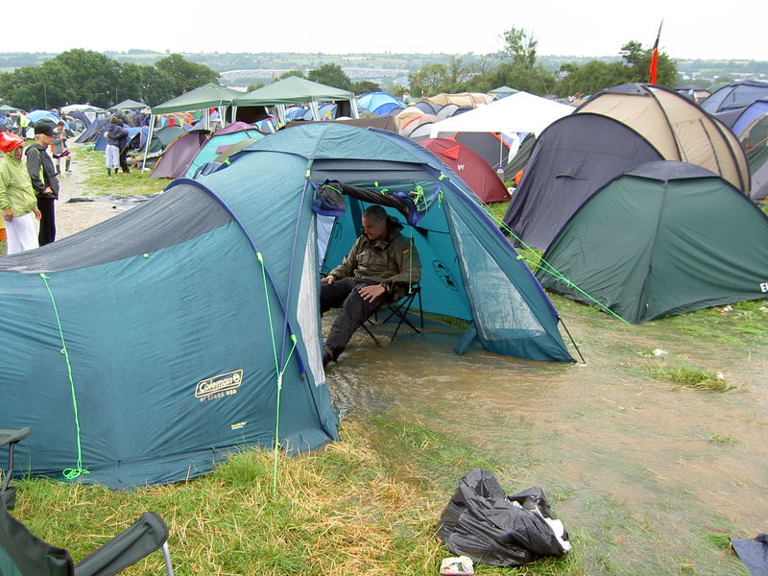
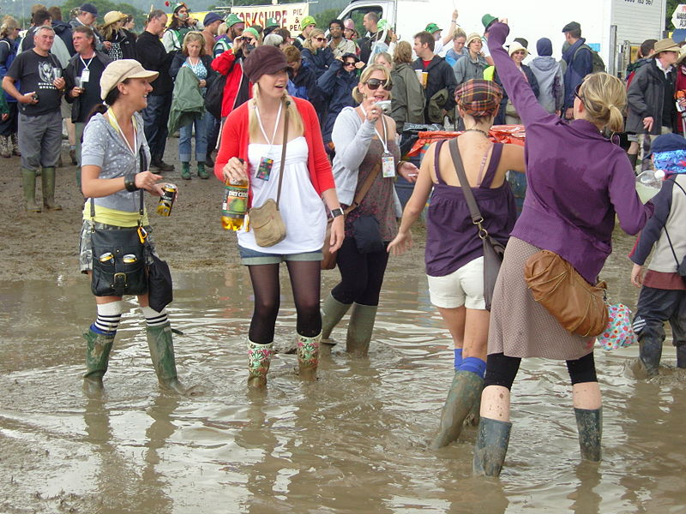
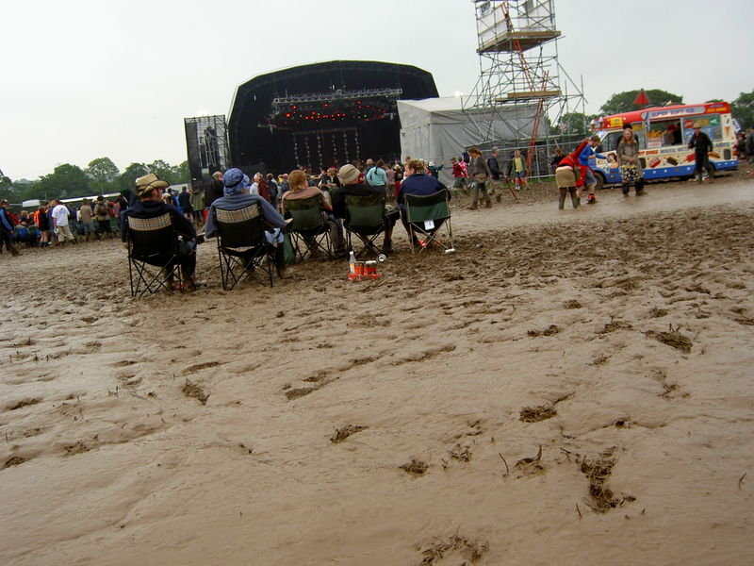
(Images from Wikimedia Commons, licensed for reuse under the Creative Commons Licence)

