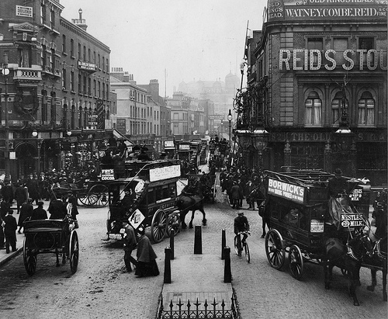
Our Place in History

Lesson 7: My place

Key ideas:
- I have a place in the local history of my area.
- I can evaluate what I have learnt about the history of my local area.

Starter activity:
Is this my place?
Surnames have a great deal of history behind them and, for the beginning part of this lesson, pupils look at the location of people with the same name as them. They should navigate to the National Trust Names website and enter their surname. A map is then produced showing the distribution of people with the same surname in both 1881 and 1998. Whilst this is an interesting activity in itself, they could then think about how their surname is distributed and how this may have changed over time. In addition, it might be interesting for them to discuss their feelings about this and whether they feel that they have a real attachment to the local area and if not, why this may be.

Main activity:
Designing a mural
This activity aims to use another cross-curricular link with Art whilst, at the same time, evaluating what the pupils have learnt about their local area. In this activity, pupils design a mural which illustrates the local history of their area. If possible, one of the designs could be selected to produce a large piece of artwork for either the school or the community. This has been done in Aylesbury and the artwork from a pupil depicting the local history now hangs in the main shopping centre.

Plenary:
Time capsule
To finish the unit pupils are asked to suggest up to five items which they might expect to find in a time capsule buried in the past. This encourages them to think of the most important things they have learnt during the unit. They should then suggest up to five items which they would put in a time capsule to inform people from the future what the local area is like now.

