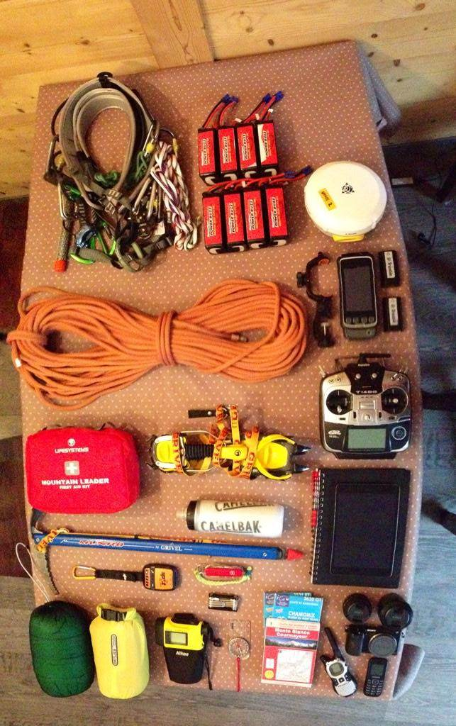
Source: Grand Alpine Tour (2014)
Identify the field equipment
(and why might we need it?)

