Ko Phi Phi: What future?

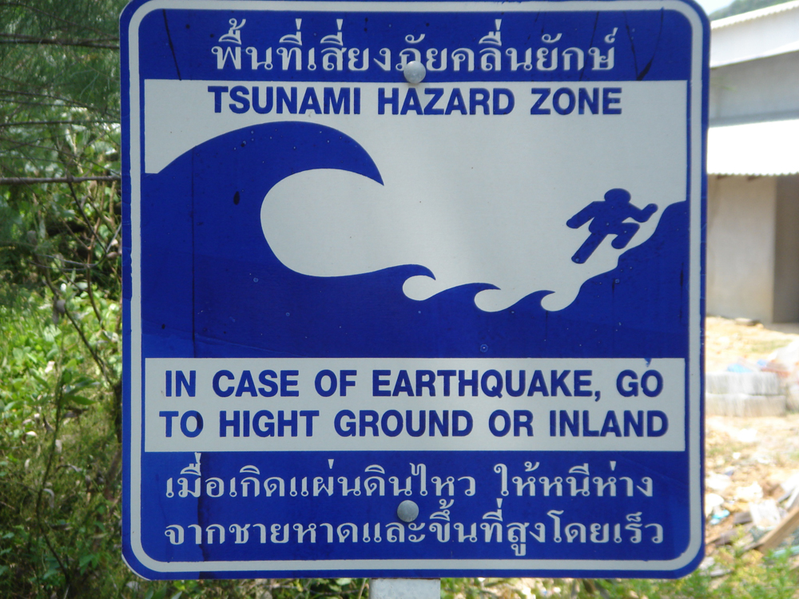

Since the tsunami devastated Ko Phi Phi in December 2004 there has been a mad rush to get tourism on the islands back on its feet.

Ko Phi Phi was the second hardest hit area in Thailand by the tsunami. Two waves, 3 and 5.5 metres in height, crashed into either side of the narrow strip of land between the beaches on Phi Phi Don, home to much of the tourist activity on the island. Nearly three-quarters of the buildings were destroyed and about 2,000 people died.

After the destruction and tragedy of ruined lives, many were thinking that this could be a new, better start for Ko Phi Phi. With most of the tourist facilities destroyed, it was time to plan for a lasting – sustainable – future.

In the first few months after the tsunami there were early warning signs that making money would take priority over planning the islands’ long-term future. A rapid rebuilding programme got underway. Two international hotel chains were given the go-ahead to build luxury resorts on the Phi Phi Don as the Thai government looked to develop Ko Phi Phi as a different kind of tourist destination than before.

The government’s vision of a sustainable future for Ko Phi Phi focuses on fewer, high spending tourists in all-inclusive resorts backed by big business from outside. The government is also thinking about a ban on the rebuilding of all residents’ houses along the beachfronts.

But what about the people that live on Ko Phi Phi? What about their businesses? And what about the pressure on the islands’ precious resources?

Think about your own vision for the future of Ko Phi Phi … how would you develop an island like Phi Phi Don?

