
The Geography of Science

Lesson 4: Climate Change: Global impacts

Key ideas:
- How might the distribution of people alter with climate change?
- Which areas of the world may experience population loss/gain?
- How might world population distribution changes impact people and the environment?
- How can geographers and scientists work together to reduce these impacts?

Starter activity:
What is climate change?
It would be useful to have covered this before this lesson. There are other resources and lesson ideas in the “Changing Climate” module on this website.

Students can recap on the main ideas of climate change including the Greenhouse Effect and the impacts of changing climate by using the interactive resources at the BBC News website.
The quiz and interactive information pages could be done as a class, individually or in groups.

Main activity:
How might climate change impact on world population density?
NB: The following lesson is based on theories and it may be useful to mention to students that we are not sure exactly what might happen in the future, if the world was to heat up by 4°C. However, as geographers/scientists theories are useful to help us prepare and minimise the impacts, should large scale changes take place.

For these tasks you will need the downloadable “How will climate change impact on world population density?” worksheet and the “Impacts of Climate Change” sheet. The work is designed to be done using a computer with internet access. However, it would be possible to complete this work by hand using atlases and a print out of the world population density map below.

Task 1 – annotating a population density map
During the task, students use a world population density map, found at Wikimedia Commons and annotate it (in Word) using the labels from the “Impacts of Climate Change” sheet.

The aim of this activity is to see the impacts of climate change spatially on a large scale.
Task 2 – Colour coding the possible impacts of climate change
Within this task students make a decision as to whether each of the labels is likely to encourage people to move to or from a country/region and colour code them. By using this decision making task, it is possible to start to visualise the areas of likely population gain and areas of population decline, if the climate were to increase by 4°C.

Task 3 – What will our planet look like in the future?
The six questions in this task are designed to help students think about the potential impacts that climate change may have on particular regions, due to population change. Depending on the ability of the class, tasks 3 and 4 may need to be continued next lesson, or done as a homework.

Task 4 - How can scientists and Geographers work together to minimise the impacts of climate change?
This task is designed to get students thinking about climate change mitigation and how geographers and scientists can work together to find solutions. Students think of ways that scientists and geographers can solve problems of food, water and space shortages.

Some examples students might consider:
Food shortages: Geographers can use GIS technology to map changes in farming and food production due to climate change. Scientists help farmers by developing new varieties of crops that are more fuel and water efficient as well as being able to survive in difficult environments.

Water shortages: Geographers can graph and map water use to detect where the hot spots of water use exist and who is using the most. Scientists can develop new more efficient technologies to reduce water use e.g. more efficient washing machines or small scale technologies such as water harvesting. Scientists can develop novel ways of transporting water from areas of surplus to areas of deficit.

Space shortages: Geographers can study and record the distribution of populations and what people need in terms of living space. Scientists can develop novel ways of using space in building construction and ways of making unsuitable areas inhabitable. These scientists can be aided by geographers who can work highlight issues of soil type, climate and tectonic movement to aid scientists in their work.

Plenary:
Discuss the main issues of the lesson. You might like to use these questions:
- How might the world’s population distribution change if the climate was to change by 4°C?
- What positive opportunities might climate change bring? E.g. to Canada and Patagonia?
- What problems might scientists and geographers have in working together on climate change?

Extension:
Students can use the resources and information gained in the lesson to create their own population choropleth map showing the possible population density if the climate was to increase by 4°C. A printable world map is available at TeacherVision:

Plenary:
To lead into the next lesson, bring the global impacts down a scale to get students to think about the local.

Discuss:
What do you think the impacts of climate change will be for people in London?
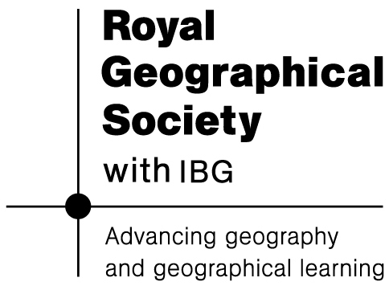

Do you think we are prepared for flooding, large movements of people or rapid changes in weather? Why/why not?

