Widening the wealth gap

How much money do you think the world’s top 100 billionaires earn, compared to the world’s poorest 100 countries?

Have a go at guessing how many US dollars each earns per second.

When you’ve made your guess look at the following pages, which show how the 100 top billionaires wealth grows against the poorest 100 countries wealth (GDP) over 1 minute.

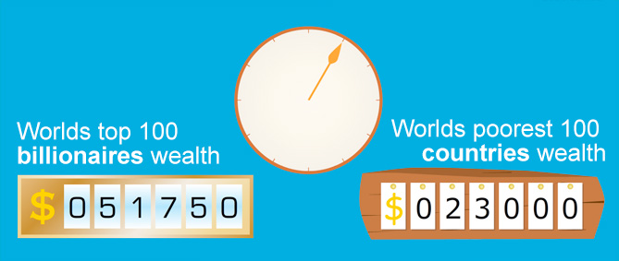

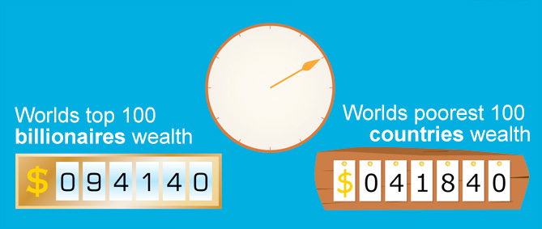

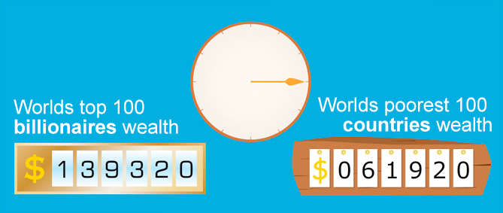
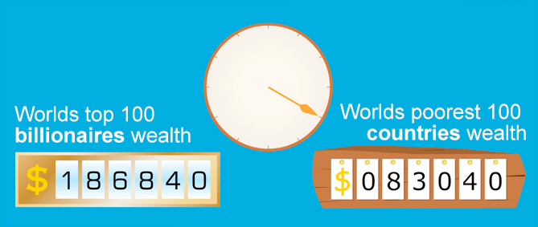

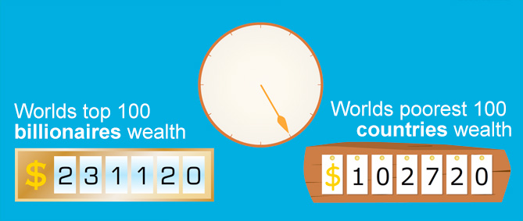

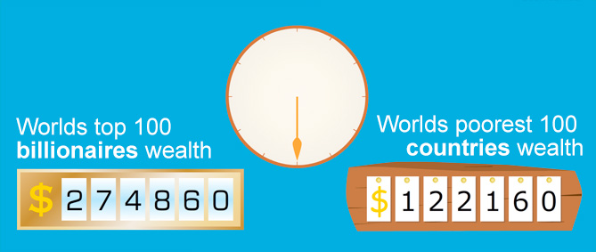
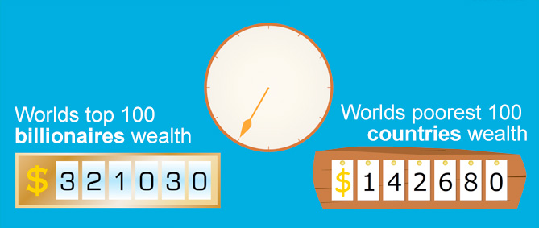

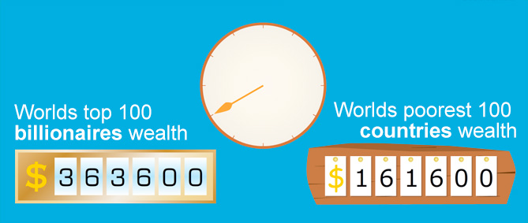

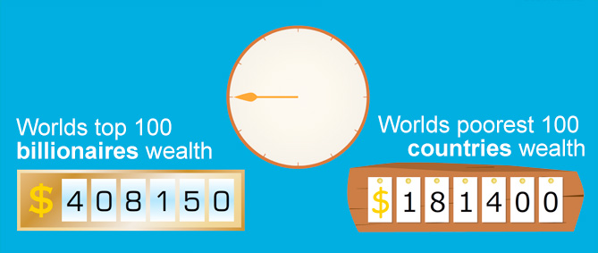
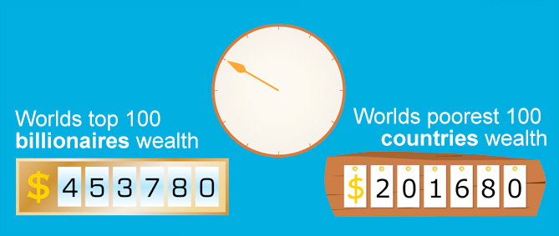

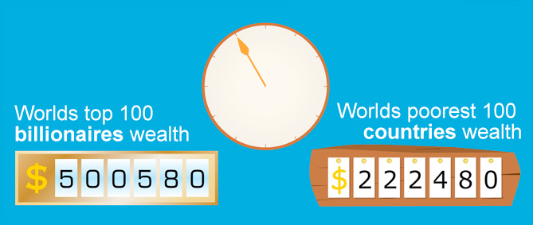

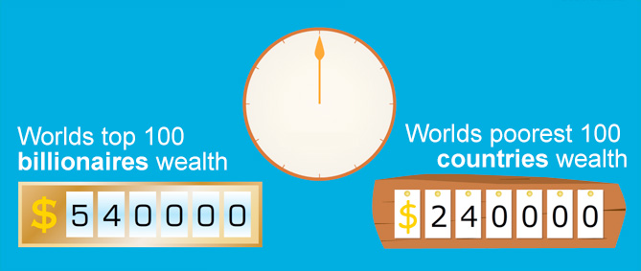
The world’s top 100 billionaires earn $9000 per second.

The world’s poorest 100 countries earn $4000 per second.

During 2006 the world’s 100 poorest countries total wealth (GDP) grew by 7.3%. The world’s top 100 billionaires’ wealth grew by 24.7%.

