Where’s bulging with wealth?

Look at the maps on the following pages to compare how wealth (GDP) has changed across the world from year 1500 to the present.

Territory size shows the proportion of worldwide Gross Domestic Product when adjusted for purchasing power parity that was produced for the given year.

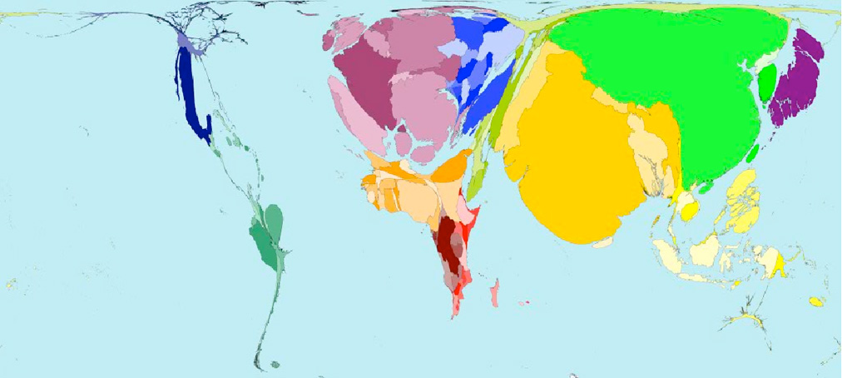
1500

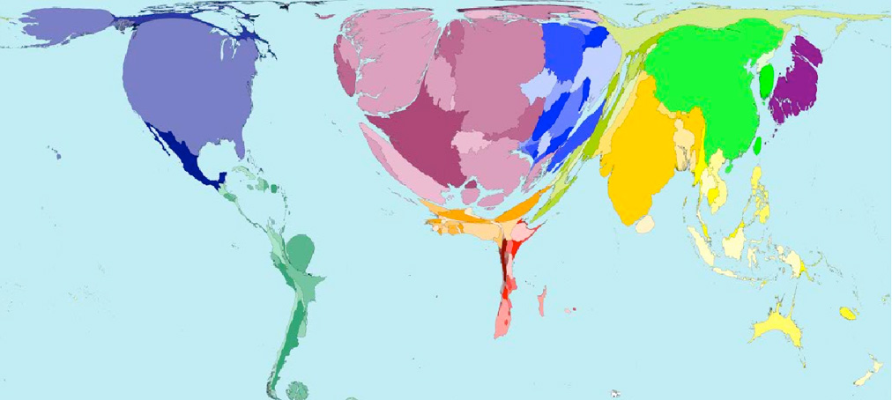

1900
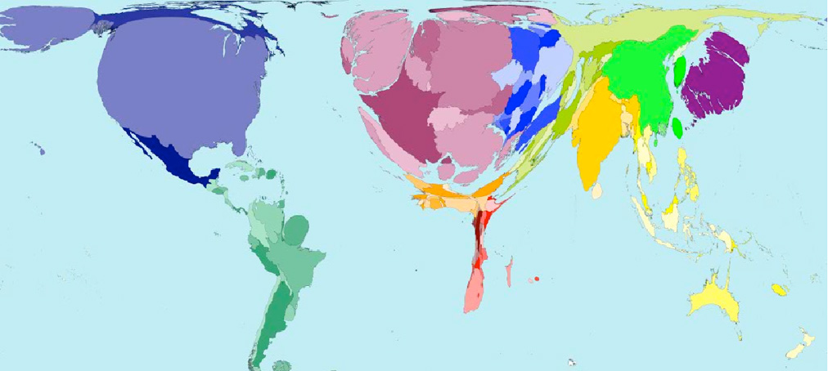

1960
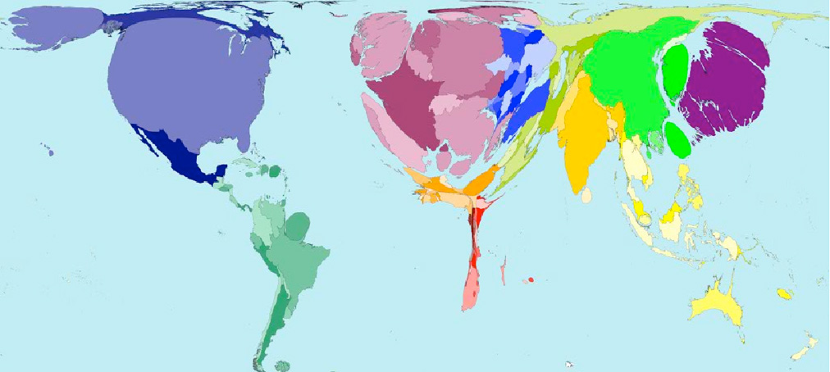

1990
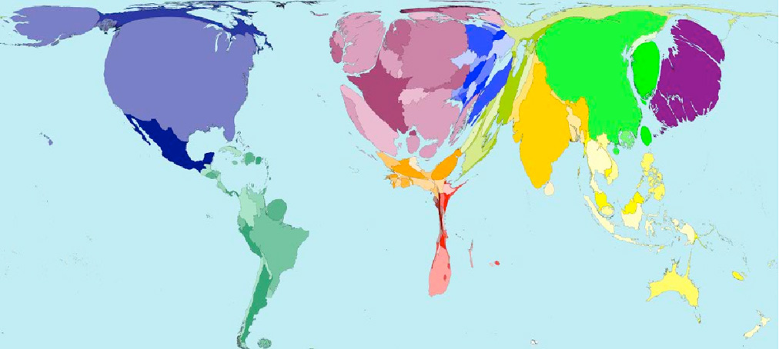

2002
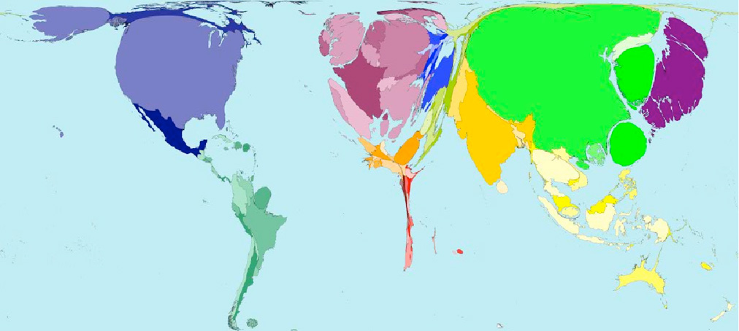

2015
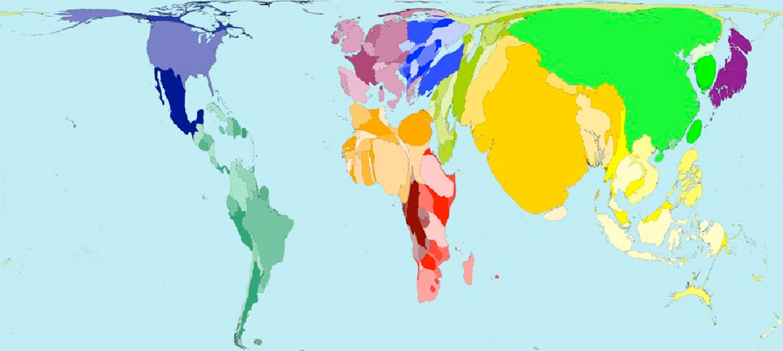

…and here’s a map where the size of the country has been adjusted in proportion to population, for the year 2000…to compare with the wealth maps!

