Factsheet for teachers
In addition to individual supporting facts for each lesson (see below), it is worth noting lessons four and five have additional factsheets for the pupils on different regions of Italy.

Lesson one: What's on the map? Bird's eye view on Europe
Key aims and questions
How do we understand Europe as a continent?
- Using geographical language and concepts to describe Europe’s location within the wider world
- By understanding that Europe comprises many different countries
- Through identifying some of its key cities, physical and human features
- Understanding that there are different kinds of maps, which are used for a variety of functions
- Understanding some of the common features of all maps (scale, key, purpose, orientation, title etc.)
Key facts
Locating Europe
From south to north, Europe stretches from around the Mediterranean at 35 degrees north (Cyprus and Crete) to Scandinavia and parts of Russia north of the Arctic Circle. From west to east, it ranges from Iceland at 24 degrees west, straddles the prime meridian, and to the Northern Urals at about 65 degrees east. Together, this comprises a land area of approximately 10,180,000 square kilometres. Its surface area makes it the word’s second largest continent (Australasia is slightly smaller).

There are 51 countries in Europe that are widely recognised by other states. These include the world’s smallest country, Vatican City, and its largest, the Russian Federation. In addition, there are some countries – such as Kosovo – which are not as widely recognised. There are also a few dependencies and territories of larger states, such as Gibraltar (UK) and the Faroe Islands (Danemark). Both the Russian Federation and Turkey are transcontinental states: their territories can be found in both Europe and Asia.

Map of Europe
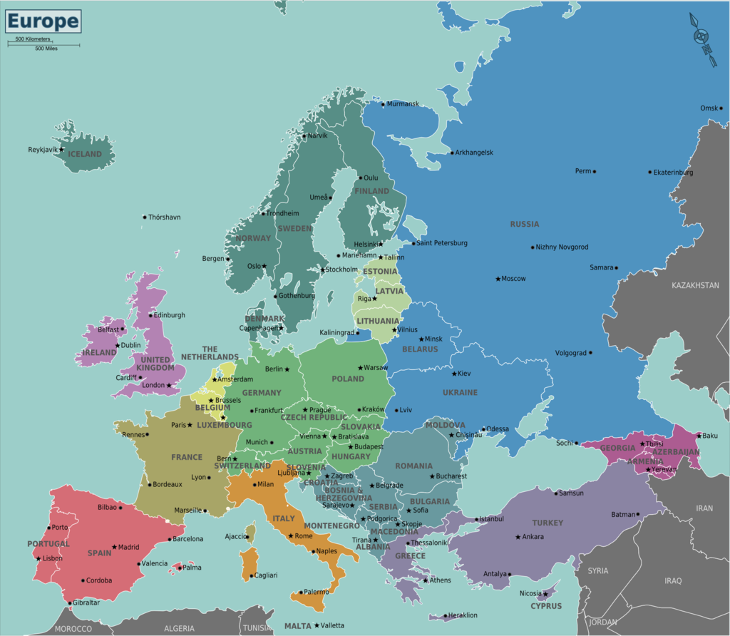
Map of Europe © Wikipedia Commons
Climate
Most of Europe’s climate is temperate, with the Gulf Stream helping keep the climate milder than might otherwise be expected so far north. Western Europe is strongly affected by westerly winds from the Atlantic, carrying mostly warm, moist air. Eastern Europe is drier, while the south - as the name suggests – has a Mediterranean climate (hot dry summers and mild winters). The continent’s biomes reflect this diversity, including tundra in the North, Mediterranean forest in the south, steppes to the South-East and temperate forest in the central band.
Much of the north of the continent is made up of a large plain, bounded by the Pyrenees and the Alps in the south, and the Urals to the east. The continent’s highest mountain is Mount Elbrus in the Russian Urals. The continent is bounded by the Arctic Ocean in the north, the Atlantic to the west, and the Mediterranean and the Black Sea to the south. There is proportionately more coastline in relation to landmass in Europe than any other continent. Major rivers include the Volga, Danube, Ural, Dnieper and Don (students may also want to be familiar with other significant rivers, such as the Rhine, Vistula, Tagus and Loire).

Population

Europe’s population is over 420 million, with about 80% of people living in or around cities. The largest cities are Istanbul (14.5 million), Moscow (12 million), London (8.5 million) and St Petersburg (5 million). The urban area around Paris has about 11 million people, and the Ruhr area, 6.5 million.

Europe is the world’s richest continent, owning about one third of the world’s wealth. However, there is huge variation both within and between countries: for example, average household wealth in Moldova is about 1% of that in Monaco.

Major languages include Russian and German (95 million speakers in Europe), French (80 million), English (67 million), Italian (60 million), Spanish (51 million), Polish (40 million) and Ukrainian (37 million).

Lesson two: Is Europe a proper continent? Is the Mediterranean a proper sea?

Key aims and questions

By taking a ‘geography conundrums approach’ this lesson invites learners to think critically about what we mean by terms such as ‘continent’ and ‘sea’ etc.

- How does Europe fare as a continent which is not a contiguous land mass surrounded by water’?
- Is there one ‘Europe’, or are there many ‘Europes’?
- What is the difference between a small sea and a big lake?
- Making sense of seas within seas: the Tyrrhenian, Ligurian, Adriatic, Cretan and Aegean Seas.
- Is the Black Sea a part of the Mediterranean?
- What continent is the Mediterranean in?

Key facts

Understanding Europe
There are several definitions of ‘continent’. Few of them conveniently fit with the boundaries of Europe, as established by convention. Europe is not a ‘contiguous land mass surrounded by water’: its principal Eastern boundary with Asia is the Ural Mountains. (The only reason that water completely separates Asia from Africa is because of the Suez Canal, so it could be argued that the three continents are all one). Europe is not on its own unique continental plate, either.

It is important to make the distinction between Europe as a continent and ‘Europe’ as a political entity (which pupils will probably have heard a lot about via news reports and other media). The European Union comprises 28 out of the 50 European states. 18 of these are even more closely united in the ‘Eurozone’, where they share the Euro as a common currency. There is freedom of movement between many states and no passports are needed for travel between 22 of the countries, and this agreement (The Schengen Agreement) also covers four non-EU countries: Liechtenstein, Iceland, Norway and Switzerland.

One of the maps we provide includes territories which are within the European Union, but outside of the conventionally-established bounds of the continent of Europe. In offering this, we are inviting children to look critically at the different ways in which the continent is defined, and to clarify some of the main ways in which we might use the term ‘Europe.’

Introducing the Mediterranean

In the second activity, we offer statements about The Mediterranean. In doing this, we are starting to tease out its relationship to other bodies of water. It may, for example, be considered as a subdivision of the Atlantic Ocean. The Mediterranean itself can also be subdivided: both into its two principal basins, and into the various ‘seas’ which exist within it. Convention dictates that The Mediterranean ends at the Sea of Marmara, but does not include the Black Sea. However, this is only an established convention, and in messy reality, the bodies of water connect to one another in a single system.

The Mediterranean touches on three continents: Europe to the North; Africa to the South; and Asia to the East (and, through Anatolia, the North-East). Where one continent ends is partly a matter of convention, partly of territorial waters (some of which are disputed).

It also sits on three continental plates: the Eurasian, the African and the Arabian. These do not exactly correspond to the points where the traditional continental divides occur. Where the plates come into contact with each other, there is heightened seismic activity, such as the volcanoes of Sicily and Southern Italy, and the high incidence of earthquakes in the Eastern Mediterranean.

Lesson three: What's so special about the Mediterranean?

Key aims and questions

- Why is the region so significant? What is exceptional about it?
- What are some of its human and natural wonders?
- What connections do we or our families have connections to the region (e.g. though family members, work or holidays)? What can these personal experiences contribute to our learning?

Key facts

Exploring the Mediterranean

The main currents in the Mediterranean flow in from the Atlantic via the Straits of Gibraltar, travel east to the Levant, and then back along the coast of North Africa, where the water is pushed northwards towards Europe. The ‘message in a bottle’ follows these currents, as the water flows first towards Greece and the Balkans, then to Sicily and Italy, to France and then Spain.

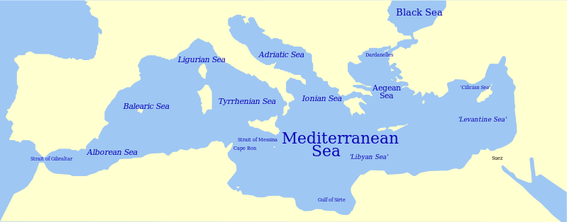
Map of the Mediterranean and subdivisions, © Wikipedia Commons

As one of the world’s oldest centres of human society, culture and trade, the 46,000 kilometres of Mediterranean coastline have provided opportunities for human activity for many millennia. Evidence of the sea’s importance and impact can be found in its history, settlements, industries, languages and culture, from Ancient Egypt to the present day. Its relatively small size make it ideal for transportation and trade between the many cities on its coast: a meeting place for people and goods from three continents. The sea is a source of natural resources, and the region’s mild climate makes it congenial for human settlement, agriculture and tourism.

The Mediterranean is unique, ‘a sea surrounded by land.’ It contains over 10,000 living species. Its many coastal settlements also bring pressures to bear on such natural resources. The many rivers and waterways that drain into the sea have nowhere else to go, making it highly polluted in places. Its 220 million tourists each year bring both opportunities and pressures, while global climate change raises further concerns about its future. Inland, forest cover is being rapidly lost and many habitats degraded.

Lesson four: Zoom in on Italy. A country of Cities and Regions

Key aims and questions

- What are the physical features of Italy?
- Why is Italy a Mediterranean country?
- What is a region?
- Why might a country be divided into regions?
- Is Italy the only European country divided into regions?
- What does a regional map of Italy look like?
- What are the differences between Italian regions?
- What is a ‘capoluogo?’
- What are the special features of the following cities: Rome, Venice, Naples, Palermo, Milan, Aosta and Florence
- How do these cities compare to cities in the UK?

Key facts

Introducing Italy

Italy became a united country for the first time on March 17, 1861 and is a relatively new nation. Italy extends from the Alps Mountain Range in the North, to the southern island of Sicily – which is close in proximity to Africa. Many rivers run through the country including the Tiber and Po. Italy also has many national parks including the Parco Paradiso in the North West of the country. Italy is a peninsula country which means three sides of the country are bordered by Sea. This affects the climate of the country. However Northern Italy is also affected by the mountain ranges and therefore if you were to travel the length of Italy in December for example, you would find contrasting environments.

Italy is divided into regions; each region has its own traditional dress, festivals, food, drinks, music and Saints. As you travel through Italy you will also hear many different accents and dialects of the Italian language. These ancient dialects have been influenced by many factors: the French and German borders; by countries who conquered Italy over time and by increasing regional unity and trade. Just as the UK has “BBC English”, Florence is said to be the place where Italian can be heard “correctly”. Even though it is a small country, these regions are very distinctive, particularly when you consider the north/south divide of the country. The north of Italy is populated by factories and banks, making it an important economic centre for the country. The south of Italy relies very heavily on tourism and therefore the Mediterranean climate and the Mediterranean Sea are essential in order to bring visitors to the area. Some of the most beautiful beaches in the world can be found around the island of Sardinia which, whilst belonging to Italy, has its own unique features.

Regional geographies

Many countries in Europe are divided into regions; two which may be worth comparison are France and Spain. In Italy, everyday life is dependent on their regional identity, rather than national.

In terms of the number of regions, Italy is divided into 20 regions which each control their own affairs. These regions are sub-divided into 110 provinces. Further still these provinces are divided into 8100 ‘communes’ each with their own mayor. For more information about this, go to Understanding Italy website: http://www.understandingitaly.com/regions.html.

As each region of Italy is so distinctive, there is one city in the region which is considered the capital city of that region – in Italian this is called ‘capoluogo’ (ending in i for the plural). The cities in this unit have been chosen for their location across Italy and their contrasting and distinctive cultural, social, economic and physical geography.

Map of Italian regions
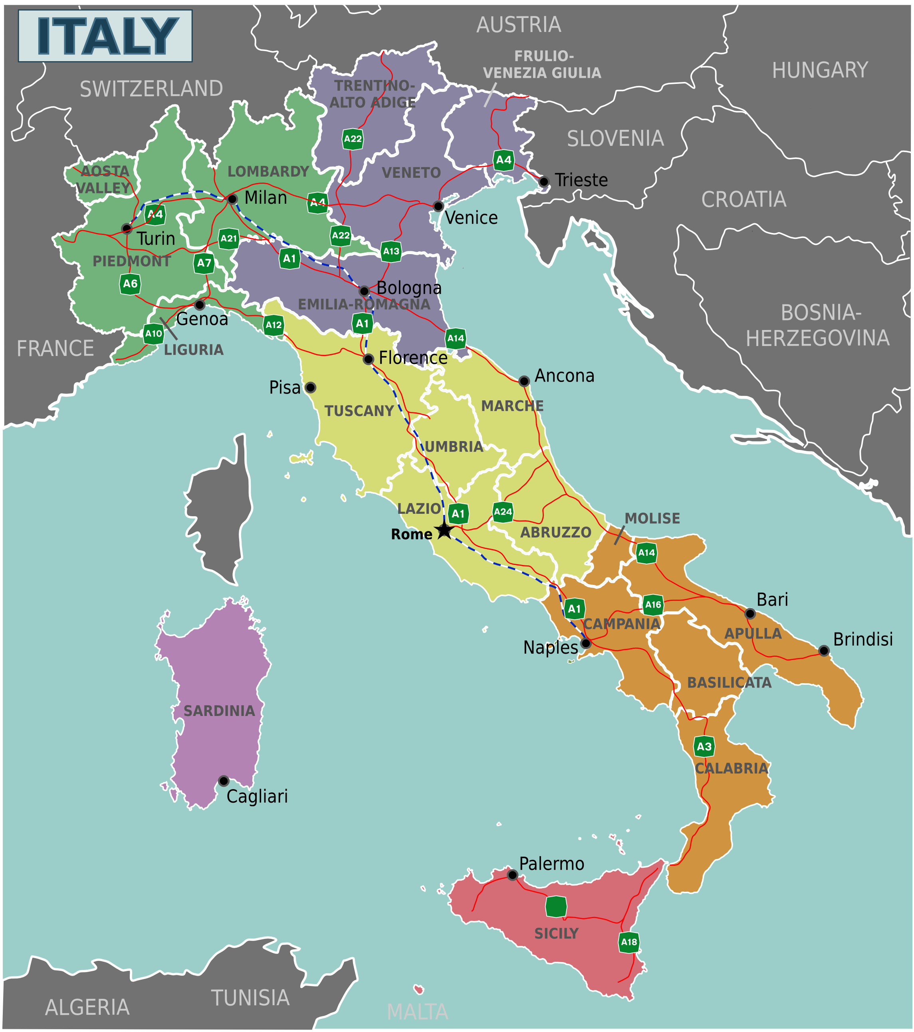
Regions of Italy © Wikipedia Commons

Lesson five: Zoom in on Bologna and the Bolognese

Key aims and questions

- How has Bologna changed over time?
- What is traditionally associated with Bologna?
- How can Bologna and its hills be seen as a place of contrasts?
- Why is Bologna the capital city of the Emilia Romagna region?
- What is meant by a historic city - what evidence is there that Bologna was an Etruscan, Roman and Medieval City?
- Bologna as a city of culture (Bologna is a UNESCO Heritage site for music, which suggests a curricular link and exploration of how we define culture)
- Bologna as a tourist city
- In what ways is Bologna like the place where we live?
- Hopes and challenges. What does the future hold for this ancient city? What are the threats to Bologna as a city? (Focus on Earthquakes).

Key facts

Introducing Bologna

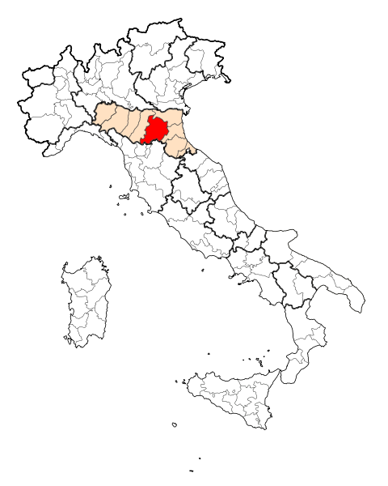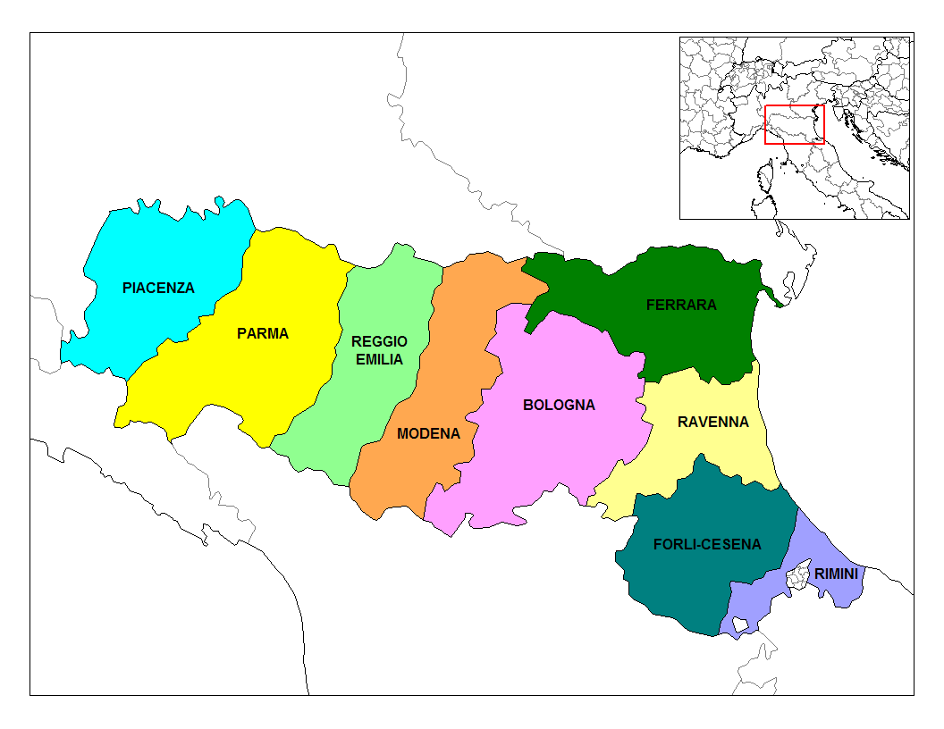
Bologna in Italy © Wikipedia Commons Emilia-Romagna region © Wikipedia Commons
Bologna grew as an Etruscan City named Felsina. It was a thriving Etruscan city which was born as part of the Etruscan Civilisation’s expansion to the east coast of Italy. In Giardini Margherita there is still evidence of one of the Etruscan’s burial grounds which was excavated when the park was landscaped. It is important to note that Bologna used to have a canal route and this made trade easier and the city accessible. In 189 BC Romans began their expansion of Bologna. They destroyed all evidence of Etruscan script, language and houses and developed road connections changing the name of the city to Bononia. Bologna had many rulers over time and became a thriving city in the Middle Ages. Much of Bologna’s city centre today boasts incredible architecture, and evidence of Roman and medieval influence can be found around the city centre. Some of the medieval city gates surrounding the city still remain.

The most famous architecture to be found in Bologna is the two towers. In its prime, Bologna had over 100 of these towers; however with redevelopment and natural decay and decline very few remain today. The most famous to still be standing are the ‘Asinelli’ erected between 1105 and 1109 and the ‘Garisendi’ built in 1110. These form a focal point of the city and attract many tourists. Bologna is also a city of Porticoes boasting the longest Portico trail from the city walls to the famous San Luca church.

It is thought that the very first university in Italy was established in Bologna in 1088. This was a university for law and religion. Whilst the first medical university was set up in Sorrento in the south of Italy, the very first dissection in Italy was conducted in Bologna in the year 1315 and it is still possible to visit this famous medical location where the dissection took place. Bologna’s rise to fame as a university city brings many students into the city and for this reason it is the Capoluogo – capital city of the Emilia Romagna region.

Whilst Bologna is one of Italy’s richest cities the beautiful ‘colli’ hills of Bologna can be reached in only ‘15 minutes’ walk from the city gate of Porta San Mamolo. The Apennine Mountains can be seen on a clear day and there is a wealth of walking paths for all abilities. This makes Bologna a very attractive place to live as the city provides historical monuments, cultural features and natural beauty.

Exploring food and culture in Bologna

In 2006 Bologna became an UNESCO City of Music. Bologna has displayed a long, rich history of musical tradition that has fostered contemporary and creative innovation. It has used musical creativity as a political tool to deal with social and cultural issues - ranging from the fight against racism, to the economic and social development of the city. Each year Bologna holds a jazz festival and there is even a ‘Strada del Jazz’ (in English ‘Road of Jazz’ to commemorate some of the world’s greatest jazz musicians. This can be found on Via degli Artieri, with the Jazz musicians written inside gold stars.

Bologna is well known food which originates from the Emilia Romagna Region. Traditional Bolognese foods include Lasagna, Tortellini and Mortadella ham. Parma Ham, Balsamic Vinegar and Parmesan are also made on the farms of the region. However, the biggest myth about food in Bologna is ‘Spaghetti Bolognese.’ Tourists may be surprised when they order this dish, as it is not coated in tomato sauce and is not, in fact, made with Spaghetti. This is an Americanized dish based on the traditional Tortellini Al Ragu which is actually the famous Bolognese dish. In traditional Italian restaurants you would never usually find meat mixed with spaghetti. Therefore, Italian Bolognese is made with Tortellini which is wider pasta and the sauce has a very slight mix of tomatoes.

Protecting Bologna

The Comune of Bologna works hard to keep this historical city functioning contemporarily, whilst trying to protect the heritage and unique features which attract so many tourists each year. Moreover, the Universities work hard to attract national and international students to the city. Bologna is an ideal location for visiting the other famous cities within Italy. From the train station, you can reach more destinations across Italy than any other train station – these excellent transport link help Bologna continue to develop.

However, as development increases the government must also respect the fact that Bologna sits along a belt of seismic activity due to its proximity to the Apennine Mountains. The entire length of Italy is along this belt with Bologna sitting above one of the major fault lines. The Apennine Mountains form part of a huge plate boundary, and they mark the collision zone between the African and European plates. On May 29th 2012 Bologna was struck by a 5.9 Magnitude Quake this provided insight into Bologna’s ability to deal with natural disasters. Whilst, Bologna has historically experienced threats to its economic, social and cultural geography – the biggest risk remains its resilience to its potential volatile landscape.

Lesson six: Everyday Life in Bologna

Key aims and questions

- What are the yearly activities like for these students?
- What is similar and different between a typical year in Italy and one in the UK?
- What might be the geographical reasons for these similarities and differences?
- What is a typical week for these children?
- What similarities can you find between the three children?
- How does one of the student’s weeks compare to yours?
- Why might our daily routines be similar and different?
- Can we say that all Italian children lead lives like this? (Discussion of the dangers of stereotyping)

Key facts
Everyday life in Italian schools
Children in Italy lead very different lives depending on the region they inhabit, their family situation, economic status and education. Therefore, this lesson connects to lesson four in terms of regional differences across the country. Comparative to the UK, it may seem lucky that Italian schools finish at 2pm on the majority of weekdays but, there are at least three hours given for homework each day and students must be very independent. Some children also attend school on Saturdays.
The yearly calendar provided in the resources is designed to encourage students to investigate – which national holidays are celebrated in Bologna and the subsequent the differences in school holidays and pupils’ experience. It is designed for pupils’ to be able to find similarities and differences across educational experience.
The weekly diary allows pupils’ to explore everyday life of children in Italy, by engaging with their ‘typical week’. However, there is also potential to see the differences between the four children, as each profile displays their individual experience that is shaped by national and personal identity.
Italy’s Mediterranean climate means that it is both dry and warm (especially from spring to autumn) compared to the UK. As a result, children in Italy are able to spend more time outside, playing with friends or visiting outdoor cafes with their families. Evening social activities happen before; during and after the evening meal and this means children in Italy normally eat much later than children in the UK. Children stay out of the house to play with friends and therefore they stay up much later than the average child in the UK. This is an interesting note of comparison as it highlights the relationship between human and physical geography.
The materials provided with this resource should be used carefully – the exercise should help to contest stereotypes, rather than facilitate them. This is an essential discussion point to have with a class as it helps students to recognise how identities are shaped by different types of geographies – and how similarities and differences occur across space and place. It is worth noting, that Italy has one of the highest child poverty rates in Europe and whilst this is not reported upon - it is a worrying statistic for the country and one that could be considered by students when engaging with the various social and economic impacts experienced in Italy.

