The Download Debate

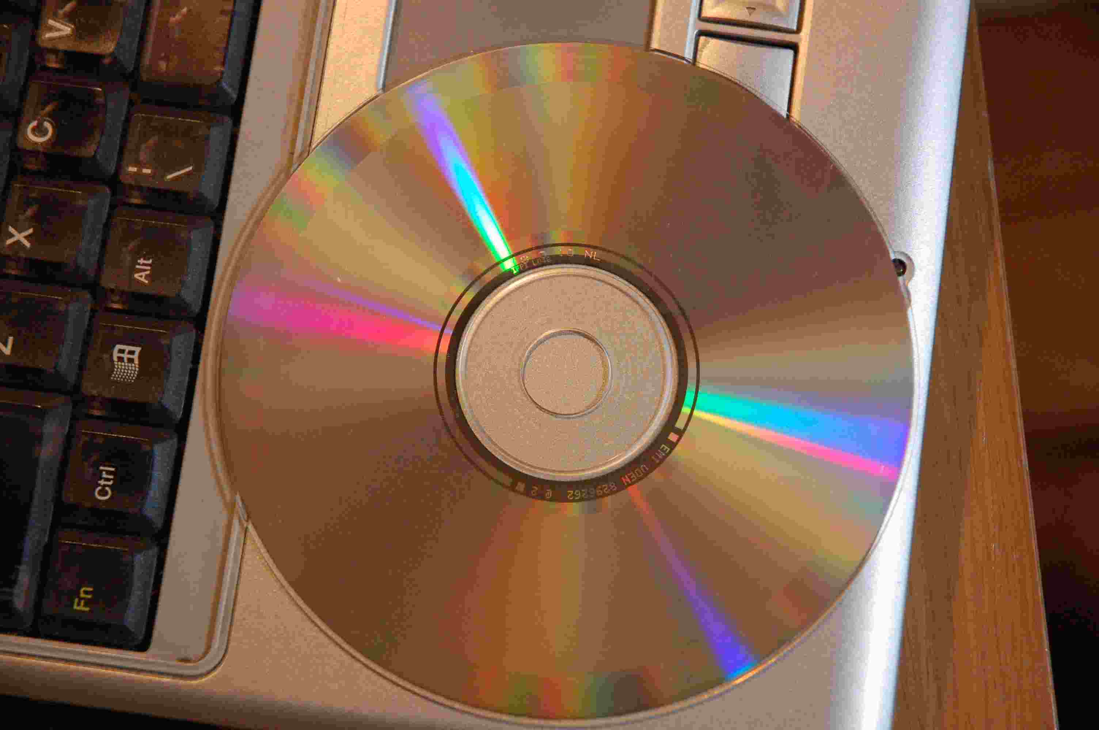
More and more people are downloading music and films from the internet - and not everyone ‘pays to play’!

Now that we no longer need to go to shops to buy music and films as physical objects (CD/DVD), it is easy to get away without paying.

You can buy music legally on the internet from sources such as itunes. But some people also like to share CDs by copying them. Some files are posted on the internet, where others can gain access to them. If music is downloaded illegally from unofficial sources like these, this is called PIRACY.

The internet is having a major effect on the music industry and how it is run. If people do not pay for music the record companies have less money to invest in future bands. The internet means that CD sales have fallen and so have profits for the performers, the songwriters and the record companies.

Radiohead, an extremely successful band, controversially decided to release their new album only through the internet. Owen Gibson wrote in The Guardian newspaper on 2nd October 2007:
“Their music has long been praised for blurring boundaries and breaking moulds. Now Radiohead are hoping to establish a new model for the struggling record industry by inviting music buyers to decide how much they want to pay for their new album.
“To their biggest fans, eagerly awaiting their first studio album for four years, it is near priceless. Those who believe Radiohead long ago descended into self-indulgence may only risk pennies. But thanks to this ground-breaking experiment, the band will bypass record labels altogether and will be able to put a fiscal value on the public's appreciation of their art.

“The release was announced with a short message from guitarist Jonny Greenwood on the band's website, revealing that the new album, In Rainbows, would be available to download from October 10. Orders started rolling in yesterday, with customers able decide how much to pay - from nothing (plus a 45p administration charge) upwards…”

Once you have read the article above, discuss the following questions (and any other points you can think of) in small groups:

- How much is a fair price to pay to listen to music?

- How much is a fair price to pay to watch a film?

- Is it OK to make copies of music other people have paid for?

- How do we think bands feel when people download their music for free?

- How do entertainment companies (like EMI) feel when people download their music for free?

- What will happen to the music and film industry if everyone download music and film for free?

- How else can artists make money, if no-one pays for their music and takes it for free?

- How can people on low incomes and teenagers without much money be able to enjoy music if they can’t listen to it for free?

- Might listening to music for free make people fall in love with a band - and then go see their show / buy t-shirts – so the band can still make money in the end?

- Radiohead are very successful. Why might copying Radiohead’s idea for downloading music not work as well for up-and-coming new bands?

