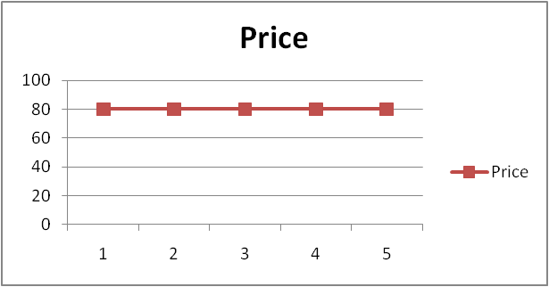
The Impact of Changes in Food Prices
GRAPH 1

The graphs show three different simple changes in the price of an imaginary food product e.g. wheat, over a period of five years. The vertical scale shows prices in US$ per tonne.

TASK:

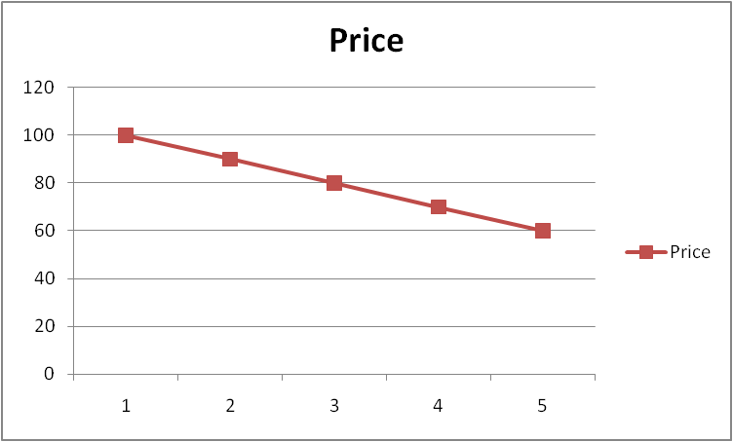
Imagine that you are working for the government in a poor, developing country. The farmers in your country are unable to grow enough food to feed everyone, particularly all the people in the cities. You are the new government minister in charge of buying extra food for the people in your country. This extra food is mainly sold in the cities. You normally buy about one million tonnes of food each year.
GRAPH 2

- For each graph, note down what you feelings would be over each of the five years as you did your job.

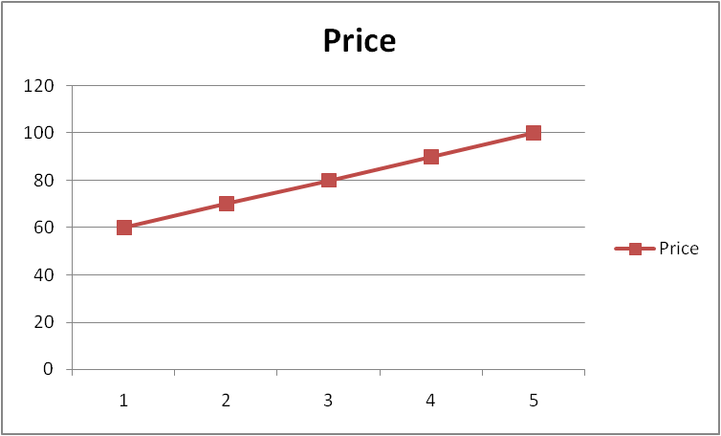
- In which graph would the government have extra money to spend on other things e.g. schools, roads, hospitals.
GRAPH 3

- What would the government do if the situation in Graph 3 happened? What would happen if you asked the Prime Minister for more money to buy food? What would happen if you were unable to get more money?

Continued on next page…

- Imagine a new graph in which the price of food changed a lot each year (went up, then down and then up again) how would this make your job more difficult?

- If your country did not have enough money to pay the extra price for the food, you could do two things:
- Borrow some money from a rich country such as the UK or the USA. In Graph 3, how much extra money would you need to borrow each year? Why would it be difficult to pay back? What would happen if it took a long time to repay?
- Ask some of the rich countries to send ‘food aid’. How long might it take to get the food to your country? If the food aid was given out free to the people in the cities, what might happen in the next year when farmers from the countryside tried to sell their food in the cities?
- If food in the city shops started to run out, what would the people in the cities do? How would the city people feel about their government?

