Lesson 4: Volcanoes
Factsheet for teachers

Purpose of Lesson
There are approximately 500 active volcanoes in the world; on average 25 of these erupt each year.

In this lesson pupils will learn that volcanoes are another type of mountain, and just like other mountains, they come in different shapes and sizes. While fold mountains, fault block mountains and dome mountains are located within the body of a tectonic plate, volcanoes are primarily (but not exclusively) located on the boundary between two tectonic plates. In its simplest terms a volcano is formed when magma penetrates the Earth’s crust. This magma then cools and hardens to form solid rock, creating a mountain.

This lesson will examine different types of plate boundary. It will also name the key features of a composite volcano in cross section.

Vocabulary

This lesson uses the following geographical terms. These should be used and explained to pupils as the lesson is taught. Some of these terms have already been taught in Lesson 3.

Core, mantle, crust These are the main layers of the Earth.
Molten rock Rocks that are in a liquid form.
Viscous Viscosity is a measure of how thick or thin a liquid is. The higher the viscosity, the thicker the liquid; the lower the viscosity, the thinner the liquid. If a liquid is described as viscous it is thick. The mantle is viscous.
Magma Magma is molten rock from the mantle. Magma is within the surface of the Earth. Magma becomes lava only once it flows out over the surface land, for example with a volcano.
Plate tectonics This is the theory of the movement of the plates that make up the Earth’s crust.
Plates The Earth’s crust is not one solid piece of land, but is formed of many different pieces or plates. There are eight major plates and many more minor plates. These plates move across the mantle.
Plate boundary Where tectonic plates meet. Three types of boundary are covered in the lesson: constructive, destructive and transform.
Converge When two plates move towards each other.
Convection currents Heat from the Earth is released in currents within mantle. This is analogous to bubbling porridge in a saucepan. The convention currents within the mantle cause the Earth’s plates to move.
Dormant volcano A volcano that has not erupted in a long time.
Extinct volcano A volcano that has not erupted in recorded history.
Active volcano A volcano that has erupted in recent history.
Shield volcanoes The slopes of a shield volcano are gentle. The eruptions are not as violent as composite volcanoes. The lava is runny (not viscous) and spreads great distances. The shape of the volcano is in its name.
Composite volcanoes (Also called Stratovolcano). These have the ‘classic’ volcano shape. Their eruptions are violent and the lava is thick (viscous).
Constructive plate boundaries
Constructive plate boundaries (also called divergent boundaries) move apart from one another. As they move apart molten rock rises from the mantle, then cools and hardens to form new rock.
Iceland: An example of a constructive plate boundary is the Mid-Atlantic Ridge. This ridge is formed at the boundary of the North American plate and the Eurasian plate. Iceland is one of the many volcanic islands that form part of the Mid-Atlantic Ridge; the boundary of the North American plate and the Eurasian plate crossing Iceland from north-east to south-west.
Iceland has 130 volcanic mountains, 35 are active. In fact, one third of the entire World’s lava output is from Icelandic volcanoes. In April 2010 the eruption of Eyjafjallajökull bought the UK’s airports to a standstill for five days and disrupted travel across Europe, with plumes of volcanic ash and gas 10km high. Researchers from the University of Iceland calculated that approximately 750 tonnes of magma were ejected from the volcano every second. The volcanic activity on Eyjafjallajökull lasted just under 40 days.
Destructive plate boundaries
At a destructive plate boundary (also called convergent boundaries) two plates move towards another. One plate is then pushed underneath the other. (It is the heavier plate that is forced beneath the lighter plate). The point at which one plate is forced beneath the other is called the subduction zone. The plate then melts, due to friction, to become molten rock (magma). The magma then forces its way up to the side of the plate boundary to form a volcano. The Nazca and South American plates have destructive plate boundaries, as do the Eurasian and Pacific plates. The 40000 km long horse shaped ‘Ring of Fire’ is formation of over 400 volcanoes- many below the ocean floor.
Villarrica in Chile: There are 500 volcanoes in Chile. This volcano is located 700 km south of Santiago, the Chilean capital and is in the Andes mountain range. It is on the boundary of the Nazca and South American plates. Villarrica is one of Chile's most active volcanoes and looms large over the lake and town of the same name. It covers an area 400km² and is 2847 metres high. It is one of the few permanently active volcanoes in the world, with a large lava lake in its crater. Significant eruptions occur, on average, once every ten years. Ash is frequently seen emerging from the crater and deep seated rumblings can be heard. Sixty percent of the volcano is permanently covered with ice and snow.
Mount Etna, Sicily, Italy: This volcano is also located on a destructive plate boundary- see below.
Transform plate boundaries
At transform plate boundaries two plates move past each other. Friction may cause them to stick, but when they eventually become unstuck, often with a violent jolt, an earthquake results. This will be covered in greater detail in Lesson 6: Earthquakes.
Shield Volcanoes
Shield volcanoes have very runny lava (they are not viscous). The silica content of the lava determines the viscosity. Shield volcanoes have a low silica level. Shield volcanoes are evident in Hawaii.

Hawaii: The Hawaiian Islands are a chain of volcanic islands located on the Pacific plate. Their formation is caused by a ‘hot spot’, an area of the mantle that spews magma through a slightly thinner crust. (There are 40 to 50 hot spots around the world, including near the Galapagos Islands). As the Pacific plate moves (approximately 9cm each year) the hot spot underneath it stays still. So, rather like a volcano conveyor belt, these islands have been formed one after the other, with older ones located to the north west, as the Pacific Plate slowly moves in this direction. There are currently five active volcanoes in Hawaii.
Mauna Loa is located on the main Hawaiian island (also called Hawaii). Mauna Loa means ‘Long Mountains’; in fact Mauna Loa forms half of the entire island, extending 120km and covering an area of 5000km². Mauna Loa rises 4169 metres above sea level. However, if measured from the ocean floor, it is over 9000 metres high. So, while Mount Everest is the mountain with the highest altitude, it could be argued that Mauna Loa is in fact the tallest mountain!
Mauna Loa
Above sea level approx 4000m

Ocean
Below sea level approx 5000m
17000m
Ocean floor

Depressed Crust (due to the weight of the volcano above)

Mauna Loa is a shield volcano. It has erupted fifteen times since 1900. These eruptions have lasted anything from a few hours to 145 days. The last eruption was in 1984 and lasted for three weeks. It is in close proximity to the town of Hilo.
Kilauea, situated to the east of Mauna Loa, is considered one of the world’s most frequently active volcanoes, over the last 250 years it has averaged one eruption every four years. However, the current eruption, which started in January of 1983, has been continuous ever since.
Composite Volcanoes
Composite volcanoes are the most common type of volcano and are common at destructive plate boundaries. The lava is viscous (thick) and has a higher silica level than with shield volcanoes. In a composite volcano the magma is too stiff to allow easy escape of volcanic gases. As such, tremendous internal pressure mounts as the trapped gases expand. The pent-up pressure is suddenly released in a violent eruption. This type of explosive eruption is like putting a thumb over a bottle of fizzy drink, shaking it, and then quickly removing your thumb allowing the gases and liquid to gush out with explosive speed and force.

Mount Etna is located on the Italian island of Sicily. It is an example of a composite volcano situated on a destructive plate boundary- where the African plate is forced beneath the Eurasian plate. Mount Etna is Europe's tallest active volcano and is located in Sicily, Italy. The height of the mountain varies depending on the summit eruptions, but it is approximately 3350 metres high. The base has a circumference of 140km. Etna has erupted many times during history; it was first thought to have erupted in 475BC. In 1669, it was at its most deadly, killing 20000 people. In 1992 Italian and U.S. soldiers used controlled explosions to divert the flow of lava to save Zafferana, a town of 7000 people. Etna is still constantly active.
In addition to Etna, Italy’s other active volcanoes are Mount Vesuvius and Stromboli. Vesuvius, located east of Naples, is thought to be one of the most dangerous volcanoes in the world because it has a population of 3 million people living nearby. It is the most densely populated volcanic region in the world.

The Structure of a Composite Volcano

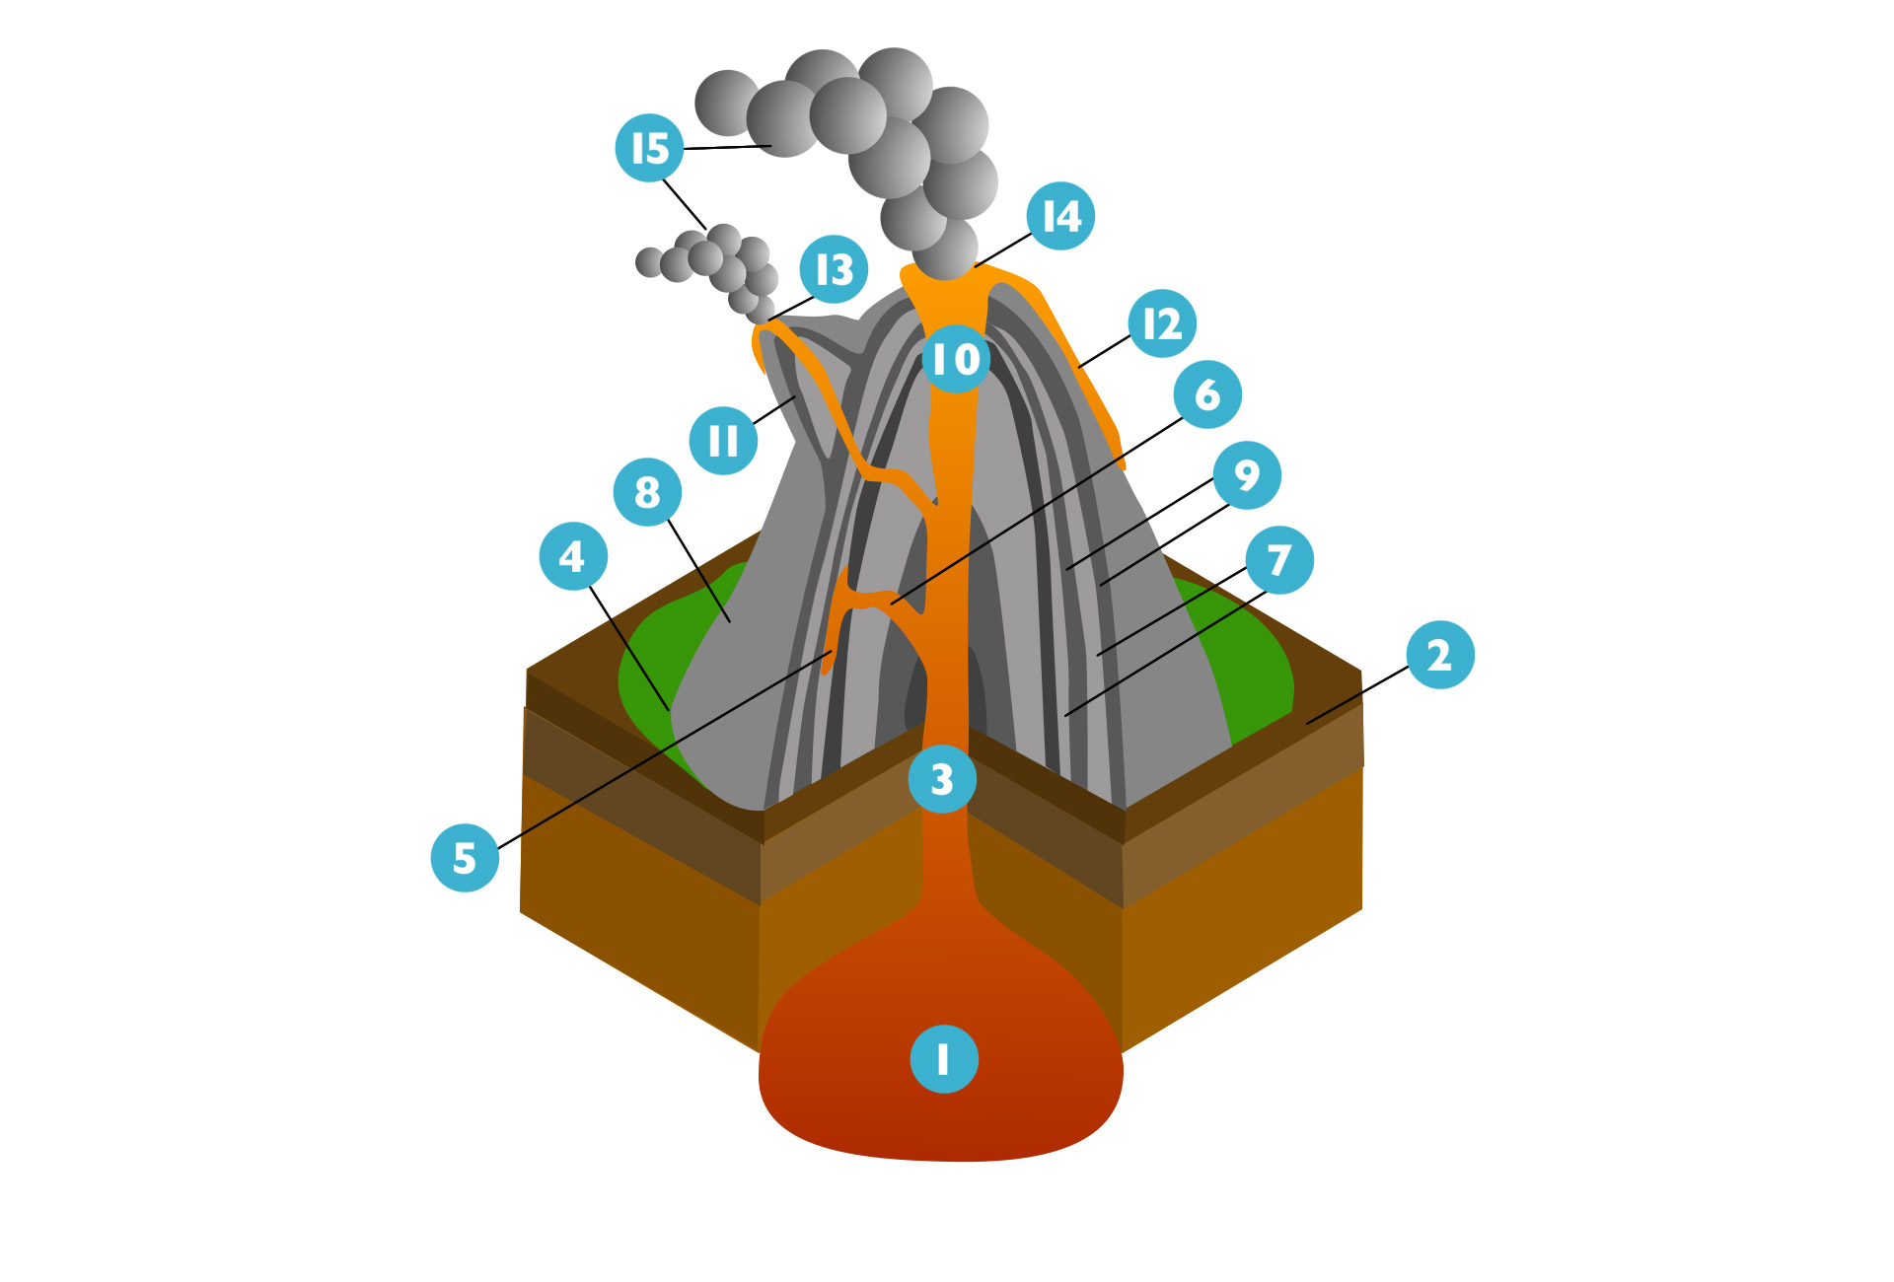

- Large magma chamber
- Bedrock (solid rock beneath the soil layer)
- Conduit or pipe
- Base
- Sill
- Branch pipe
- Layers of ash
- The flank (the sides of the mound)
- Layers of lava from previous eruptions
- Throat
- Parasitic cone
- Lava flow
- Vent
- Crater
- Ash cloud (also termed pyroclastic flow- the mix of gas, ash and small rock particles)

Does the UK have volcanoes?
Yes, but they are extinct. The Hebrides Terrace Seamount (an undersea volcano) off the west coast of Scotland is higher than Ben Nevis, but its peak is 1000 metres beneath the ocean surface. This is a remnant of a volcano (The UK has three underwater mountains, or seamounts). For information visit the BBC website: http://www.bbc.co.uk/news/28583945?ocid=socialflow_twitter
The Giant's Causeway is located in County Antrim, Northern Ireland. It is comprised of 40,000 interlocking basalt columns, each with an average diameter of 45 cm. The face of each column is a regular polygon, typically hexagonal, but some also have five, seven and eight sides. The tops of the columns form stepping stones that lead from the cliff to the sea. The tallest are about 12 metres. The columns are the result of a volcanic activity 50-60 million years ago. Both the Giant's Causeway and Fingal's Cave, Scotland, were created by the same lava flow, which may have at one time formed a bridge between the two sites. Fingal’s Cave is located on Staffa, one of the smallest islands in the Southern Hebrides. The cave has a cathedral-like structure and its basaltic hexagonal columns are similar to those found at the Giant’s Causeway.
Castle Rock, Edinburgh, Scotland: Edinburgh Castle is situated on Castle Rock in the heart of the city. Castle Rock was formed 350 million years ago due to volcanic activity. The castle was built on the rock- a volcanic plug- by David I in memory of his mother Queen Margaret in the 12th century. It sits 70 metres above the surrounding city. Like Castle Rock, the hills surrounding Edinburgh, which form Holyrood Park, are also extinct volcanoes. Arthur’s Seat, one and a half kilometres east of Edinburgh Castle, is the largest hill at 251 metres. For an animated explanation of the formation of Castle Rock visit the BBC website: http://www.bbc.co.uk/learningzone/clips/igneous-landscapes-edinburgh-castle/3072.html

Interview with a volcanologist: You may also like to read an interview with Sarah Henton, a graduate student, at the Alaska Volcano Observatory, University of Alaska, who researches volcanoes. Go to the RGS-IBG Geography in the News website: http://www.rgs.org/OurWork/Schools/Geography+in+the+News/Ask+the+experts/Volcanoes+and+volcanology.htm

