Map Skills End of Unit Assessment

- Place the correct directions on each compass point.

- Name three different types of map.

________________ ________________ _________________

- Look at the map extract. Write the four-figure grid reference for the London Eye.

_________________

- Write the four-figure grid reference for the Globe Theatre. ________________

- What direction is St. James’s Palace from St. Paul’s Cathedral? _____________-______________

- Look at the contours below. Draw what the landscape would look like.

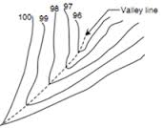

- How else is height recorded on an OS map?
___________________ & ____________________

- Write the six-figure grid reference for the Aquarium. _______________

- Write the six-figure grid reference for Waterloo Station.
________________

- What distance is it from the Tower of London to the Globe Theatre as the crow flies (i.e. a straight line)? Give your answer to the nearest ½ km. __________________

