A Caribbean Community

The Pepperpot Centre

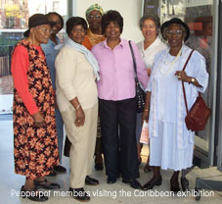
The Pepperpot Day Centre in Ladbroke Grove, London has existed for 21 years and was established to promote independence and social gatherings for African Caribbean elders in the borough of Kensington and Chelsea.

The day care centre provides a range of services, including healthcare and health promotion talks, reminiscence opportunities, outings, trips and arts and crafts activities. The Centre also works with other services in the community such as historyTALK, formerly Kensington and Chelsea Community History Group and the Tabernacle Theatre. It also provides an outreach service to help African-Caribbean elderly residents in Kensington and Chelsea to live more independently and with dignity in their own homes. The Census data shows that there are many older people in the community and with black men and women over 60 forming 9.9% of the population in this age group in Kensington and Chelsea. (GLA Nov 2002)

Activities

- What is a community – what communities do you belong to?
- Why are local community groups like the Pepperpot Centre important?
- What are the community groups in your local area? Use sources of information such as local authority websites, newspapers, local phone directories to identify local community groups working.
- Find out what activities they carry out for their members. Write to a local community group asking for information about its role and purpose.
- Find out when the community group was set up. Why did the members feel they had to establish a community group?
- What brought these groups to live in the area? Were they born there or moved from other places or countries? Have the reasons for people living here changed over time?
- Does your school community reflect the population of the local community?
- Do you think it is important for communities to have a social centre?

