

Getting to Know Google Earth
The following diagram describes some of the features available in the main window of Google Earth.
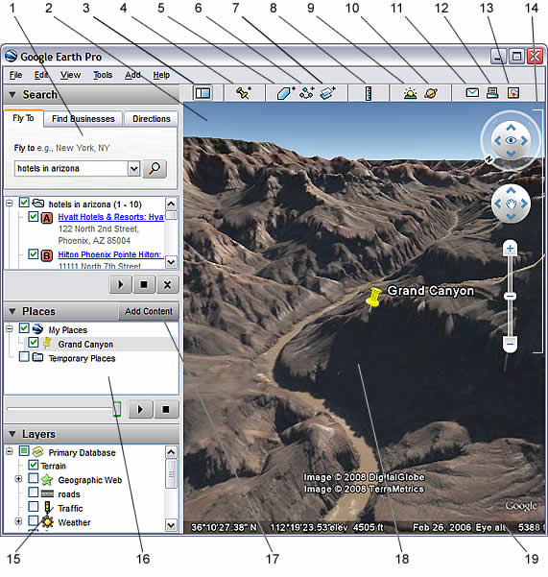
- Search panel - Use this to find places, simply enter the place name or postcode.
- Overview map - Use this for an additional perspective of the Earth.
- Hide/Show sidebar - Click this to conceal or the display the side bar.
- Placemark - Click this to add a placemark for a location (see later section).
- Polygon - Click this to add a polygon (see later section)
- Path - Click this to add a path (line or lines)
- Image Overlay - Click this to add an image overlay on the Earth.
- Measure - Click this to measure a distance or area size.
- Sun - Click this to display sunlight across the landscape.
- Sky - Click this to view stars, constellations, galaxies, planets and the Earth's moon.
- Email - Click this to email a view or image.
- Print - Click this to print the current view of the Earth.
- Show in Google Maps - Click this to show the current view in Google Maps in your web browser.
- Navigation controls - Use these to zoom, look and move around (see below).
- Layers panel - Use this to display points of interest.
- Places panel - Use this to locate, save, organise and revisit placemarks.
- Add Content - Click this to import content
- 3D Viewer - View the globe and its terrain in this window.
- Status bar - View coordinate, elevation, imagery date and streaming status here.
Depending on when you first installed Google Earth and whether you’re system is set-up to receive updates you may be using a slightly older version of the interface, shown below. Don’t worry, many of the features are the same. The main difference is the navigation controls (which most users preferred before the update!).
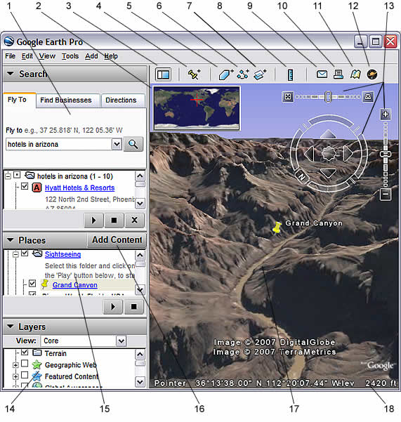

Using the Navigation Controls
To view and use the navigation controls, you must move the cursor over to the right corner of the 3D viewer. The navigation controls fade from sight when you move the cursor elsewhere on the screen

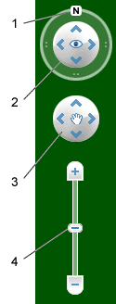
The New Look…

- Click the north-up button to reset the view so that north is at the top of the screen. Click and drag the ring to rotate your view.
- Use the Look joystick to look around from a single vantage point, as if you were turning your head. Click an arrow to look in that direction.
- Use the Move joystick to move your position from one place to another.
- Use the zoom slider to zoom in or out (+ to zoom in, - to zoom out) or click the icons at the end of the slider. As you move closer to the ground, Google Earth swoops (tilts) to change your viewing angle to be parallel to the Earth's surface. You can turn off this automatic tilt (Tools > Options > Navigation > Navigation controls).

The Old Look….
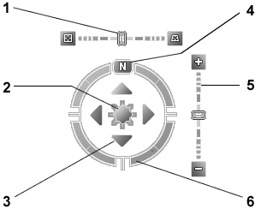
- Use the tilt slider to tilt the terrain toward a horizon view. Double click the icons at the end of the slider to reset the tilt all the way to a top-down view or to a horizon view.
- Use the joystick to move the centre point of the view down, up, right or left.
- Click the direction arrows to move the view in the direction you wish.
- Click the north up button to reset the view so that north is at the top of the screen.
- Use the zoom slider to zoom in or out (+ to zoom in, - to zoom out). Double click the icons at the end of the slider to reset the zoom all the in or out.
- Click and drag the navigation ring to rotate the view.

Tilting and Viewing Hilly Terrain
- When you first start Google Earth, the default view of the earth is a "top-down" view, which looks like the view straight down out of an airplane window.
- Tilt the terrain from 0 - 90 degrees - You can use the mouse or the navigation controls to tilt the view in order to see a different perspective of the area you're exploring.
- Turn on terrain - Using the tilt feature is particularly interesting when you are looking at a part of the earth where the terrain is hilly, so be sure to also have the terrain box selected in the Layers panel when tilting the view.
- TOP TIP - You can adjust the appearance of the terrain if you would like the elevation to appear more pronounced. To do this… click Tools, Options and then select the 3D View tap. Now change the Elevation Exaggeration figure. You can set it to any value from 1 to 3, including decimal points. A common setting is 1.5, which achieves an obvious yet natural elevation appearance.
- Rotate the view for a new perspective - Once you have tilted the view so that you are looking at a particular object, such as a volcano or river gorge, you can also rotate around that object. When you do this, the object remains in the centre of the view, but you look at it from different perspectives.
- TOP TIP – On the new version of Google Earth, as you move closer to the ground Google Earth automatically tilts. If like me, you find this feature extremely annoying you can turn it off by selecting tools, clicking options and then choosing the navigation tab.
- TOP TIP – You can also navigate around Google Earth using a combination of your keyboard’s arrow keys and the shift button. Many users find this method much easier to control. (See table below).

Command | Keystroke(s)
Move left | Left arrow
Move right | Right arrow
Move up | Up arrow
Move down | Down arrow
Rotate clockwise | Shift + left arrow
Rotate anti-clockwise | Shift + right arrow
Tilt up | Shift + down arrow
Tilt down | Shift + up arrow

How to add a Placemark to Google Earth
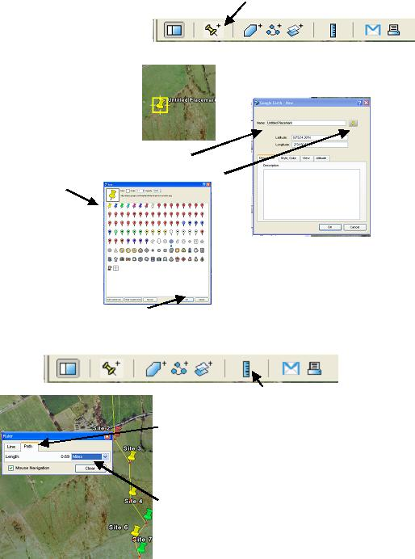
1. Click on the ‘placemark’ icon

2. Place the ‘target’ on the point where
you want the place mark to be dropped.

3. Give your placemark an appropriate name
4. Click on the placemark icon and choose a suitable colour / image

5. Click ‘OK’ to close windows. Your marker will have appeared.

How to Measure Real Life Distances

- Click on the ruler icon on the toolbar

2. If your measuring between multiple
points click on the path tab.

- Using the target click on the starting
point

- As you click through your route the
distance is shown in the pop-up.

Online Materials - Layers
If your lucky enough to have internet access in your classroom, then you may wish to consider using the layers provided by Google Earth. Although many are US based and offer few educational opportunities, there are a number worth exploring. Just tick the relevant box, and related icons will appear. The screen shot below shows the impact of ticking the volcanoes layer, which can be found under the Geographic Features heading, excellent when discussing plate margins.
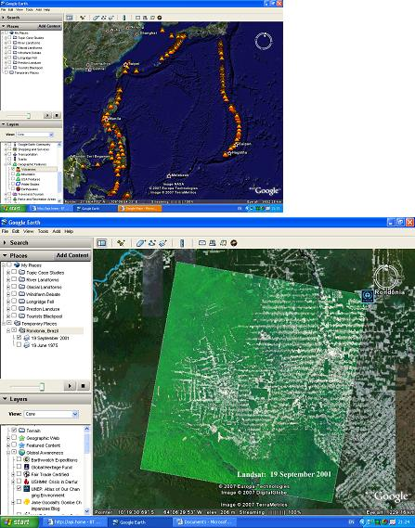
However, my favourite features are the time specific layers provided by the UNEPs Atlas of Environmental Change.

By clicking on this option you can view archive satellite images, which graphically illustrate the growing impact of humanity on the natural world. The images of rainforest destruction and the shrinking Aral Sea are particularly thought provoking.

How to show lines of latitude and Longitude

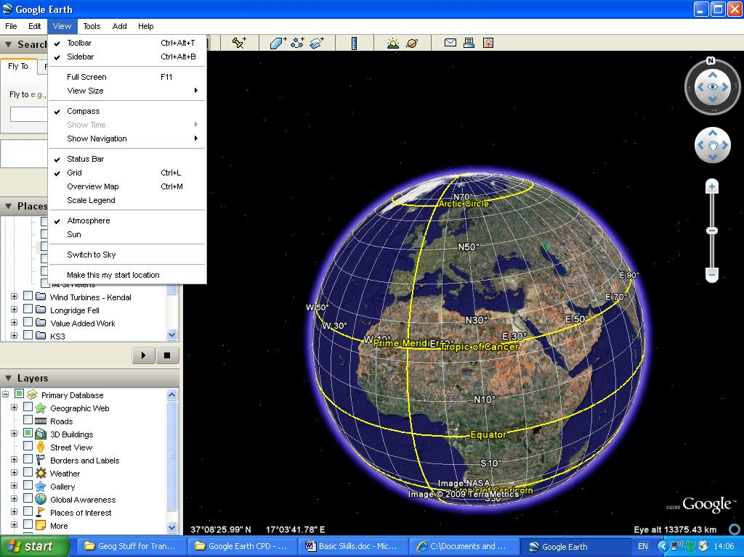
Click on view on the tool bar and select grid.

What’s the Scale?
To show a scale line, click view on the tool bar and then select the legend option.
