Who are the Maasai?

The Maasai are a tribe of people who live in parts of Tanzania and Kenya and are known as tall and fierce warriors.
- They can be recognised by the special red cloth they wear which is called a Shuka.
- Maasai people live a nomadic life, which means they move from place to place with their animals.
- They rely on their animals for food (including milk, meat and animal blood) and walk for many miles with their animals to find fresh food and water. They get all the other foods they need by trading (swapping) with other Maasai people.
- Maasai men herd cattle and carry spears to protect their cattle from wild animals such as lions.
- The Maasai women are responsible for cooking, collecting sticks for the fire and building the home.

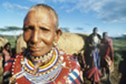
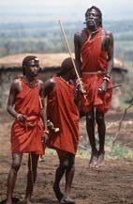
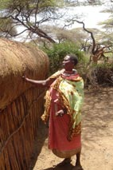

(© Adrian Arbib)
A Maasai mother wearing traditional jewellery she has made

(© Adrian Arbib) © A & D Boys
Maasai warriors (or Moran) doing a traditional dance
A Maasai woman building a Manyatta

Where do the Maasai people live?
In Kenya most Maasai people live in the Maasai Mara Reserve which is a large park in the South West of Kenya. It is named after the Maasai people who live there and the Mara River which cuts through the park.
- The Maasai live in shelters called manyatta which are built from branches and grass.
- Maasai homes do not have windows or chimneys so it is dark and smoky inside.
- Animal skins are laid on the floor and are used for warmth.
- There is no electricity or running water.
- When food and water run out the Maasai pack up their homes and walk across the land to a place where there is food and water for their animals.

Why is the Maasai Mara Reserve so important?
The Maasai Mara Reserve is a large protected park and is important because
- Many famous animals including: lions, rhinos, giraffes, zebras, warthogs and buffaloes live there.
- The animals are protected by the Government of Kenya so nobody can go and hunt them.
- Many tourists from other countries visit the area to see the animals in their natural habitat. A habitat is a place where a plant or animal usually lives. Tourists go on a ‘Safari’, Safari is the Swahili word for journey. This brings lots of money to the country.
- All of the animals and plants in the reserve are part of a special ecosystem. An ecosystem is an area where plants and animals live in balance with the environment.

