MODULE 7: HOW IS Bangladesh’S TEMPERATURE CHANGING?

STUDENT ACTIVITY 1, 2 & 3: past present AND PREDICTIONS FOR THE FUTURE

Activity one
graphic 7.1

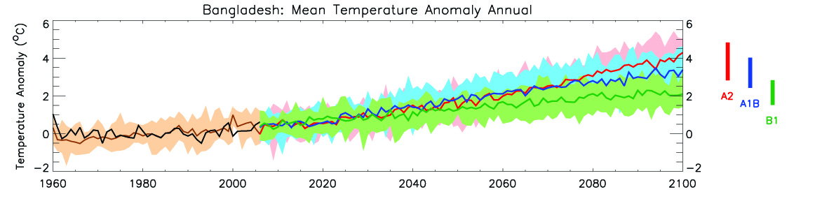

The left hand side of the Graphic 7.1 shows how Bangladesh’s climate has changed from 1960 – 2009.
- The black line shows the actual temperature anomaly for each year from 1960 to 2000. This is the difference in temperature between the year’s recorded temperature and the average of all years between 1970 and 1999. If the anomaly is positive, that year was warmer than the 1970-1999 average. If it is negative, that year was colder than the 1970-1999 average.
- The brown line shows past temperature anomalies as produced by a computer model with the brown shading showing the range of temperatures produced by the model.

- What is the general trend of the line?

Activity two
In order to make projections about future climate change, scenarios that describe possible global emissions of greenhouse gases throughout the 21st century are used. These scenarios are based on different ‘storylines’ that illustrate how things may change in the future. They take into account different projected trends in population, economic and technological developments, as well as changes in the political environment.

A number of different scenarios were proposed in a Special Report on Emissions Scenarios(SRES)
- A2 is a high carbon world, medium-high emissions scenario. This is based on a fairly divided world, where nations are self reliant and operate independently. Population rises continually, economic development is mainly regional and technological change is slow and fragmented.

- A1B is a medium carbon world, medium-low emissions scenario. This is based on a more integrated world. There is rapid economic growth on a global scale, technological change is fast and efficient, and there is a balanced emphasis on all energy sources. Global population rises to 9 billion in 2050 then declines.

- B1 is a low carbon world, low emissions scenario. This is based on a more integrated and ecologically friendly world. There is rapid economic growth as in A1 but with rapid changes towards a service and information economy. Global population rises to 9 billion in 2050 then declines. Clean and resource efficient technologies are introduced and global solutions to economic, social and environmental stability are emphasised.

The right hand section of the graphic below shows how Bangladesh’s climate might change between 2009 and 2100 based on predictions using each of the three scenarios above.

- The green, blue and red lines show projected future temperatures from 2006 to 2100, according to three different emissions scenarios – green ( B1 low), blue (A1B medium) and red (A2 high).
- The coloured bars summarise the range of temperatures for each emissions scenario.
- All scenarios show future temperatures will be warmer.
- Bangladesh is expected to warm by 0.9-2.6°C by the 2060s and 1.3-4.1°C by the 2090s.

- What is the main difference between scenarios A2 and A1B after 2050?
- Why does that affect the temperature?

Activity three
The three maps in Graphic 7.2 show the predicted change in Bangladesh’s annual temperature average in 2030, 2060 and 2090 if there is a high emissions scenario as in A2.
- All values are temperature anomalies – compared to average temperatures from 1970 to 1999.
- Areas shaded deep orange will be 6˚C hotter than average temperatures from 1970 to 1999. Whereas, areas shaded green will be the same as the 1970 – 1999 average.
- The tiny numbers in the centre of each grid box is the average expected temperature; numbers in the upper and lower corners give the maximum and minimum annual mean temperatures.
- The numbers along the y axis are Latitude and the numbers on the x axis are Longitude.

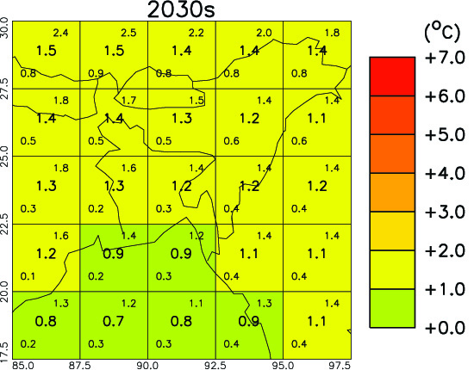
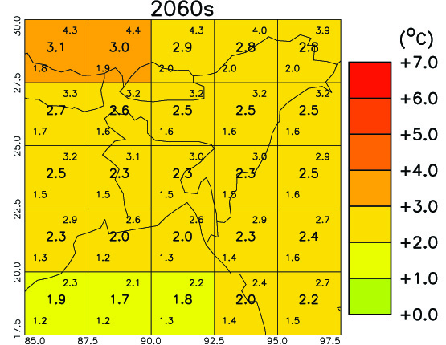
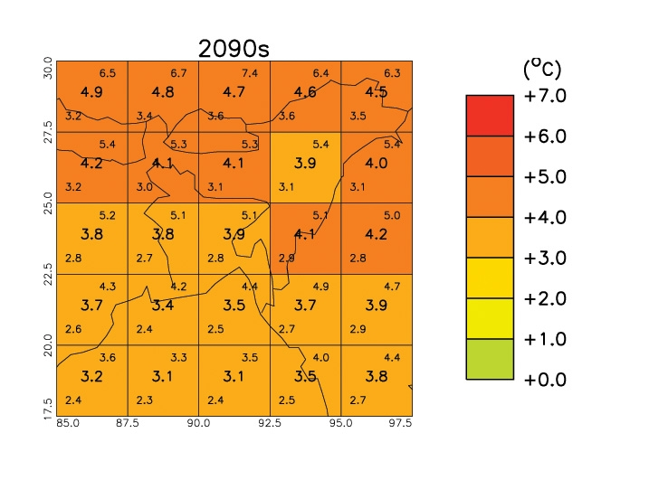

- Where will the most rapid temperature increases occur?
- Why is this?
- How will this affect the locations you studied in lesson 1?

PERSONAL ACTIVITY
How old will you be in 2050?
What will happen to the temperature of the place where you live?

