Why did David Livingstone go to Africa?

There were many reasons why Livingstone went to Africa; some of his journeys were sponsored by the British government. After his journeys, from 1880 to 1900, almost all of Africa was carved up between Europe’s main powers. This has been known as the ‘Scramble for Africa’.

Missionaries
David Livingstone was a missionary, someone who spread Christianity in the world. They set up mission stations, where people were often given food and medical treatment as well as the Bible. Schools were often attached to the mission stations which were used to spread knowledge and British culture around the world. Although Livingstone didn’t manage to convert many Africans, many missionaries who came after him set up schools and people did become Christians.

Livingstone did note the point of view of those who did not want to be converted:
The only cause of dislike was expressed by a very influential and sensible man, the uncle of Sechele:
We like you as well as if you had been born among us; you are the only white man we can become familiar with; but we wish you to give up that everlasting preaching and praying; we cannot become familiar with that at all. You see we never get rain, while those tribes who never pray as we do obtain abundance.
This was a fact; and we often saw it raining on the hills ten miles off, while it would not look at us even with one eye.
From Missionary Travels and Researches in South Africa by David Livingstone.

London Missionary Society
The Society was founded in 1795 and by the time Livingstone joined in 1838, it had a worldwide network of missions in every continent, including South Africa.

The Slave Trade
The European slave trade forced Africans onto slave ships and transported them in terrible conditions across the Atlantic Ocean to work on plantations in North and South America, growing sugar, tobacco and cotton for Europe. This was known as the triangular trade. Between 1500 and 1850 more than 11 million Africans arrived on European owned plantations. The Portuguese were the first Europeans to trade in African slaves.

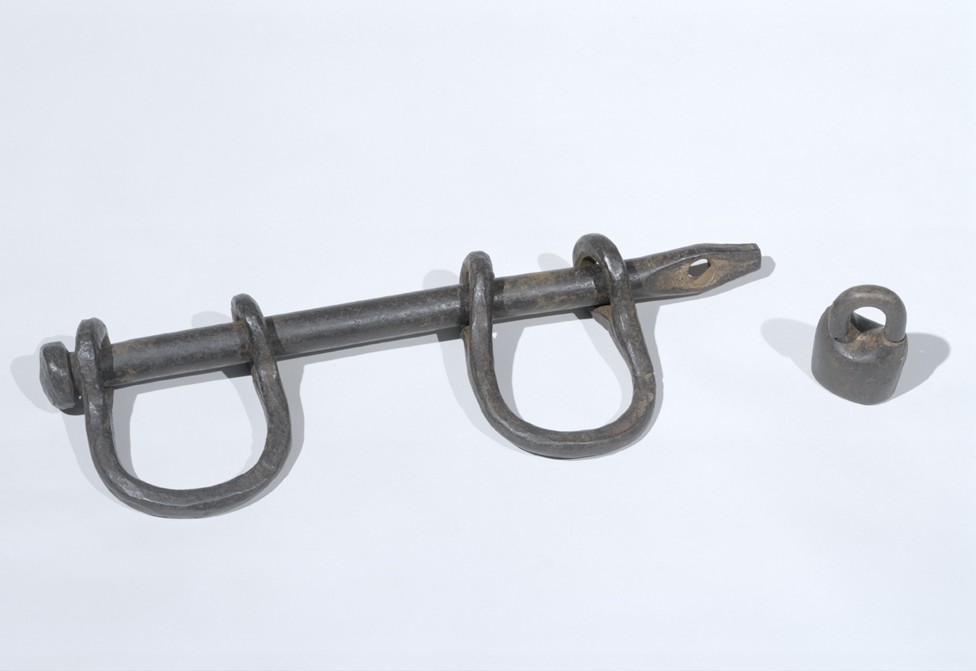By the eighteenth century the British were the main slave traders. Many of Livingstone’s accounts tell of the appalling conditions of African
Slaves. He also told stories of the Portuguese traders who had settlements on the coast and the Arab traders who he often had to get supplies from. He gave a lecture after one of his journeys where he showed people slave chains that he had brought back with him. He called the slave trade the ‘open sore’ of the world.

British and Foreign Anti-Slavery Society
This Society was founded in 1839. It produced a journal, the Anti-Slavery Reporter which was written by people around the world. They were known as campaigners, some criticised Europeans for colonising countries.
Livingstone became involved with the Society before going to Africa.

