Introducing the Grand Tour – Where am I?

“For these ten days past have I been traversing a ‘lapland’: winds whistling in my ears, and cones showering down upon my head from the wilds of pine through which our route conducted us. Often were we obliged to travel by moonlight, and I leave you to imagine the awful aspect of the mountains buried in snow. I scarcely ventured to utter an exclamation of surprise, though prompted by some of the most striking scenes in nature, lest I should interrupt the sacred silence that prevails, during winter, in these boundless solitudes. The streams are frozen, and mankind petrified, for aught I know to the contrary, since whole days have we journeyed on without perceiving the slightest hint of their existence. I never before felt the pleasure of discovering a smoke rising from a cottage, or of hearing a heifer lowing in its stall…”

Place a circle on the map marking the place you think the writer is describing.

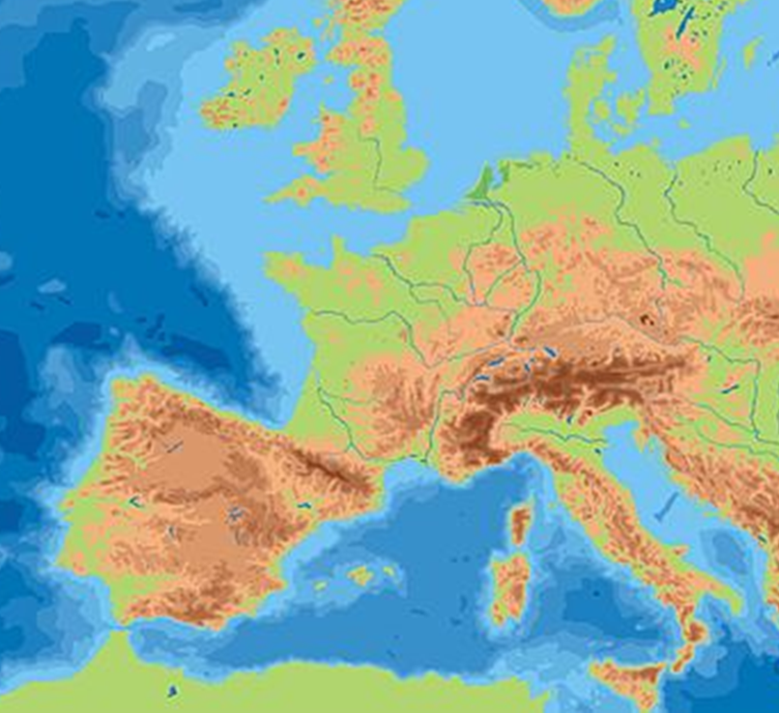
What clues from the text have led you to choose this place?

………………………………………….

…………………………………………..

……………………………………………

…………………………………………..

……………………………………………

…………………………………………..

When do you think the text might have been written?


……………………………………………………….……

