 | 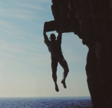  Adventure Landscapes in the UK |  |  |  |  |  | 
You have been spotted as a very good geographer and keen adventurer. Your favourite adventure club (which you will have to decide) have asked you to produce a booklet about the natural landscape that is so important to your sport. The reason you have been asked to produce this is because it is believed junior members are damaging the environment that is essential to their, and others, enjoyment.

Produce a booklet about one natural landscape for adventurers between eight and ten years of age.

- A title of your choice.  - An introduction that states your chosen sport, where it can be done, a map of your chosen location and what this booklet tells the reader.  - Information about each relevant natural feature – what it is, what it looks like, a print-out picture of it with labels, Aim to cover at least three natural features.  - Information about damage that adventures could do in your chosen landscape.  - A Code of Conduct for your chosen sport. You could do this in a cartoon style. |  |  |  | Three lessons  Two homeworks  You will need to use your homework time to gather your information about your chosen adventure sport, and the location setting for your booklet. It is your responsibility to bring your information to class. In class you will be able to use books to find out how different physical features are formed. |  | You will be assessed on the key concepts of:  Place  Scale  Physical and Human Processes  Environmental Interaction  You will be assessed on the key processes of:  Enquiry Skills  Use of Evidence  Presentation  Geographical Communication  Use your levelling grid to work out what you actually need to do for your target level.
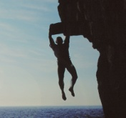
Adventure Landscapes in the UK
Levelling Grid  Internet – www.ordnancesurvey.gov.uk (‘Get-a-Map’),  A4 coloured paper  A4 plain paper  A4 lined paper  Resource Sheet B4 Using Sources  Resource Sheet C4 - Plan |  |  |  |  | Your completed booklet  Resource Sheet B4 Using Sources  Resource Sheet C4 - Plan |  |  | conserve  landform  landmark  physical feature  protection  respect  sustainable actions  Connectives for Emphasis  most of all  mostly  mainly  significantly  Connectives for Time Sequence  firstly …secondly ….thirdly…  next  then  later  as a result of  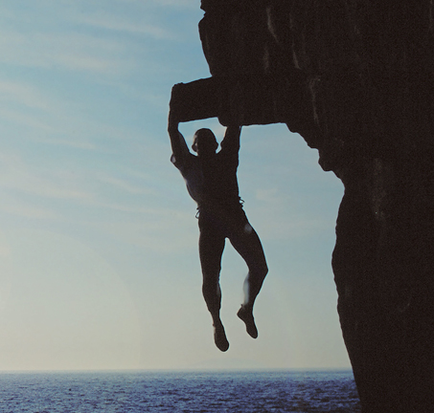
- Choose the adventure activity that your booklet will be for. It could be one of the activities studied in class (climbing, caving, or walking) or it could be one of your own choice such as: potholing, river kayaking, sea kayaking, or windsurfing. If you decide to choose an activity not studied in class then make sure that a particular landscape is associated with this activity – check with your teacher.

- Find out about your chosen activity – what people do where they do it and why they enjoy it.

- Choose a location to write your booklet about.

- Locate your chosen area on a map print out. Use ‘Get-a-map’ from www.ordnancesurvey.gov.uk

Continued on the next page ....
 |  |  | Adventure Landscapes in the UK
..... continued from previous page
- Find out about these three things and write about them in your own words:
  - Exactly what youngsters do within this activity. For example, Junior climbers are taught how to climb as a second climber in the out of doors with an instructor. They climb ‘easy’ and ‘difficult’ rock faces in gorges and on cliffs.
  - What physical features are seen, heard and smelt.
  - Pictures of physical features seen, heard and smelt.
  - What physical features are used by your activity and why,
  - What damage adventurers could cause.

- Produce a ‘Code of Conduct’ for your chosen activity. This is a list of instructions telling people how to behave so that they look after the environment that they use.

Writing styles for Adventure Landscapes in the UK
You will need to use descriptive writing and explanative writing. Remember to use a lot of geographical vocabulary for nouns and verbs. Lots of adjectives will also make your writing more interesting. Make your writing flow well by using emphasis connectives.

Your ‘Code of Respect’ will need to be written using Instruction Writing; each point you want to make is given as a short statement and these statements are put into a list. Each point then has a number.

