Environment Fact Sheet

Kenya has some of the most beautiful landscapes in the world. Here are some examples of the things you would find in Kenya:

Highest Mountain: Mount Kenya. The Kenyan people call the mountain ‘Kirinyaga’ which means ‘Mountain of God’. The mountain is 5199 metres high and is the second highest mountain in Africa. Although it is on the equator, the top of the mountain (or the summit) is always covered with snow.

Other Mountains: Mount Elgon (4,321m) is on the border between Kenya and Uganda. It was formed by hot rock (or lava) forcing its way up through cracks in the earth.

Volcanoes: Mount Longonot in the Rift Valley. There are very good soils around the volcano which means that many farmers grow crops here.

Rivers: The Tana River is the country’s longest river and is 700km long. The other main river is the Galana River (this is also called the Athi River).

Deserts: Chalbi Desert

Largest national park: Tsavo National Park (The park measures 20,810 square km and is divided into 2 parts – Tsavo East and Tsavo West).

Other important national parks and reserves: Kenya has 60 protected parks, these cover 7.5% of Kenya’s land. The Maasai Mara National Reserve, Amboseli National Park, Lake Nakuru National Park, Nairobi National Park are some famous examples.

Climate: Dry and warm. Kenya’s location on the equator means that temperatures change very little over the year. However temperatures do change across the country depending on the height of the land and its distance from the sea. For example the coastal areas (below 1000 metres) have temperatures of between 28-35°C during the daytime, but the dry lands in the north have temperatures of up to 40°C.

Rainfall: The rains arrive in 2 seasons, the long rains happen between March and May and the short rains happen between October and December. But rainfall changes from region to region, the dry bush land in the North of the country gets very little rain but the area around Lake Victoria gets rainfall nearly everyday.

This map shows some of the important parts of Kenya’s landscape. Can you pick out any others?
Lake Turkana
Lake Turkana is also known as the ‘Jade Sea’. This is because tiny plants in the water change colour with the wind and light!
Hippos and crocodiles also live in the lake so watch out!

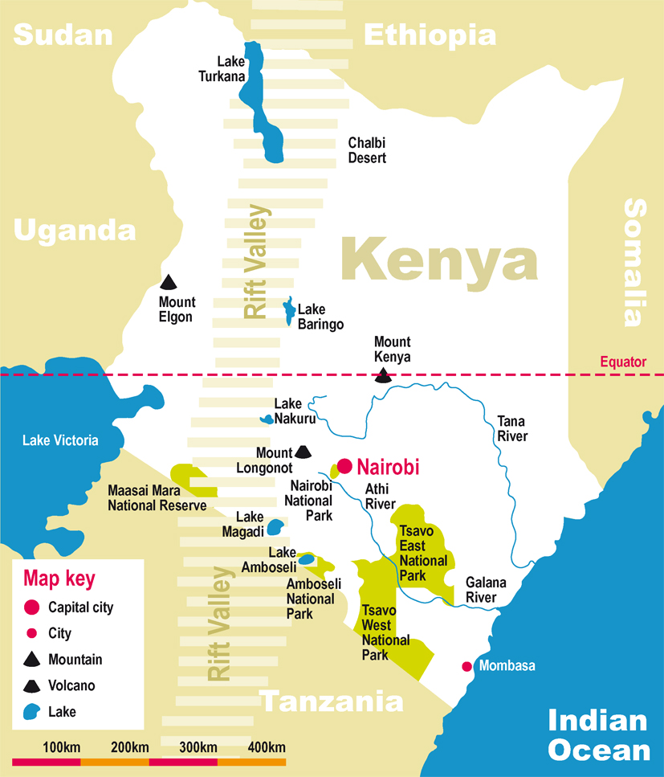

Tsavo National Park
The park is divided into 2 by a railway that runs from Mombasa to Nairobi. In 1899, 2 large lions began to hunt railway workers as they helped build the railway. The lions killed and ate 120 people and were called the ‘Maneaters’ of Tsavo!

Mount Kenya
Did you know that Maasai people believe that the God Ngai lives here? They believe that Ngai created the world.

Largest Lake: Lake Turkana. This is in the Rift Valley and is an important habitat for plants and animals.

Other important Lakes: Lake Victoria – Kenya controls 6% of it. It is the second largest freshwater lake in the world and is bordered by Tanzania, Uganda and Kenya. It is home to many important plants and animals, herds of wildebeest rely on the lake in the summer for drinking water.
Other Lakes include: Lake Nakuru, Lake Baringo, Lake Naivasha, Lake Magadi.

Coastline: 480 kilometres along the Indian Ocean

Plants: Acacia trees, baobab trees, thorn bushes, grassland, groundsel tree, giant lobelias, mangroves.

Animals: Rhinos, elephants, leopards, lions, antelope, giraffes, monkeys, flamingos, warthogs, cheetahs, hyenas, buffaloes, crocodiles.

Landscape: There are a variety of landscapes in Kenya including tropical coast, highlands, lowlands and savannah grasslands.

The Rift Valley: A closer look
Kenya is famous for the Rift Valley which runs from the north of the country to the south, the valley is so big that it can actually be seen from outer space. The valley was created when parts of the Earth’s surface began to move apart, this caused the land in the middle to sink. The valley has a number of shallow lakes that are famous for their flamingos (particularly Lake Nakuru and Lake Bogoria). The flamingos come to the lakes to feed on the algae that live in the water. The unique ecosystems found in the valley attract tourists from all over the world and also supply many of Kenya’s natural resources. The steep sides of the valley (or escarpments) provide good land for farming due to their rich soils.
Did you know that in 1976 scientists discovered footprints in the valley that were 3,600,000 years old and similar to those of humans! It was these early ‘people’ from which humans developed.

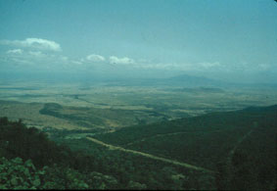

This is an image of the Rift Valley. If you look carefully you can see the other side of the valley. What do you think makes the land on each side of the valley good for farming?

© Cliff Pereira

Can you find out…
- What Africa’s highest mountain is called?
- What country it’s in?
- For bonus points, how much taller is it than Mount Kenya?

A Challenge for you…

