Matthew Wellington
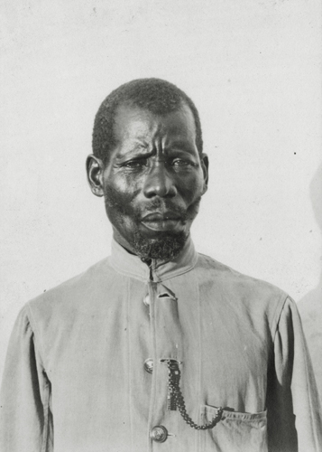 W. McGregor Ross, Date: 1909
© Royal Geographical Society

1847 | Born among the Yao tribe in East Africa (modern-day Northern Mozambique), named Chengwimbe.  Captured and made a domestic slave among the Yao. Taken to Kilwa (modern-day Tanzania) and sold for a “roll of cloth”. Taken first to Zanzibar and resold. Taken by dhow to Mogadishu (present-day Somalia), then towards Arabia.
1871 | The dhow holding some 200 enslaved Africans is captured by a British ship, HMS Thetis. The Africans are freed and are taken to the port of Bombay. From Bombay the Africans are taken to the mission station at Nasik, further North.
1872 | Chengwimbe is baptized as Mathew Wellington. Returns to Africa as a volunteer to join an expedition in search of David Livingstone.
1874 | Joined the Church Missionary Society, and became one  of the pioneers in the establishment of Freretown and Rabai as communities  for liberated (freed) Africans in what later became Mombasa, Kenya.
1911 | The governor of British East Africa suggested Mathew Wellington should be given a pension in recognition of his connection with Livingstone. This was refused by the British government
1935 | Died on 6 June.

