Extreme sports – the future

Surfing has got to be one of the coolest sports in the world and the waves we see in the tropical regions of the world may be available to ride on a beach near you soon.

As sea levels rise and coast lines are changed, the well known surfing spots found in Fiji and Hawaii will be engulfed and scientists predict that these rollers may be available for riding in the UK. An increase in sea levels means that coastlines will change and wave heights will increase. The popular surfing spots in Cornwall may well become a favourite location of the surfing world and this means that the next surfing world champion may be you.

The increase in wave height is expected to have more serious impacts on the UK coastlines, with the increased storm frequencies coastal protection will be demolished meaning that the beaches will be removed and the coastal regions flooded. The stormy seas will eventually mean that visiting the beach may be a thing of the past.

Kelly Slater- 8 Time Surfing World Champion

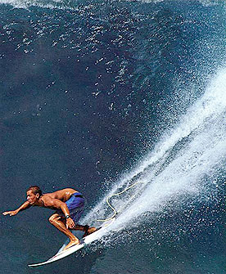
Kelly Slater is the most successful surfer in history and current world champion. He is currently sponsored by Quicksilver and Al Merrick surfboards and visits some of the most beautiful places on earth to surf the world’s best waves.

Surfing in many parts of the world rely on coral reefs to break the wave, due to warming sea temperatures these are now dying. This will eventually have a major effect on the waves used for surfing. Furthermore, those that live on the islands will be exposed to the full force of the wave which will erode beaches and flood the coastline.

Kelly Slater currently works for Reef Check an organisation that works towards the conservation of these fragile ecosystems. Through coral bleaching and increased storm intensity these areas are dying and the large ecosystems that exist in these areas will be destroyed forever.

Do you think surfing is sustainable?

Links

- http://www.globalissues.org/EnvIssues/Biodiversity/CoralReefs.asp
- http://www.reefcheck.org/
- http://www.youtube.com/watch?v=AlPqL7IUT6M
Big wave Surfing

Snowboarding

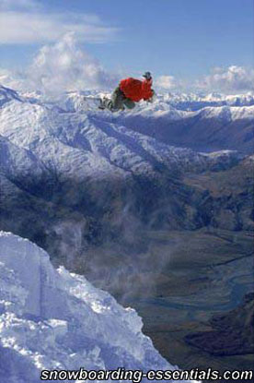
Snowboarding has become an extremely popular since its emergence in America, the young cool image of snowboarding has become a major attraction for those who enjoy the extreme sports. This pastime is now threatened and in the near future may become a pastime of history.

This year has been the warmest winter for 1300 years in the Alps and this has had a serious effect on the snow levels. Many of the resorts which rely on the winter sports industry for their annual income have suffered due to the warm weather, a problem which is predicted to continue into the future. Pressure is increasing in the high resorts and this is having its own environmental impacts on these sensitive alpine ecosystems.

This has more serious impacts in other mountainous regions, where glaciers do not only provide a source of income but a main source of fresh water.
The picture is evidence of how the mountain regions are threatened by higher global temperatures and how winter sports may be confined to the mountain tops.

Underwater snowboarding?

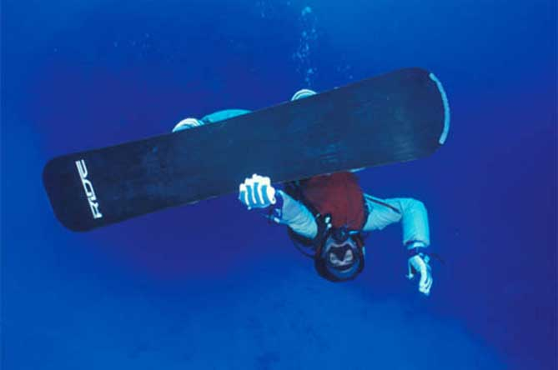
Maybe once the snow has melted this will become the new pastime…

Links

- http://www.newscientist.com/channel/opinion/climate-change/dn10749-alps-at-their-warmest-since-ad-800.html
- http://environment.guardian.co.uk/climatechange/story/0,,1968090,00.html
- http://observer.guardian.co.uk/world/story/0,,1989999,00.html

