Urban Observatory – comparing cities – a User Guide

Go to Urban Observatory website http://www.urbanobservatory.org/



The original Urban Observatory was an interactive exhibit that gave users the chance to compare and contrast data from cities around the world – all from one location. It aimed to make the world’s data both understandable and useful. It was developed by Richard Saul Wurman, Radical Media, and Esri, and was the first exhibit of its kind. It grew out of the 192021 project, which had the basic idea that there were 19 cities with a population above 20 million at the start of the 21st Century. Go to the 192021 website http://192021.org/ There were several large screens displaying data for several cities to enable comparison.

On arriving at the Urban Observatory website, you will be presented with information about the project.

An ‘app’ is now available which enables access to the information on the site and enable comparisons.
Click the APP tab on the home page, then ‘LAUNCH APP’ to be taken to the comparison page: http://urbanobservatory.org/compare/index.html

Three cities are displayed as the default: London, New York and Tokyo.

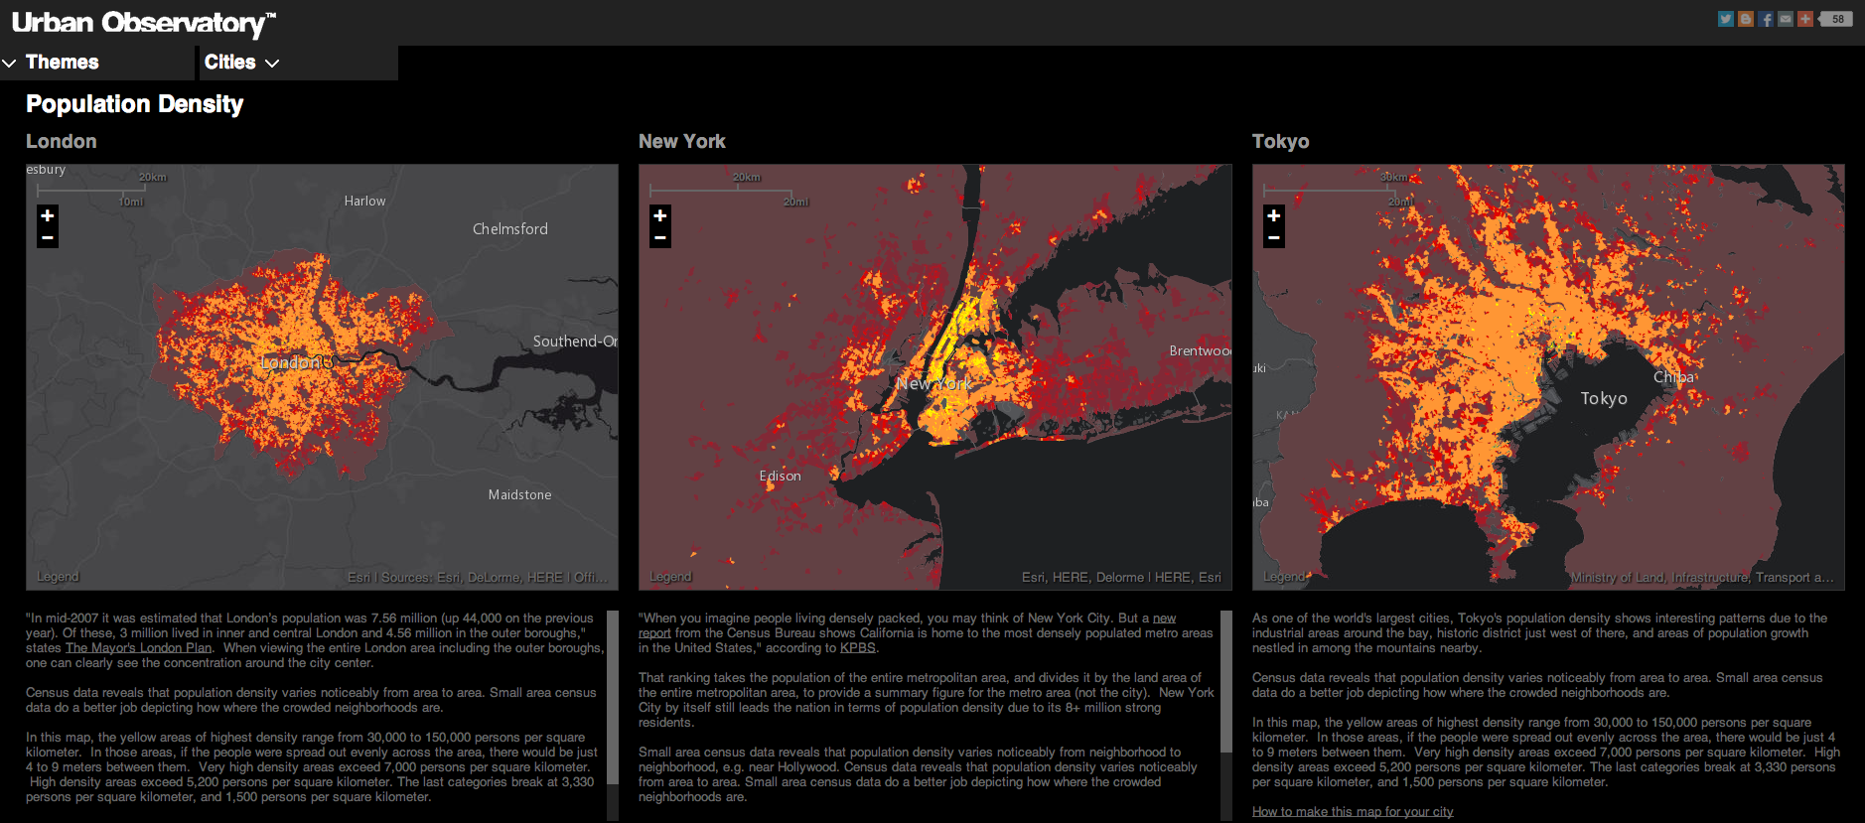
There are details about the three cities displayed beneath the graphics, which show the extent of the cities, complete with a scale line.
The Urban Observatory city comparison app enables you to explore the living fabric of great cities by browsing a variety of cities and themes.
To change Themes, click on a theme name in the Themes list.
To change Cities, click on the city name in the Cities list, or drag-and-drop it over a map.

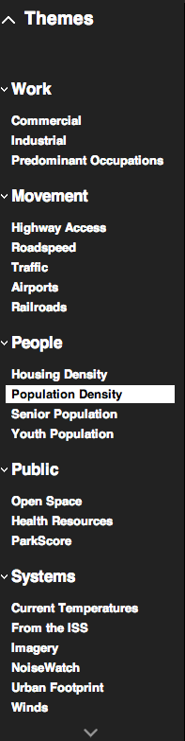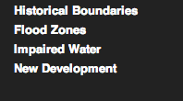

Cities that can currently be used for comparison are highlighted in bold.

Select a theme from the dropdown box and this can be seen in each of the three cities to enable comparison.

Use the recording sheets on the next page to record your observations. Your teacher may provide these for you in paper or electronic form.

Comparing Cities task.
Cities  Themes | London

How does London compare with the two cities that you selected?

