Africa – a continent of contrasts
Lesson 7: Africa – looking to the future

Kenya – Computers for schools scheme

Video: Download or watch online the video from
http://www.videoreporter.nl/computersforschools_uk_branded.wmv

There are several possible uses of this video. One is to look at the export of discarded technology from rich western countries and how this technology is disposed of in poor African countries. The second is look at the importance of students in countries such as Kenya becoming IT literate and the problems associated with this happening.

There are a number of supplementary resources available which could be used alongside this video.
Computers for Africa
http://www.computers4africa.org/

Computers to Africa
http://www.computerstoafrica.org/

BBC report
http://news.bbc.co.uk/1/hi/world/africa/2989567.stm

Digital Pipeline
http://www.digital-links.org/submenu-id-2-menuid-111.asp

Computer Aid
http://www.computeraid.org/wherewework.htm

Guardian – computer waste photo slideshow
http://www.guardian.co.uk/business/gallery/2008/may/06/computer.waste?picture=333898276

Guardian – computer waste article
http://www.guardian.co.uk/environment/2008/may/06/waste.pollution

BBC report e-waste
http://news.bbc.co.uk/1/hi/world/africa/7543489.stm

Computer waste
http://www.computertakeback.com/docUploads/TheDigitalDumpWeb.pdf
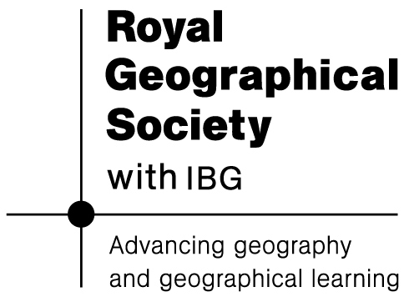

Photo credits: computer waste – Flickr (Creative Commons Licence) – photographer – kbaird, dismantling computers - Flickr (Creative Commons Licence) – photographer – greenpeace

