Lesson One Assessment Quiz: Answers

1. Look at the map below, can you name the continent?
South America

2. Can you name and locate the two oceans that border South America?
Atlantic Ocean and Pacific Ocean

3. Look at the map below, can you name and locate Brazil on the map?
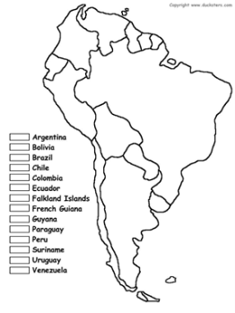
Brazil
4. Look at the map below, can you name and locate the 10 countries that share a border with Brazil?
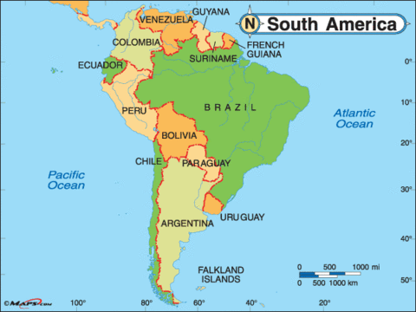

5. Look at the map below, can you name and locate the capital city of Brazil?
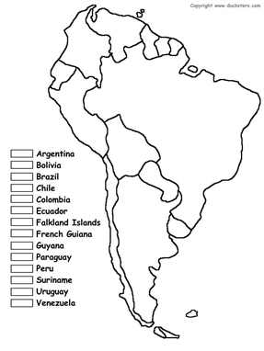
Brasilia
6. Can you name three large cities in Brazil (excluding the capital city)?
Sao Paulo, Salvador, Rio de Janeiro

7. What is the name of the longest river in Brazil?
The Amazon River

8. What is the name of the largest mountain range in Brazil?
Serra do Espinhaço

9. A) What is a human feature? Provide examples.
A man-made feature in the environment. For example: buildings, bridges, tunnels, railroad tracks, dams, monuments, piers, cultivated land).
B) What is a physical feature? Provide examples.
Natural landforms and bodies of water. For example: cliffs, rivers, waterfalls, caves, mountains.
10. A) Can you name the six geographical regions of Brazil?
Tropical rainforest (Amazonia), The Cerrado, The Pantanal, The Pampas, The Caatinga, The Mata Atlantic
B) Can you describe any of the features of these regions?
See downloads: Geographical Regions Information Sheet

